# **Flight Controller (Autopilot) Hardware**

This section provides information about the different autopilot hardware that can be used to run the PX4 flight stack.

There are a number of options:

* [Pixhawk Series](https://docs.px4.io/en/flight_controller/pixhawk_series.html) - Open hardware flight controllers that run PX4 on NuttX OS. With many form factors, there are versions targeted towards many use cases and market segments
* Autopilots for computationally intensive tasks:
  + [Qualcomm Snapdragon Flight](https://docs.px4.io/en/flight_controller/snapdragon_flight.html) - High-end autopilot with integrated onboard computer.
  + [Intel® Aero Ready to Fly Drone](https://docs.px4.io/en/flight_controller/intel_aero.html) - UAV development platform with high-end autopilot and integrated onboard computer.
  + [Raspberry Pi 2/3 Navio2](https://docs.px4.io/en/flight_controller/raspberry_pi_navio2.html)
  + [BeagleBone Blue](https://docs.px4.io/en/flight_controller/beaglebone_blue.html)
* Consumer drones that can run PX4:
  + [Crazyflie 2.0](https://docs.px4.io/en/flight_controller/crazyflie2.html)
  + [Parrot Bebop](https://docs.px4.io/en/flight_controller/bebop.html)

## **Documented Boards**

The list of boards documented in this library can be found in the sidebar (reproduced below):

The library does not document all boards that can run PX4 (there are other compatible flight controllers and variants).

* [Pixhawk Series](https://docs.px4.io/en/flight_controller/pixhawk_series.html)
  + [Pixhawk 1](https://docs.px4.io/en/flight_controller/pixhawk.html)
  + [mRo Pixhawk](https://docs.px4.io/en/flight_controller/mro_pixhawk.html)
  + [mRobotics-X2.1](https://docs.px4.io/en/flight_controller/mro_x2.1.html)
  + [HKPilot32](https://docs.px4.io/en/flight_controller/HKPilot32.html)
  + [Pixfalcon](https://docs.px4.io/en/flight_controller/pixfalcon.html)
  + [Dropix](https://docs.px4.io/en/flight_controller/dropix.html)
  + [Pixracer](https://docs.px4.io/en/flight_controller/pixracer.html)
  + [Pixhawk 2](https://docs.px4.io/en/flight_controller/pixhawk-2.html)
  + [Pixhawk Mini](https://docs.px4.io/en/flight_controller/pixhawk_mini.html)
  + [Pixhawk 3 Pro](https://docs.px4.io/en/flight_controller/pixhawk3_pro.html)
  + [Pixhack v3](https://docs.px4.io/en/flight_controller/pixhack_v3.html)
  + [Pixhawk 4](https://docs.px4.io/en/flight_controller/pixhawk4.html)
  + [Pixhack v5](https://docs.px4.io/en/flight_controller/pixhack_v5.html)
  + [AUAV-X2 (Discontinued)](https://docs.px4.io/en/flight_controller/auav_x2.html)
* [(Air)Mind Series](https://docs.px4.io/en/flight_controller/mind_series.html)
  + [MindPX](https://docs.px4.io/en/flight_controller/mindpx.html)
  + [MindRacer](https://docs.px4.io/en/flight_controller/mindracer.html)
* [Omnibus F4 SD](https://docs.px4.io/en/flight_controller/omnibus_f4_sd.html)
* [Snapdragon Flight](https://docs.px4.io/en/flight_controller/snapdragon_flight.html)
* [Intel® Aero Ready to Fly Drone](https://docs.px4.io/en/flight_controller/intel_aero.html)
* [Raspberry Pi 2/3 Navio2](https://docs.px4.io/en/flight_controller/raspberry_pi_navio2.html)
* [OcPoC-Zynq Mini](https://docs.px4.io/en/flight_controller/ocpoc_zynq.html)
* [Crazyflie 2.0](https://docs.px4.io/en/flight_controller/crazyflie2.html)
* [Parrot Bebop](https://docs.px4.io/en/flight_controller/bebop.html)
* [BeagleBone Blue](https://docs.px4.io/en/flight_controller/beaglebone_blue.html)

**Pixhawk Series**

[Pixhawk®](https://pixhawk.org/) is an independent open-hardware project providing readily-available, low-cost, and high-end, *autopilot hardware designs* to the academic, hobby and industrial communities. "Pixhawk-series" boards run PX4 on the [NuttX](http://nuttx.org/) OS.

Manufacturers have created many different boards based on the open designs, with form factors that are optimised for applications from cargo carrying though to first person view (FPV) racers.

For computationally intensive tasks (e.g. computer vision) you will need a separate companion computer (e.g. [Raspberry Pi 2/3 Navio2](https://docs.px4.io/en/flight_controller/raspberry_pi_navio2.html)) or a platform with an integrated companion solution (e.g. [Intel® Aero Ready to Fly Drone](https://docs.px4.io/en/flight_controller/intel_aero.html), [Qualcomm Snapdragon Flight](https://docs.px4.io/en/flight_controller/snapdragon_flight.html)).

## **Key Benefits**

Key benefits of using a *Pixhawk series* controller include:

* Software support - as PX4 reference hardware these are our best-maintained boards.
* Flexibility in terms of hardware peripherals that can be attached.
* High quality.
* Highly customizable in terms of form factor.
* Widely-used and thus well-tested/stable.
* Automated update of latest firmware via *QGroundControl* (end-user friendly).

## **Recommended Boards**

The following products in the series are recommended/regularly tested with PX4:

* [mRo Pixhawk](https://docs.px4.io/en/flight_controller/mro_pixhawk.html)
* [HKPilot32](https://docs.px4.io/en/flight_controller/HKPilot32.html)
* [Pixfalcon](https://docs.px4.io/en/flight_controller/pixfalcon.html)
* [DroPix](https://docs.px4.io/en/flight_controller/dropix.html)
* [Pixracer](https://docs.px4.io/en/flight_controller/pixracer.html)
* [Pixhack v3](https://docs.px4.io/en/flight_controller/pixhack_v3.html)
* [Pixhawk 2](https://docs.px4.io/en/flight_controller/pixhawk-2.html)
* [Pixhawk 3 Pro](https://docs.px4.io/en/flight_controller/pixhawk3_pro.html)
* [Pixhawk 4](https://docs.px4.io/en/flight_controller/pixhawk4.html)
* [Pixhawk 4 Mini](https://docs.px4.io/en/flight_controller/pixhawk4_mini.html)
* [Pixhack v5](https://docs.px4.io/en/flight_controller/pixhack_v5.html)
* This is not an exhaustive list of all boards that can run PX4. Other boards are linked from the sidebar, and there may be other flight controllers that we have not documented.

The rest of this topic explains a bit more about the Pixhawk series, but is not required reading.

## **Background**

The [Pixhawk project](https://pixhawk.org/) creates open hardware designs in the form of schematics, which define a set of components (CPU, sensors, etc.) and their connections/pin mappings.

Manufacturers are encouraged to take the [open designs](https://github.com/PX4/Hardware#hardware) and create products that are best suited to a particular market or use case (the physical layout/form factor not part of the open specification). Boards based on the same design are binary compatible.

While a physical connector standard is not mandated, newer products generally follow the [Dronecode® Autopilot Connector Standard](https://wiki.dronecode.org/workgroup/connectors/start).

The project also creates reference autopilot boards based on the open designs, and shares them under the same [licence](https://docs.px4.io/en/flight_controller/pixhawk_series.html#licensing-and-trademarks).

### **FMU Versions**

The Pixhawk project has created a number of different open designs/schematics. All boards based on a design should be binary compatible (run the same firmware).

Each design is named using the designation: FMUvX (e.g.: FMUv1, FMUv2, FMUv3, FMUv4, etc.). Higher FMU numbers indicate that the board is more recent, but may not indicate increased capability (versions can be almost identical - differing only in connector wiring).

PX4 *users* generally do not need to know very much about FMU versions:

* *QGroundControl* automatically downloads the correct firmware for a connected autopilot (based on its FMU version "under the hood").
* Choosing a controller is usually based on physical constraints/form factor rather than FMU version.

PX4 *developers* need to know the FMU version of their board, as this is required to build custom hardware.

At very high level, the main differences are:

* **FMUv2:** Single board with STM32427VI processor ([Pixhawk 1](https://docs.px4.io/en/flight_controller/pixhawk.html), [HKPilot32](https://docs.px4.io/en/flight_controller/HKPilot32.html), [Pixfalcon](https://docs.px4.io/en/flight_controller/pixfalcon.html), [DroPix](https://docs.px4.io/en/flight_controller/dropix.html))
* **FMUv3:** Identical to FMUv2, but usable flash doubled to 2MB ([Pixhawk 2](https://docs.px4.io/en/flight_controller/pixhawk-2.html),[Pixhack v3](https://docs.px4.io/en/flight_controller/pixhack_v3.html),[mRo Pixhawk](https://docs.px4.io/en/flight_controller/mro_pixhawk.html), [Pixhawk Mini (Discontinued)](https://docs.px4.io/en/flight_controller/pixhawk_mini.html))
* **FMUv4:** Increased RAM. Faster CPU. More serial ports. No IO processor ([Pixracer](https://docs.px4.io/en/flight_controller/pixracer.html))
* **FMUv4-PRO:** Slightly increased RAM. More serial ports. IO processor ([Pixhawk 3 Pro](https://docs.px4.io/en/flight_controller/pixhawk3_pro.html))
* **FMUv5:** New processor (F7). Much faster. More RAM. More CAN busses. Much more configurable.([Pixhawk 4](https://docs.px4.io/en/flight_controller/pixhawk4.html),[Pixhack v5](https://docs.px4.io/en/flight_controller/pixhack_v5.html))

### **Licensing and trademarks**

Pixhawk project schematics and reference designs are licensed under [CC BY-SA 3](https://creativecommons.org/licenses/by-sa/3.0/legalcode).

The license allows you to use, sell, share, modify and build on the files in almost any way you like - provided that you give credit/attribution, and that you share any changes that you make under the same open source license (see the [human readable version of the license](https://creativecommons.org/licenses/by-sa/3.0/) for a concise summary of the rights and obligations).

Boards that are *derived directly* from Pixhawk project schematic files (or reference boards) must be open sourced. They can't be commercially licensed as proprietary products.

Manufacturers can create (compatible) *fully independent products* by first generating fresh schematic files that have the same pin mapping/components as the FMU designs. Products that are based on independently created schematics are considered original works, and can be licensed as required.

Product names/brands can also be trademarked. Trademarked names may not be used without the permission of the owner.

*Pixhawk* is a trademark, and cannot be used in product names without permission.

## **Additional Information**

## **LEDs**

All *Pixhawk-series* flight controllers have an RGB LED to indicate the current status of the vehicle. To interpret the LEDs see: [LED Meanings](https://docs.px4.io/en/flying/led_meanings.html).

**Pixhawk 1 Flight Controller**

The *Pixhawk® 1* autopilot is a popular general purpose flight controller based on the [Pixhawk-project](https://pixhawk.org/) **FMUv2** open hardware design (it combines the functionality of the PX4FMU + PX4IO). It runs PX4 on the [NuttX](http://nuttx.org/) OS.

Originally manufactured by 3DR® this board was the original standard microcontroller platform for PX4. While the board is no longer manufactured by 3DR, you can use the [mRo Pixhawk](https://word-edit.officeapps.live.com/we/mro_pixhawk.html) as a drop-in replacement.

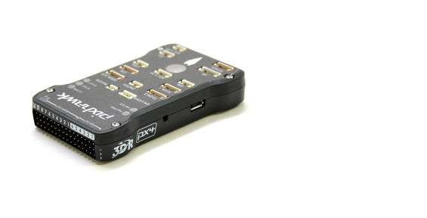

Assembly/setup instructions for use with PX4 are provided here: [Pixhawk Wiring Quickstart](https://word-edit.officeapps.live.com/assembly/quick_start_pixhawk.html)

## **Key Features**

* Main System-on-Chip: [STM32F427](http://www.st.com/web/en/catalog/mmc/FM141/SC1169/SS1577/LN1789)
  + CPU: 180 MHz ARM® Cortex® M4 with single-precision FPU
  + RAM: 256 KB SRAM (L1)
* Failsafe System-on-Chip: STM32F100
  + CPU: 24 MHz ARM Cortex M3
  + RAM: 8 KB SRAM
* Wifi: ESP8266 external
* GPS: U-Blox® 7/8 (Hobbyking®) / U-Blox 6 (3D Robotics)
* Optical flow: [PX4 Flow unit](http://www.hobbyking.com/hobbyking/store/__66308__HK_Pilot32_Optical_Flow_Kit_With_Sonar.html)
* Redundant power supply inputs and automatic failover
* External safety switch
* Multicolor LED main visual indicator
* High-power, multi-tone piezo audio indicator
* microSD card for high-rate logging over extended periods of time

Connectivity

* 1x I2C
* 1x CAN (2x optional)
* 1x ADC
* 4x UART (2x with flow control)
* 1x Console
* 8x PWM with manual override
* 6x PWM / GPIO / PWM input
* S.BUS / PPM / Spektrum input
* S.BUS output

# **Where to Buy**

Originally manufactured by 3DR® this board was the original standard microcontroller platform for PX4®. While the board is no longer manufactured by 3DR, you can use the [mRo Pixhawk](https://word-edit.officeapps.live.com/we/mro_pixhawk.html) as a drop-in replacement.

Order mRo Pixhawk from:

* [Bare Bones](https://store.mrobotics.io/Genuine-PixHawk-1-Barebones-p/mro-pixhawk1-bb-mr.htm) - Just the board (useful as a 3DR Pixhawk replacement)
* [mRo Pixhawk 2.4.6 Essential Kit](https://store.mrobotics.io/Genuine-PixHawk-Flight-Controller-p/mro-pixhawk1-minkit-mr.htm) - includes everything except for telemetry radios
* [mRo Pixhawk 2.4.6 Cool Kit! (Limited edition)](https://store.mrobotics.io/product-p/mro-pixhawk1-fullkit-mr.htm) - includes everything you need including telemetry radios

If out of stock the software-compatible but not connector-compatible versions can be used:

* [HKPilot32](http://www.hobbyking.com/hobbyking/store/__55561__HKPilot32_Autonomous_Vehicle_32Bit_Control_Set_w_Power_Module.html)

## **Specifications**

### **Processor**

* 32bit STM32F427 [Cortex-M4F](http://en.wikipedia.org/wiki/ARM_Cortex-M#Cortex-M4) core with FPU
* 168 MHz
* 256 KB RAM
* 2 MB Flash
* 32 bit STM32F103 failsafe co-processor

### **Sensors**

* ST Micro L3GD20H 16 bit gyroscope
* ST Micro LSM303D 14 bit accelerometer / magnetometer
* Invensense MPU 6000 3-axis accelerometer/gyroscope
* MEAS MS5611 barometer

### **Interfaces**

* 5x UART (serial ports), one high-power capable, 2x with HW flow control
* 2x CAN (one with internal 3.3V transceiver, one on expansion connector)
* Spektrum DSM / DSM2 / DSM-X® Satellite compatible input
* Futaba S.BUS® compatible input and output
* PPM sum signal input
* RSSI (PWM or voltage) input
* I2C
* SPI
* 3.3 and 6.6V ADC inputs
* Internal microUSB port and external microUSB port extension
* 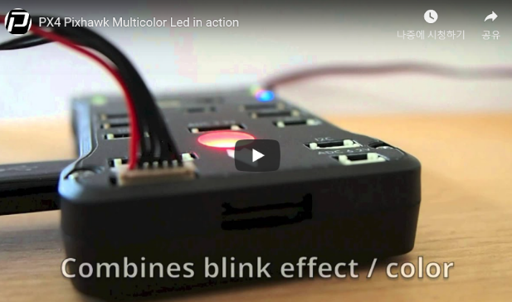
* https://youtu.be/gCCC5A-Bvv4

### **Power System and Protection**

* Ideal diode controller with automatic failover
* Servo rail high-power (max. 10V) and high-current (10A+) ready
* All peripheral outputs over-current protected, all inputs ESD protected

## **Voltage Ratings**

Pixhawk can be triple-redundant on the power supply if three power sources are supplied. The three rails are: Power module input, servo rail input, USB input.

### **Normal Operation Maximum Ratings**

Under these conditions all power sources will be used in this order to power the system

* Power module input (4.8V to 5.4V)
* Servo rail input (4.8V to 5.4V) **UP TO 10V FOR MANUAL OVERRIDE, BUT AUTOPILOT PART WILL BE UNPOWERED ABOVE 5.7V IF POWER MODULE INPUT IS NOT PRESENT**
* USB power input (4.8V to 5.4V)

### **Absolute Maximum Ratings**

Under these conditions the system will not draw any power (will not be operational), but will remain intact.

* Power module input (4.1V to 5.7V, 0V to 20V undamaged)
* Servo rail input (4.1V to 5.7V, 0V to 20V)
* USB power input (4.1V to 5.7V, 0V to 6V)

## **Schematics**

[FMUv2 + IOv2 schematic](https://raw.githubusercontent.com/PX4/Hardware/master/FMUv2/PX4FMUv2.4.5.pdf) -- Schematic and layout

As a CC-BY-SA 3.0 licensed Open Hardware design, all schematics and design files are [available](https://github.com/PX4/Hardware).

## **Connectors**

The RC IN port is for RC receivers only and provides power. **NEVER** connect any servos, power supplies or batteries to it or to the receiver connected to it.



## **Pinouts**

TELEM1, TELEM2 ports

|  |  |  |
| --- | --- | --- |
| **Pin** | **Signal** | **Volt** |
| 1 (red) | VCC | +5V |
| 2 (blk) | TX (OUT) | +3.3V |
| 3 (blk) | RX (IN) | +3.3V |
| 4 (blk) | CTS (IN) | +3.3V |
| 5 (blk) | RTS (OUT) | +3.3V |
| 6 (blk) | GND | GND |

GPS port

|  |  |  |
| --- | --- | --- |
| **Pin** | **Signal** | **Volt** |
| 1 (red) | VCC | +5V |
| 2 (blk) | TX (OUT) | +3.3V |
| 3 (blk) | RX (IN) | +3.3V |
| 4 (blk) | CAN2 TX | +3.3V |
| 5 (blk) | CAN2 RX | +3.3V |
| 6 (blk) | GND | GND |

SERIAL 4/5 port - due to space constraints two ports are on one connector.

|  |  |  |
| --- | --- | --- |
| **Pin** | **Signal** | **Volt** |
| 1 (red) | VCC | +5V |
| 2 (blk) | TX (#4) | +3.3V |
| 3 (blk) | RX (#4) | +3.3V |
| 4 (blk) | TX (#5) | +3.3V |
| 5 (blk) | RX (#5) | +3.3V |
| 6 (blk) | GND | GND |

ADC 6.6V

|  |  |  |
| --- | --- | --- |
| **Pin** | **Signal** | **Volt** |
| 1 (red) | VCC | +5V |
| 2 (blk) | ADC IN | up to +6.6V |
| 3 (blk) | GND | GND |

ADC 3.3V

|  |  |  |
| --- | --- | --- |
| **Pin** | **Signal** | **Volt** |
| 1 (red) | VCC | +5V |
| 2 (blk) | ADC IN | up to +3.3V |
| 3 (blk) | GND | GND |
| 4 (blk) | ADC IN | up to +3.3V |
| 5 (blk) | GND | GND |

I2C

|  |  |  |
| --- | --- | --- |
| **Pin** | **Signal** | **Volt** |
| 1 (red) | VCC | +5V |
| 2 (blk) | SCL | +3.3 (pullups) |
| 3 (blk) | SDA | +3.3 (pullups) |
| 4 (blk) | GND | GND |

CAN

|  |  |  |
| --- | --- | --- |
| **Pin** | **Signal** | **Volt** |
| 1 (red) | VCC | +5V |
| 2 (blk) | CAN_H | +12V |
| 3 (blk) | CAN_L | +12V |
| 4 (blk) | GND | GND |

SPI

|  |  |  |
| --- | --- | --- |
| **Pin** | **Signal** | **Volt** |
| 1 (red) | VCC | +5V |
| 2 (blk) | SPI_EXT_SCK | +3.3 |
| 3 (blk) | SPI_EXT_MISO | +3.3 |
| 4 (blk) | SPI_EXT_MOSI | +3.3 |
| 5 (blk) | !SPI_EXT_NSS | +3.3 |
| 6 (blk) | !GPIO_EXT | +3.3 |
| 7 (blk) | GND | GND |

POWER

|  |  |  |
| --- | --- | --- |
| **Pin** | **Signal** | **Volt** |
| 1 (red) | VCC | +5V |
| 2 (blk) | VCC | +5V |
| 3 (blk) | CURRENT | +3.3V |
| 4 (blk) | VOLTAGE | +3.3V |
| 5 (blk) | GND | GND |
| 6 (blk) | GND | GND |

SWITCH

|  |  |  |
| --- | --- | --- |
| **Pin** | **Signal** | **Volt** |
| 1 (red) | VCC | +3.3V |
| 2 (blk) | !IO_LED_SAFETY | GND |
| 3 (blk) | SAFETY | GND |

## **Console Port**

The system's serial console runs on the port labeled SERIAL4/5. The pinout is standard serial pinout, to connect to a standard FTDI cable (3.3V, but its 5V tolerant).

Please refer to the Devguide [wiring](https://dev.px4.io/en/debug/system_console.html) page for details of how to wire up this port.

## **Build Firmware**

To build (and upload) PX4 firmware for this board:

make px4fmu-v2_default upload

## **Parts / Housings**

* **ARM MINI JTAG (J6**, //not populated per default//**)**: 1.27 mm 10pos header (SHROUDED, for Black Magic Probe: FCI 20021521-00010D4LF ([Distrelec](http://www.distrelec.ch/en/Pin-header-SMT-straight-for-IDC-1-27-mm-10-Minitek-127-Pin-header-for-IDC%2C-shrouded%2C-straight%2C-SMT-FCI-20021521-00010D4LF/p/14352308?q=20021521-00010D4LF&page=1&origPos=1&origPageSize=10&simi=99.4), [Digi-Key](http://www.digikey.com/product-detail/en/20021521-00010T1LF/609-4054-ND/2414951),) or Samtec FTSH-105-01-F-DV-K (untested) or Harwin M50-3600542 ([Digikey](http://www.digikey.com/product-detail/en/M50-3600542/952-1389-ND/2264370) or [Mouser](http://ch.mouser.com/ProductDetail/Harwin/M50-3600542/?qs=%2fha2pyFadujTt%2fIEz8xdzrYzHAVUnbxh8Ki%252bwWYPNeEa09PYvTkIOQ%3d%3d))
  + JTAG Adapter Option #1: [BlackMagic Probe](http://www.blacksphere.co.nz/main/blackmagic), comes without cables, needs the **Samtec FFSD-05-D-06.00-01-N** cable ([Samtec sample service](http://www.samtec.com/suddenservice/samples/samples.aspx) or [Digi-Key Link: SAM8218-ND](http://www.digikey.com/product-search/en?x=0&y=0&lang=en&site=us&KeyWords=FFSD-05-D-06.00-01-N)) or [Tag Connect Ribbon](http://www.tag-connect.com/CORTEXRIBBON10) and a Mini-USB cable
  + JTAG Adapter Option #2: [Digi-Key Link: ST-LINK/V2](http://search.digikey.com/us/en/cat/programmers-development-systems/in-circuit-programmers-emulators-and-debuggers/2621880?k=st%20link%20v2) / [ST USER MANUAL](http://www.st.com/internet/com/TECHNICAL_RESOURCES/TECHNICAL_LITERATURE/USER_MANUAL/DM00026748.pdf), needs an ARM Mini JTAG to 20pos adapter: [Digi-Key Link: 726-1193-ND](http://search.digikey.com/us/en/products/MDL-ADA2/726-1193-ND/1986451)
  + JTAG Adapter Option #3: [SparkFun Link: Olimex ARM-TINY](http://www.sparkfun.com/products/8278) or any other OpenOCD-compatible ARM Cortex JTAG adapter, needs an ARM Mini JTAG to 20pos adapter: [Digi-Key Link: 726-1193-ND](http://search.digikey.com/us/en/products/MDL-ADA2/726-1193-ND/1986451)
* **USARTs**: Hirose DF13 6 pos ([Digi-Key Link: DF13A-6P-1.25H(20)](http://search.digikey.com/scripts/DkSearch/dksus.dll?WT.z_header=search_go&lang=en&site=us&keywords=DF13A-6P-1.25H%2820%29&x=0&y=0))
  + Mates: Hirose DF13 6 pos housing ([Digi-Key Link: Hirose DF13-6S-1.25C](http://search.digikey.com/us/en/products/DF13-6S-1.25C/H2182-ND/241752))
* **I2C and CAN**: Hirose DF13 4 pos ([Digi-Key Link: DF13A-4P-1.25H(20)](http://search.digikey.com/scripts/DkSearch/dksus.dll?WT.z_header=search_go&lang=en&site=us&keywords=DF13A-4P-1.25H%2820%29&x=0&y=0))
  + Mates: Hirose DF13 4 pos housing ([Digi-Key Link: Hirose DF13-4S-1.25C](http://www.digikey.com/product-search/en?KeyWords=DF13-4S-1.25C))
* **USB (J5)**: Micro USB-B
  + Mates: Cell phone data / charger cables, e.g. [Digi-Key Link: ASSMANN AK67421-0.5-R](http://search.digikey.com/us/en/products/AK67421-0.5-R/AE10418-ND/2263977)

## **Supported Platforms / Airframes**

Any multicopter / airplane / rover or boat that can be controlled with normal RC servos or Futaba S-Bus servos.

**mRo Pixhawk Flight Controller (Pixhawk 1)**

The *mRo Pixhawk®* is a hardware compatible version of the original [Pixhawk 1](https://docs.px4.io/en/flight_controller/pixhawk.html). It runs PX4 on the [NuttX](http://nuttx.org/) OS.

The controller can be used as a drop-in replacement for the 3DR® [Pixhawk 1](https://docs.px4.io/en/flight_controller/pixhawk.html).

The main difference is that it is based on the [Pixhawk-project](https://pixhawk.org/) **FMUv3** open hardware design, which corrects a bug that limited the original Pixhawk 1 to 1MB of flash.

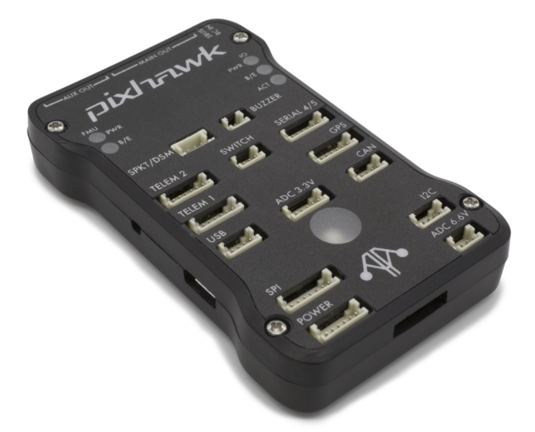

Assembly/setup instructions for use with PX4 are provided here: [Pixhawk Wiring Quickstart](https://docs.px4.io/en/assembly/quick_start_pixhawk.html)

## **Key Features**

* Microprocessor:
  + 32-bit STM32F427 Cortex® M4 core with FPU
  + 168 MHz/256 KB RAM/2 MB Flash
  + 32 bit STM32F103 failsafe co-processor
* Sensors:
  + ST Micro L3GD20 3-axis 16-bit gyroscope
  + ST Micro LSM303D 3-axis 14-bit accelerometer / magnetometer
  + Invensense® MPU 6000 3-axis accelerometer/gyroscope
  + MEAS MS5611 barometer
* Interfaces:
  + 5x UART (serial ports), one high-power capable, 2x with HW flow control
  + 2x CAN
  + Spektrum DSM / DSM2 / DSM-X® Satellite compatible input up to DX8 (DX9 and above not supported)
  + Futaba® S.BUS compatible input and output
  + PPM sum signal
  + RSSI (PWM or voltage) input
  + I2C
  + SPI
  + 3.3 and 6.6V ADC inputs
  + External microUSB port
* Power System:
  + Ideal diode controller with automatic failover
  + Servo rail high-power (7 V) and high-current ready
  + All peripheral outputs over-current protected, all inputs ESD protected
* Weight and Dimensions:
  + Weight: 38g (1.31oz)
  + Width: 50mm (1.96")
  + Thickness: 15.5mm (.613")
  + Length: 81.5mm (3.21")

## **Availability**

* [Bare Bones](https://store.mrobotics.io/Genuine-PixHawk-1-Barebones-p/mro-pixhawk1-bb-mr.htm) - Just the board (useful as a 3DR Pixhawk replacement)
* [mRo Pixhawk 2.4.6 Essential Kit!](https://store.mrobotics.io/Genuine-PixHawk-Flight-Controller-p/mro-pixhawk1-minkit-mr.htm) - Everything except for telemetry radios
* [mRo Pixhawk 2.4.6 Cool Kit! (Limited edition)](https://store.mrobotics.io/product-p/mro-pixhawk1-fullkit-mr.htm) - Everything you need including telemetry radios

## **Pinouts and Schematics**

The board is based on the [Pixhawk-project](https://pixhawk.org/) **FMUv3** open hardware design.

* [FMUv3 schematic](https://github.com/PX4/Hardware/raw/master/FMUv3_REV_D/Schematic%20Print/Schematic%20Prints.PDF) -- Schematic and layout

As a CC-BY-SA 3.0 licensed Open Hardware design, all schematics and design files are [available](https://github.com/PX4/Hardware).

# **mRo-X2.1 Autopilot**

The [mRo-X2.1 autopilot](http://www.mrobotics.io/) is based on the [Pixhawk®-project](https://pixhawk.org/) **FMUv2** open hardware design. It runs PX4 on the [NuttX](http://nuttx.org/) OS.

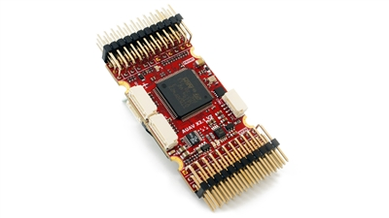

## **Quick Summary**

* Main System-on-Chip: [STM32F427](http://www.st.com/web/en/catalog/mmc/FM141/SC1169/SS1577/LN1789)
  + CPU: STM32F427VIT6 ARM® microcontroller - Revision 3
  + IO: STM32F100C8T6 ARM® microcontroller
* Sensors:
  + Invensense® MPU9250 9DOF
  + Invensense ICM-20602 6DOF
  + MEAS MS5611 barometer
* Dimensions/Weight
  + Size: 36mm x 50mm (Can be ordered with vertical, horizontal or no headers installed)
  + Mounting Points: 30.5mm x 30.5mm 3.2mm diameter
  + Weight: 10.9g

The diagram below provides a side-by-side comparison with a Pixhawk 1. The mRo features almost identical hardware and connectivity but has a much smaller footprint. Major differences are updated sensors and Rev 3 FMU.

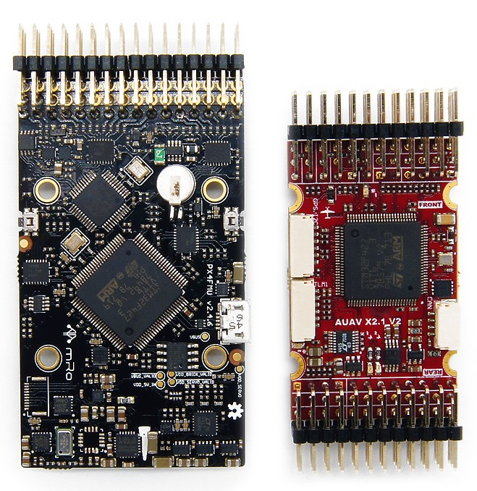

## **Connectivity**

* 2.54mm headers:
* GPS (USART4) with I2C
* CAN Bus
* RC input
* PPM input
* Spektrum input
* RSSI input
* sBus input
* sBus output
* Power input
* Buzzer output
* LED output
* 8 x Servo outputs
* 6 x Aux outputs
* Offboard microUSB connector
* Kill Pin output *(Currently not supported by firmware)*
* AirSpeed Sensor
* USART2 (Telem 1)
* USART3 (Telem 2)
* USART7 (Console)
* USART8 (OSD)

## **PX4 BootLoader Issue**

By default a mRo X2.1 might come preconfigured for ArduPilot® rather than PX4. This can be seen during firmware update when the board is recognized as FMUv2 instead of X2.1.

In this case you must update the BootLoader using [BL_Update_X21.zip](https://github.com/PX4/px4_user_guide/raw/master/assets/hardware/BL_Update_X21.zip). If this correction is not carried out your compass direction will be wrong and the secondary IMU will not be detected.

The update steps are:

1. Download and extract [BL_Update_X21.zip](https://github.com/PX4/px4_user_guide/raw/master/assets/hardware/BL_Update_X21.zip).
2. Find the folder *BL_Update_X21*. This contains a **bin** file and a subfolder named **/etc** containing an **rc.txt** file
3. Copy these files to your micro SD card's root directory and insert it into the mRO x2.1
4. Power on the mRO x2.1 Wait for it to boot and then reboot 1 time.

## **Availability**

This product can be ordered at the [mRobotics® Store](https://store.mrobotics.io/mRo-X2-1-Rev-2-p/mro-x2.1rv2-mr.htm).

## **Wiring Guide**

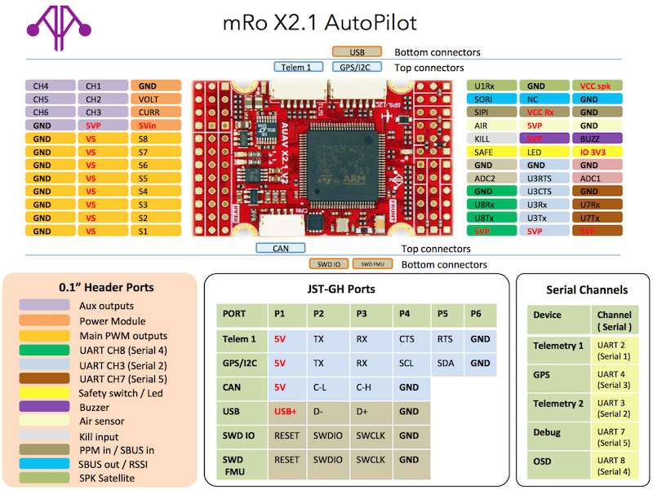

## **Schematics**

The board is documented on the mRo hardware repo: [x21_V2_schematic.pdf](https://github.com/mRoboticsIO/Hardware/blob/master/X2.1/Docs/x21_V2_schematic.pdf).

# **HKPilot32 Flight Controller**

The Hobbyking® *HKPilot32 autopilot* is based on the [Pixhawk®-project](https://pixhawk.org/) **FMUv2** open hardware design. It runs the PX4 Flight Stack on the [NuttX](http://nuttx.org/) OS.

The HKPilot32 is software compatible with the 3DR® [Pixhawk 1](https://docs.px4.io/en/flight_controller/pixhawk.html). It is not connector compatible, but is otherwise physically very similar to the 3DR Pixhawk or mRo Pixhawk.

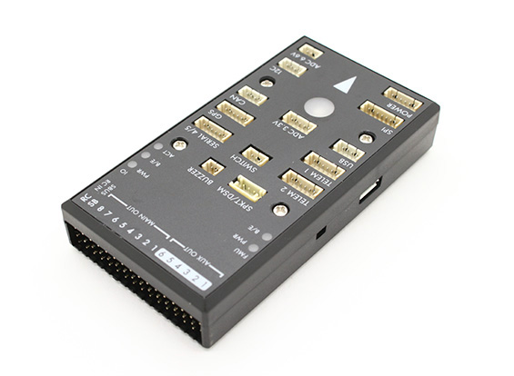

As a CC-BY-SA 3.0 licensed Open Hardware design, schematics and design files should be [available here](https://github.com/PX4/Hardware).

## **Key Features**

* Main System-on-Chip: [STM32F427](http://www.st.com/web/en/catalog/mmc/FM141/SC1169/SS1577/LN1789)
  + CPU: 32-bit STM32F427 Cortex® M4 core with FPU
  + RAM: 168 MHz/256 KB
  + Flash: 2 MB
* Failsafe System-on-Chip: STM32F103
* Sensors:
  + ST Micro L3GD20 3-axis 16-bit gyroscope
  + ST Micro LSM303D 3-axis 14-bit accelerometer / magnetometer
  + Invensense® MPU 6000 3-axis accelerometer/gyroscope
  + MEAS MS5611 barometer
* Dimensions/Weight
  + Size: 81x44x15mm
  + Weight: 33.1g
* GPS: U-blox® super precision Neo-7M with compass
* Input Voltage: 2~10s (7.4~37V)

### **Connectivity**

* 1x I2C
* 2x CAN
* 3.3 and 6.6V ADC inputs
* 5x UART (serial ports), one high-power capable, 2x with HW flow control
* Spektrum DSM / DSM2 / DSM-X® Satellite compatible input up to DX8 (DX9 and above not supported)
* Futaba® S.BUS compatible input and output
* PPM sum signal
* RSSI (PWM or voltage) input
* SPI
* External microUSB port

### **Accessories**

* [Digital airspeed sensor](http://www.hobbyking.com/hobbyking/store/__62752__HKPilot_32_Digital_Air_Speed_Sensor_And_Pitot_Tube_Set.html)
* [Hobbyking® Wifi Telemetry](http://www.hobbyking.com/hobbyking/store/__87841__APM_Pixhawk_Wireless_Wifi_Radio_Module.html)
* [Hobbyking OSD + EU Telemetry (433 MHz)](http://www.hobbyking.com/hobbyking/store/__74650__Micro_HKPilot_Telemetry_Radio_Module_with_On_Screen_Display_OSD_unit_433MHz_.html)

## **Availability**

* [Hobbyking EU version (433 MHz)](http://www.hobbyking.com/hobbyking/store/__80554__HKPilot32_Autonomous_Vehicle_32Bit_Control_Set_with_Telemetry_and_GPS_433Mhz_.html)
* [Hobbyking US version (915 MHz)](http://www.hobbyking.com/hobbyking/store/__80555__HKPilot32_Autonomous_Vehicle_32Bit_Control_Set_with_Telemetry_and_GPS_915Mhz_.html)

## **Pinouts and Schematics**

The board is based on the [Pixhawk project](https://pixhawk.org/) **FMUv2** open hardware design.

* [FMUv2 + IOv2 schematic](https://raw.githubusercontent.com/PX4/Hardware/master/FMUv2/PX4FMUv2.4.5.pdf) -- Schematic and layout

As a CC-BY-SA 3.0 licensed Open Hardware design, all schematics and design files are [available](https://github.com/PX4/Hardware).

# **Pixfalcon Flight Controller**

The Pixfalcon autopilot (designed by [Holybro®](http://www.holybro.com/)) is binary-compatible (FMUv2) derivative of the [Pixhawk 1](https://docs.px4.io/en/flight_controller/pixhawk.html) design that has been optimized for space-constrained applications such as FPV racers. It has less IO to allow for the reduction in size.

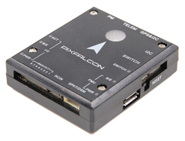

## **Quick Summary**

* Main System-on-Chip: [STM32F427](http://www.st.com/web/en/catalog/mmc/FM141/SC1169/SS1577/LN1789)
  + CPU: 180 MHz ARM® Cortex® M4 with single-precision FPU
  + RAM: 256 KB SRAM (L1)
* Failsafe System-on-Chip: STM32F100
  + CPU: 24 MHz ARM Cortex M3
  + RAM: 8 KB SRAM
* GPS: U-Blox® M8 (bundled)

### **Connectivity**

* 1x I2C
* 2x UART (one for Telemetry / OSD, no flow control)
* 8x PWM with manual override
* S.BUS / PPM input

## **Availability:**

From manufacturer: [Holybro](http://www.holybro.com/product/8) or from distributor [Hobbyking®](http://www.hobbyking.com/hobbyking/store/__86437__PixFalcon_Micro_PX4_Autopilot_plus_Micro_M8N_GPS_and_Mega_PBD_Power_Module.html)

Optional hardware:

* Optical flow: PX4 Flow unit from manufacturer [Holybro](http://www.holybro.com/product/24) or distributor [Hobbyking](http://www.hobbyking.com/hobbyking/store/__66308__HK_Pilot32_Optical_Flow_Kit_With_Sonar.html)
* Digital Airspeed sensor from manufacturer [Holybro](http://www.holybro.com/product/26) or distributor [Hobbyking](http://www.hobbyking.com/hobbyking/store/__62752__HKPilot_32_Digital_Air_Speed_Sensor_And_Pitot_Tube_Set.html)
* On screen display with integrated Telemetry:
  + [Hobbyking OSD + EU Telemetry (433 MHz)](http://www.hobbyking.com/hobbyking/store/__74650__Micro_HKPilot_Telemetry_Radio_Module_with_On_Screen_Display_OSD_unit_433MHz_.html)
* Pure Telemetry options:
  + [Hobbyking Wifi Telemetry](http://www.hobbyking.com/hobbyking/store/__87841__APM_Pixhawk_Wireless_Wifi_Radio_Module.html)
  + [Hobbyking EU Micro Telemetry (433 MHz)](http://www.hobbyking.com/hobbyking/store/__74647__Micro_HKPilot_Telemetry_radio_Set_With_Integrated_PCB_Antenna_433Mhz.html)
  + [Hobbyking US Micro Telemetry (915 MHz)](http://www.hobbyking.com/hobbyking/store/__74648__Micro_HKPilot_Telemetry_radio_Set_With_Integrated_PCB_Antenna_915Mhz.html)

## **Build Instructions**

make px4fmu-v2_default upload

## **Key Links**

* [User Manual](http://www.holybro.com/manual/pixfalcon.pdf)

# **DroPix Flight Controller**

The Drotek® *DroPix autopilot* is based on the [Pixhawk®-project](https://pixhawk.org/) **FMUv2** open hardware design. It runs the PX4 Flight Stack on the [NuttX](http://nuttx.org/) OS.

The DroPix system includes integrated multithreading, a Unix/Linux-like programming environment, completely new autopilot functions such as Lua scripting of missions and flight behavior, and a custom PX4 driver layer ensuring tight timing across all processes.

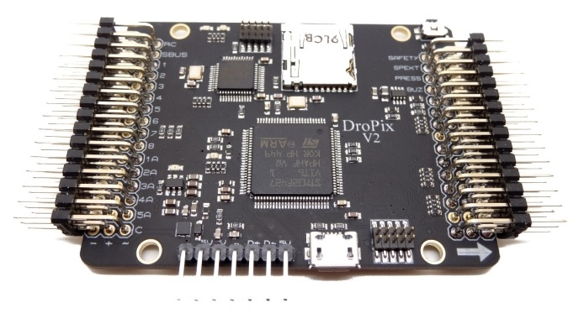

## **Key Features**

* Advanced 32 bit ARM Cortex® M4 Processor running NuttX RTOS
* 14 PWM/servo outputs (8 with failsafe and manual override, 5 auxiliary, high-power compatible)
* Abundant connectivity options for additional peripherals (UART, I2C, CAN)
* Integrated backup system for in-flight recovery and manual override with dedicated processor and stand-alone power supply
* Backup system integrates mixing, providing consistent autopilot and manual override mixing modes
* Redundant power supply inputs and automatic failover
* External safety button for easy motor activation
* Multicolor LED indicator
* High-power, multi-tone piezo audio indicator
* microSD card for long-time high-rate logging
* Sensors
  + ST Micro L3GD20 3-axis 16-bit gyroscope
  + ST Micro LSM303D 3-axis 14-bit accelerometer / magnetometer
  + Invensense® MPU 6000 3-axis accelerometer/gyroscope
  + MEAS MS5611 barometer
* Standard MK style mounting holes 45 mm x 45 mm (M3 holes)
* Dimensions
  + Size: 67*50*6 mm
  + Weight: 15g (without connectors)

## **Availability**

[Dropix Pack](https://drotek.com/shop/en/flight-controllers/494-dropix-flight-controller.html) (drotek.com)

## **Key Links**

* [DroPix Setup](https://drotek.com/en/documentation/docs-dropix/)

## **Wiring Guides**

The following diagrams show the Dropix connector information (for more information see the [drotek documentation](https://drotek.com/en/documentation/docs-dropix/)).

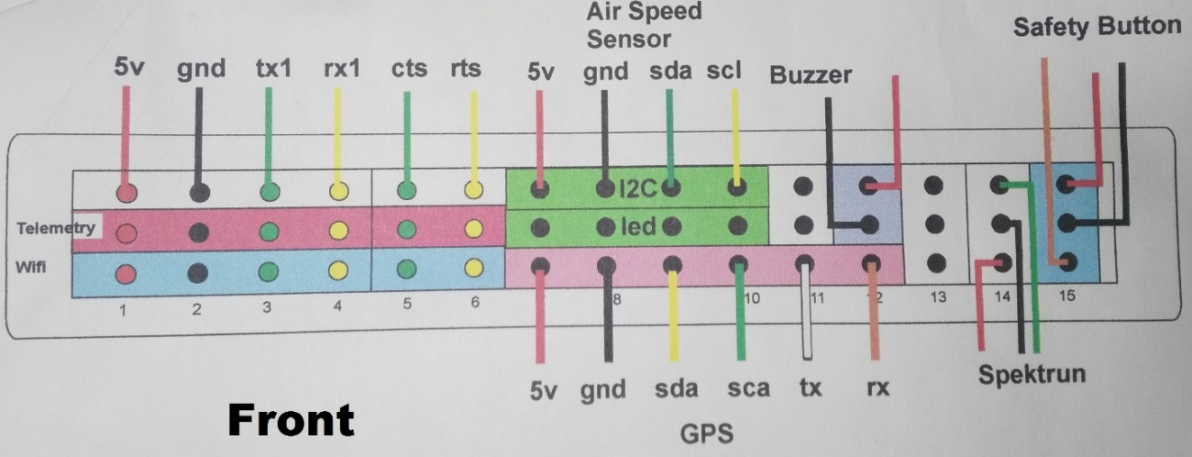

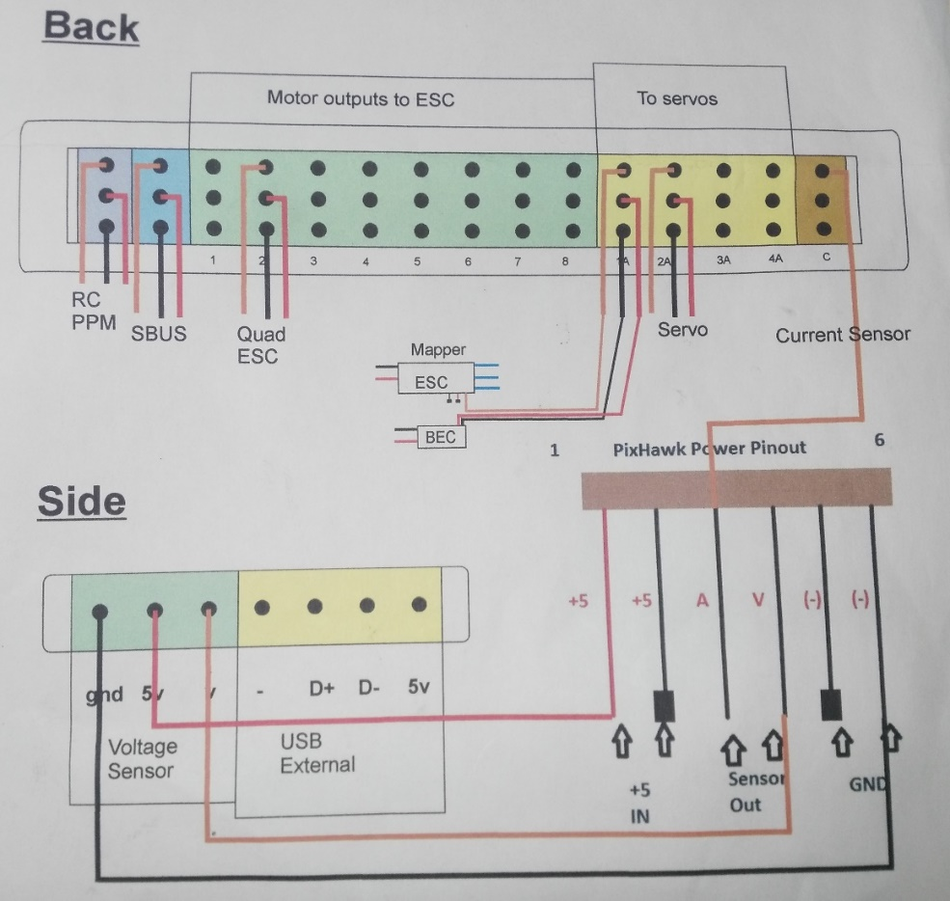

# **Pixracer**

The Pixhawk® XRacer board family is optimized for small racing quads and planes. In contrast to [Pixfalcon](https://word-edit.officeapps.live.com/we/pixfalcon.html) and [Pixhawk](https://word-edit.officeapps.live.com/we/pixhawk.html) it has in-built Wifi, new sensors, convenient full servo headers, CAN and supports 2M flash.

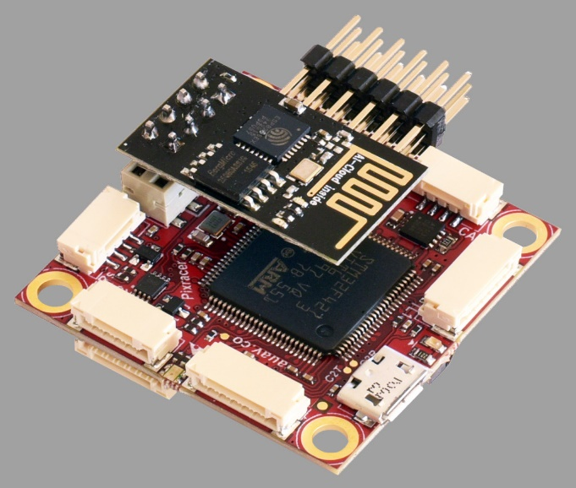

## **Key Features**

* Main System-on-Chip: [STM32F427VIT6 rev.3](http://www.st.com/web/en/catalog/mmc/FM141/SC1169/SS1577/LN1789)
  + CPU: 180 MHz ARM Cortex® M4 with single-precision FPU
  + RAM: 256 KB SRAM (L1)
* Standard FPV form factor: 36x36 mm with standard 30.5 mm hole pattern
* Invensense® ICM-20608 Accel / Gyro (4 KHz) / MPU9250 Accel / Gyro / Mag (4 KHz)
* HMC5983 magnetometer with temperature compensation
* Measurement Specialties MS5611 barometer
* JST GH connectors
* microSD (logging)
* Futaba S.BUS and S.BUS2 / Spektrum DSM2 and DSMX / Graupner SUMD / PPM input / Yuneec ST24
* FrSky® telemetry port
* OneShot PWM out (configurable)
* Optional: Safety switch and buzzer

## **Where to Buy**

Pixracer is available from the [mRobotics.io](https://store.mrobotics.io/mRo-PixRacer-R15-Official-p/auav-pxrcr-r15-mr.htm).

Accessories include:

* [Digital airspeed sensor](http://www.hobbyking.com/hobbyking/store/__62752__HKPilot_32_Digital_Air_Speed_Sensor_And_Pitot_Tube_Set.html)
* [HKPilot Transceiver Telemetry Radio Set V2 (915Mhz - US Telemetry)](https://hobbyking.com/en_us/hkpilot-transceiver-telemetry-radio-set-v2-915mhz.html)
* [Hobbyking® OSD + EU Telemetry (433 MHz)](http://www.hobbyking.com/hobbyking/store/__74650__Micro_HKPilot_Telemetry_Radio_Module_with_On_Screen_Display_OSD_unit_433MHz_.html)

## **Kit**

The Pixracer is designed to use a separate avionics power supply. This is necessary to avoid current surges from motors or ESCs to flow back to the flight controller and disturb its delicate sensors.

* Power module (with voltage and current sensing)
* I2C splitter (supporting AUAV, Hobbyking and 3DR® peripherals)
* Cable kit for all common peripherals

## **Wifi (no USB required)**

One of the main features of the board is its ability to use Wifi for flashing new firmware, system setup and in-flight telemetry. This frees it of the need of any desktop system.

Setup and telemetry are already available, firmware upgrade is already supported by the default bootloader but not yet enabled

* [ESP8266 Wifi](https://word-edit.officeapps.live.com/telemetry/esp8266_wifi_module.html)
* [Custom ESP8266 MAVLink firmware](https://github.com/dogmaphobic/mavesp8266)

## **Wiring Diagrams**

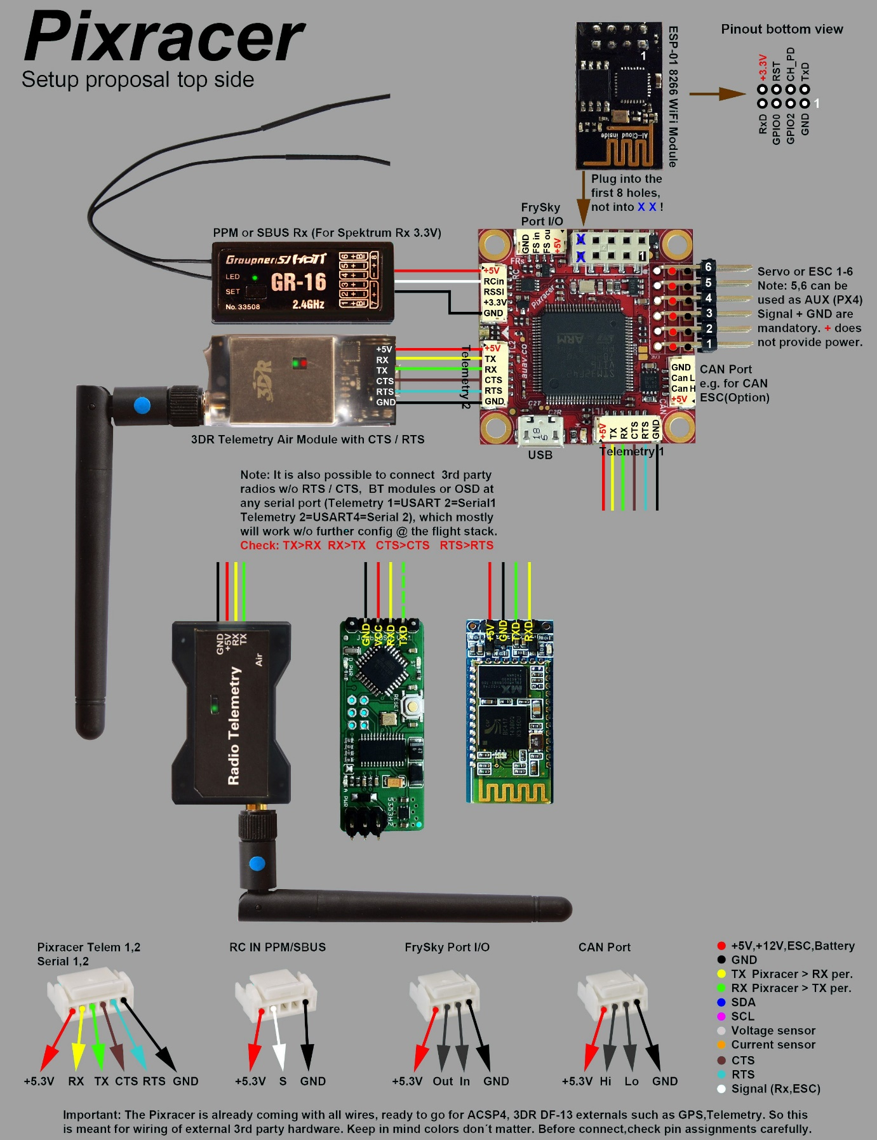

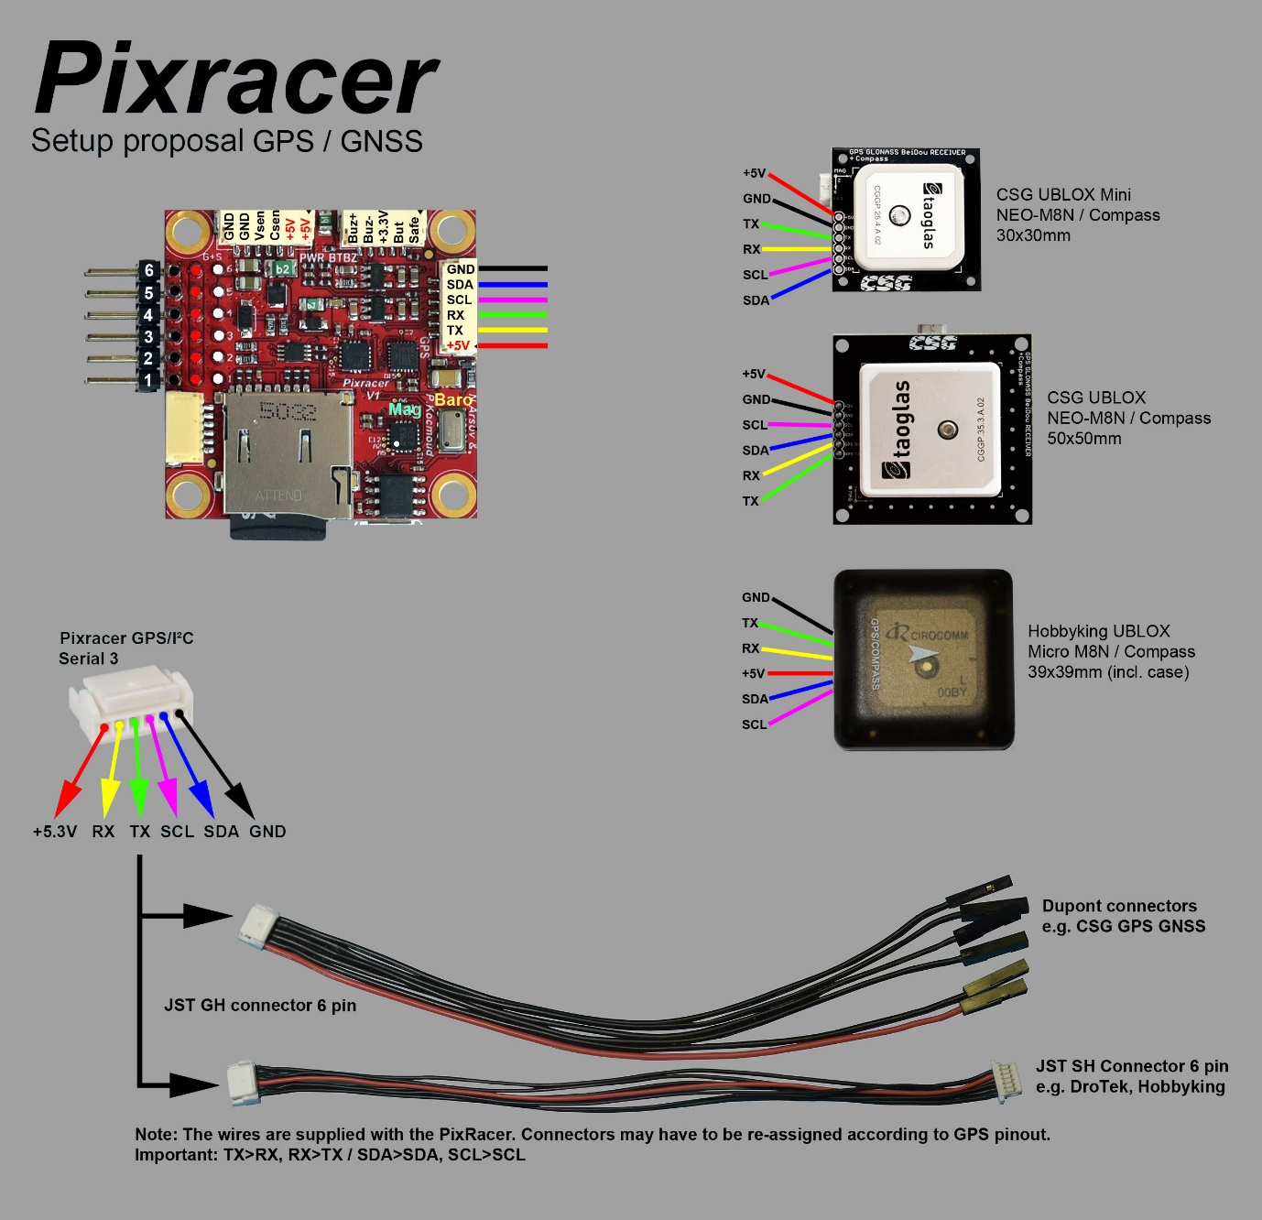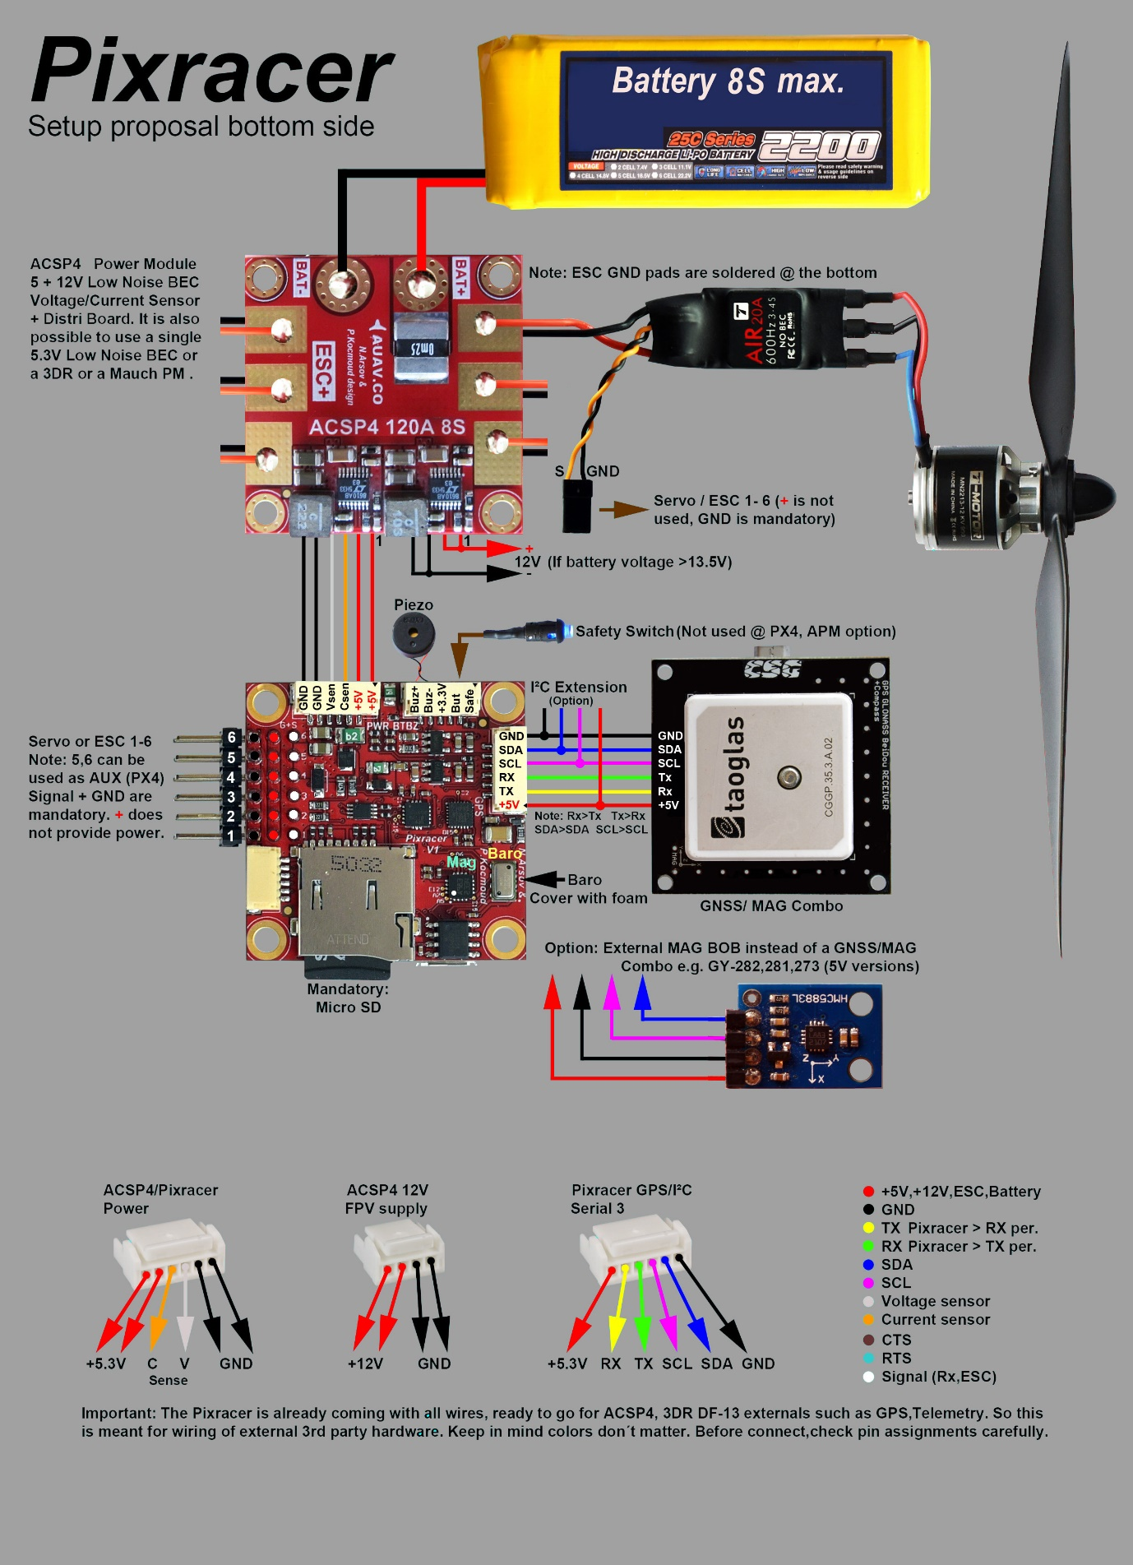

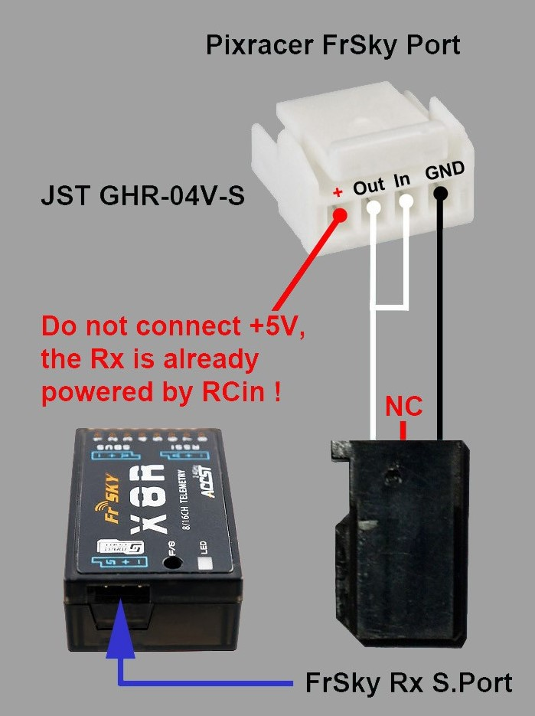

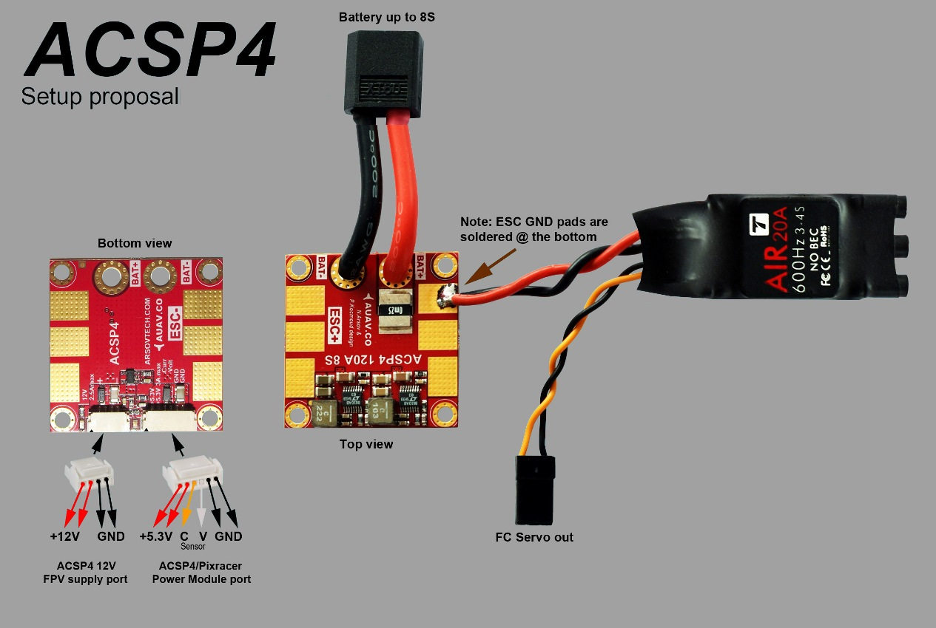

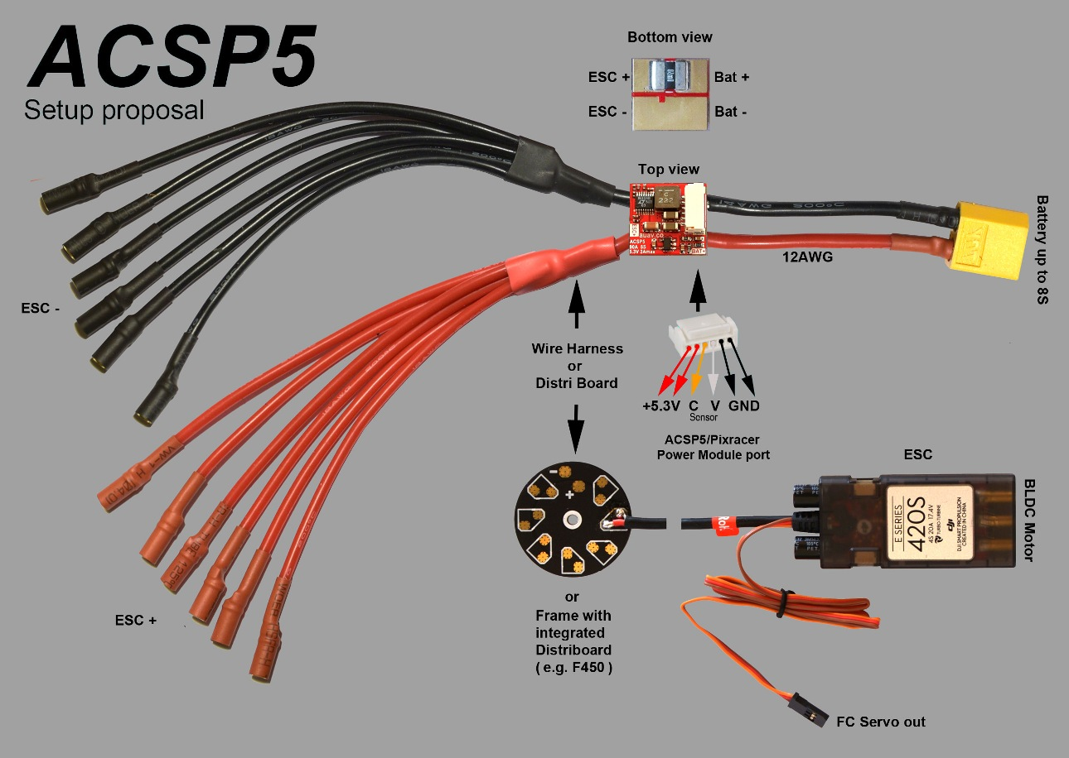

## **Connectors**

All connectors follow the [Dronecode connector standard](https://wiki.dronecode.org/workgroup/connectors/start). Unless noted otherwise all connectors are JST GH.

## **Pinouts**

TELEM1, TELEM2+OSD ports

|  |  |  |
| --- | --- | --- |
| **Pin** | **Signal** | **Volt** |
| 1 (red) | VCC | +5V |
| 2 (blk) | TX (OUT) | +3.3V |
| 3 (blk) | RX (IN) | +3.3V |
| 4 (blk) | CTS (IN) | +3.3V |
| 5 (blk) | RTS (OUT) | +3.3V |
| 6 (blk) | GND | GND |

GPS port

|  |  |  |
| --- | --- | --- |
| **Pin** | **Signal** | **Volt** |
| 1 (red) | VCC | +5V |
| 2 (blk) | TX (OUT) | +3.3V |
| 3 (blk) | RX (IN) | +3.3V |
| 4 (blk) | I2C1 SCL | +3.3V |
| 5 (blk) | I2C1 SDA | +3.3V |
| 6 (blk) | GND | GND |

FrSky Telemetry / SERIAL4

|  |  |  |
| --- | --- | --- |
| **Pin** | **Signal** | **Volt** |
| 1 (red) | VCC | +5V |
| 2 (blk) | TX (OUT) | +3.3V |
| 3 (blk) | RX (IN) | +3.3V |
| 4 (blk) | GND | GND |

RC Input (accepts PPM / S.BUS / Spektrum / SUMD / ST24)

|  |  |  |
| --- | --- | --- |
| **Pin** | **Signal** | **Volt** |
| 1 (red) | VCC | +5V |
| 2 (blk) | RC IN | +3.3V |
| 3 (blk) | RSSI IN | +3.3V |
| 4 (blk) | VDD 3V3 | +3.3V |
| 5 (blk) | GND | GND |

CAN

|  |  |  |
| --- | --- | --- |
| **Pin** | **Signal** | **Volt** |
| 1 (red) | VCC | +5V |
| 2 (blk) | CAN_H | +12V |
| 3 (blk) | CAN_L | +12V |
| 4 (blk) | GND | GND |

POWER

|  |  |  |
| --- | --- | --- |
| **Pin** | **Signal** | **Volt** |
| 1 (red) | VCC | +5V |
| 2 (blk) | VCC | +5V |
| 3 (blk) | CURRENT | +3.3V |
| 4 (blk) | VOLTAGE | +3.3V |
| 5 (blk) | GND | GND |
| 6 (blk) | GND | GND |

SWITCH

|  |  |  |
| --- | --- | --- |
| **Pin** | **Signal** | **Volt** |
| 1 (red) | SAFETY | GND |
| 2 (blk) | !IO_LED_SAFETY | GND |
| 3 (blk) | VCC | +3.3V |
| 4 (blk) | BUZZER- | - |
| 5 (blk) | BUZZER+ | - |

Dronecode debug port (JST SM06B connector)

|  |  |  |
| --- | --- | --- |
| **Pin** | **Signal** | **Volt** |
| 1 (red) | VCC TARGET SHIFT | +3.3V |
| 2 (blk) | CONSOLE TX (OUT) | +3.3V |
| 3 (blk) | CONSOLE RX (IN) | +3.3V |
| 4 (blk) | SWDIO | +3.3V |
| 5 (blk) | SWCLK | +3.3V |
| 6 (blk) | GND | GND |

## Pixracer top pinouts

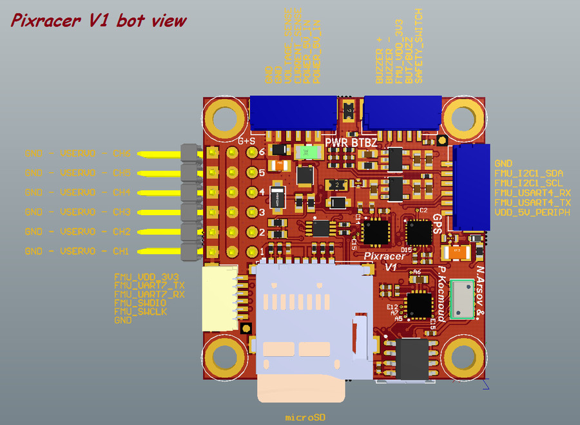

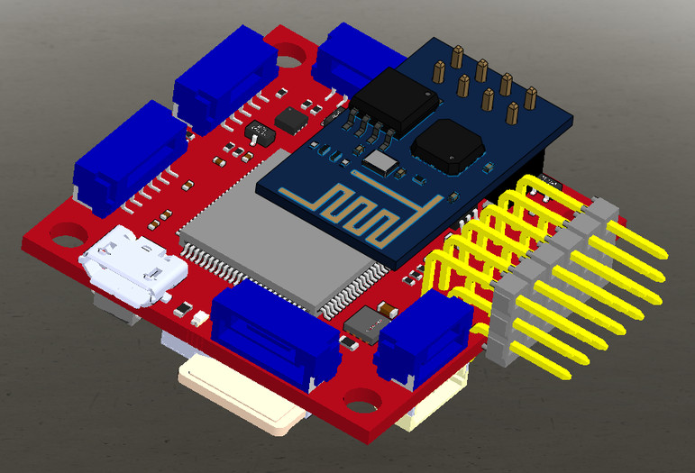

## **Schematics**

The reference is provided as: [Altium Design Files](https://github.com/AUAV-OpenSource/FMUv4-PixRacer)

The following PDF files are provided for *convenience only*:

* [pixracer-rc12-12-06-2015-1330.pdf](https://github.com/PX4/px4_user_guide/raw/master/assets/flight_controller/pixracer/pixracer-rc12-12-06-2015-1330.pdf)
* [pixracer-r14.pdf](https://github.com/PX4/px4_user_guide/raw/master/assets/flight_controller/pixracer/pixracer-r14.pdf) - R14 or RC14 is printed next to the SDCard socket

## **Build Firmware**

To build (and upload) PX4 firmware for this board:

make px4fmu-v4_default upload

## **Credits**

This design was created by Nick Arsov and Phillip Kocmoud and architected by Lorenz Meier, David Sidrane and Leonard Hall.

# **Cube Flight Controller**

The [Cube](http://www.proficnc.com/61-system-kits2) flight controller (previously known as Pixhawk 2.1) is a flexible autopilot intended primarily for manufacturers of commercial systems. It is based on the [Pixhawk-project](https://pixhawk.org/) **FMUv3** open hardware design and runs PX4 on the [NuttX](http://nuttx.org/) OS.

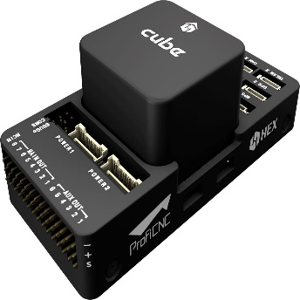

The controller is designed to be used with a domain-specific carrier board in order to reduce the wiring, improve reliability, and ease of assembly. For example, a carrier board for a commercial inspection vehicle might include connections for a companion computer, while a carrier board for a racer could includes ESCs form the frame of the vehicle.

Cube includes vibration isolation on two of the IMU's, with a third fixed IMU as a reference / Backup.

## **Key Features**

* 32bit STM32F427 [Cortex-M4F](http://en.wikipedia.org/wiki/ARM_Cortex-M#Cortex-M4)® core with FPU
* 168 MHz / 252 MIPS
* 256 KB RAM
* 2 MB Flash (fully accessible)
* 32 bit STM32F103 failsafe co-processor
* 14 PWM / Servo outputs (8 with failsafe and manual override, 6 auxiliary, high-power compatible)
* Abundant connectivity options for additional peripherals (UART, I2C, CAN)
* Integrated backup system for in-flight recovery and manual override with dedicated processor and stand-alone power supply (fixed-wing use)
* Backup system integrates mixing, providing consistent autopilot and manual override mixing modes (fixed wing use)
* Redundant power supply inputs and automatic failover
* External safety switch
* Multicolor LED main visual indicator
* High-power, multi-tone piezo audio indicator
* microSD card for high-rate logging over extended periods of time

## **Where to Buy**

* [The Cube](http://www.proficnc.com/61-system-kits) (ProfiCNC)

## **Assembly**

* [Cube Wiring Quickstart](https://docs.px4.io/en/assembly/quick_start_cube.html)

## **Specifications**

### **Processor**

* 32bit STM32F427 [Cortex M4](http://en.wikipedia.org/wiki/ARM_Cortex-M#Cortex-M4) core with FPU
* 168 MHz / 252 MIPS
* 256 KB RAM
* 2 MB Flash (fully accessible)
* 32 bit STM32F103 failsafe co-processor

### **Sensors**

* TBA

### **Interfaces**

* 5x UART (serial ports), one high-power capable, 2x with HW flow control
* 2x CAN (one with internal 3.3V transceiver, one on expansion connector)
* Spektrum DSM / DSM2 / DSM-X® Satellite compatible input
* Futaba S.BUS® compatible input and output
* PPM sum signal input
* RSSI (PWM or voltage) input
* I2C
* SPI
* 3.3 and 6.6V ADC inputs
* Internal microUSB port and external microUSB port extension

### **Power System and Protection**

* Ideal diode controller with automatic failover
* Servo rail high-power (max. 10V) and high-current (10A+) ready
* All peripheral outputs over-current protected, all inputs ESD protected

### **Voltage Ratings**

Pixhawk can be triple-redundant on the power supply if three power sources are supplied. The three rails are: Power module input, servo rail input, USB input.

#### Normal Operation Maximum Ratings

Under these conditions all power sources will be used in this order to power the system

* Power module input (4.8V to 5.4V)
* Servo rail input (4.8V to 5.4V) **UP TO 10V FOR MANUAL OVERRIDE, BUT AUTOPILOT PART WILL BE UNPOWERED ABOVE 5.7V IF POWER MODULE INPUT IS NOT PRESENT**
* USB power input (4.8V to 5.4V)

#### Absolute Maximum Ratings

Under these conditions the system will not draw any power (will not be operational), but will remain intact.

* Power module input (4.1V to 5.7V, 0V to 20V undamaged)
* Servo rail input (4.1V to 5.7V, 0V to 20V)
* USB power input (4.1V to 5.7V, 0V to 6V)

## **Pinouts and Schematics**

Board schematics and other documentation can be found here: [The Cube Project](https://github.com/proficnc/The-Cube).

The datasheet from Hex manufacturing can be found [here](http://www.hex.aero/wp-content/uploads/2016/07/DRS_Pixhawk-2-17th-march-2016.pdf).

## **Ports**

### **Top-Side (GPS, TELEM etc)**

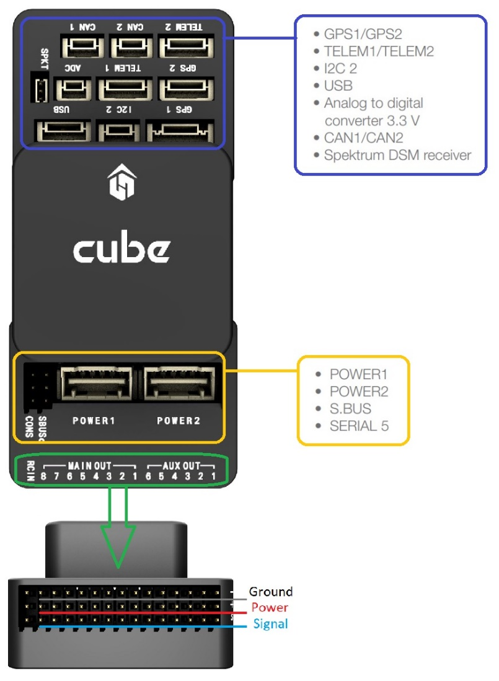

### **Debug Ports**

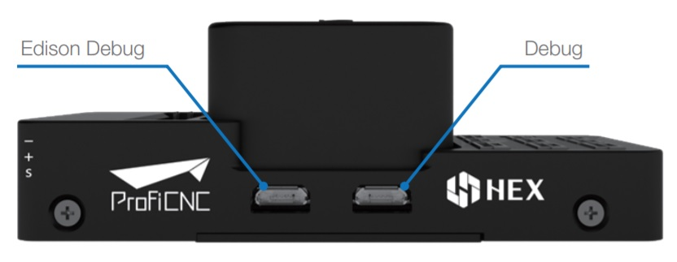

### **USB/SDCard Ports**

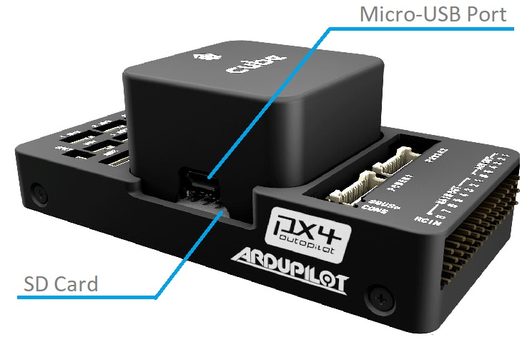

## **Build Firmware**

make px4fmu-v3_default upload

## **Issues**

CAN1 and CAN2 silk screen on the Pixhawk 2.1 are flipped (CAN1 is CAN2 and vice versa).

# **Pixhawk 3 Pro**

The Pixhawk® 3 Pro is based on the FMUv4 hardware design (Pixracer) with some upgrades and additional features. The board was designed by [Drotek®](https://drotek.com/) and PX4.

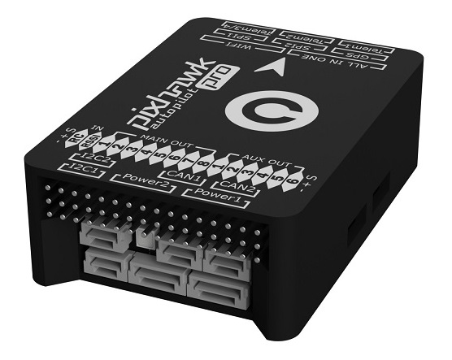

The main hardware documentation is here: <https://pixhawk.drotek.com/en/>

## **Quick Summary**

* Microcontroller: **STM32F469**; Flash size is **2MiB**, RAM size is **384KiB**
* **ICM-20608-G** gyro / accelerometer
* **MPU-9250** gyro / accelerometer / magnetometer
* **LIS3MDL** compass
* Sensors connected via two SPI buses (one high rate and one low-noise bus)
* Two I2C buses
* Two CAN buses
* Voltage / battery readings from two power modules
* FrSky® Inverter
* 8 Main + 6 AUX PWM outputs (Separate IO chip, PX4IO)
* microSD (logging)
* S.BUS / Spektrum / SUMD / PPM input
* JST GH user-friendly connectors: same connectors and pinouts as Pixracer

## **Build Instructions**

make px4fmu-v4pro_default upload

# **Pixhack V3**

The CUAV *Pixhack V3* flight controller board is a flexible autopilot intended primarily for manufacturers of commercial systems.

The board is a variant of the SOLO Pixhawk® 2 (PH2) flight controller, which is in turn based on the [Pixhawk-project](https://pixhawk.org/) **FMUv3** open hardware design. It runs PX4 on the [NuttX](http://nuttx.org/) OS, and is fully compatible with both PX4 or ArduPilot® (APM) firmware.

*Pixhack V3* has significant improvements with respect to the original design, including better interface layout and the addition of vibration damping and a thermostat system.

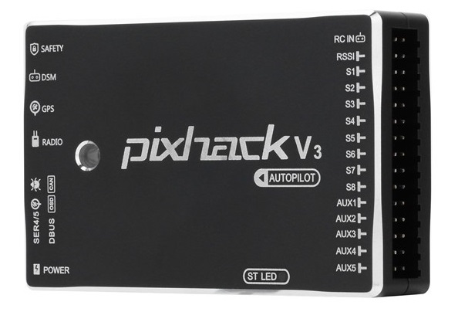

## **Quick Summary**

* Microprocessor:
  + STM32F427
  + STM32F100 (Failsafe co-processor)
* Sensors:
  + Accelerometers (3): LS303D, MPU6000, MPU9250/hmc5983
  + Gyroscopes (3): L3GD20, MPU6000, MPU9250
  + Compass (2): LS303D, MPU9250
  + Barometer (2): MS5611 X2
* Interfaces:
  + MAVLink UART (2)
  + GPS UART (2)
  + DEBUG UART (1)
  + RC IN (for PPM, SBUS, DSM/DSM2)
  + RSSI IN: PWM OR 3.3ADC
  + I2C (2)
  + CAN BUS (1)
  + ADC IN: 3.3V X1 , 6.6V X1
  + PWM OUT: 8 PWM IO + 4 IO
* Power System:
  + PM POWER IN: 4.5 ~ 5.5 V
  + USB POWER IN: 5.0 V +- 0.25v
* Weight and Dimensions:
  + Weight: 63g
  + Width: 68mm
  + Thickness: 17mm
  + Length: 44mm
* Other Characteristics:
  + Operating temperature: -20 ~ 60°C

## **Availability**

The board can be purchased from:

* [store.cuav.net](http://store.cuav.net/index.php?id_product=8&id_product_attribute=0&rewrite=pixhack-v3-autopilot&controller=product&id_lang=3)
* [leixun.aliexpress.com/store](https://leixun.aliexpress.com/store)

## **Pinouts and Schematics**

* Open hardware files: <https://github.com/cuav/CUAV_Hardware/tree/master/Pixhack_V3>
* Documentation/wiring guides: <http://doc.cuav.net/PixHack/pixhack-v3.html>

# **Pixhawk 4**

*Pixhawk 4*® is an advanced autopilot designed and made in collaboration with Holybro® and the PX4 team. It is optimized to run PX4 version 1.7, suitable for academic and commercial developers.

It is based on the [Pixhawk-project](https://pixhawk.org/) **FMUv5** open hardware design and runs PX4 on the [NuttX](http://nuttx.org/) OS.

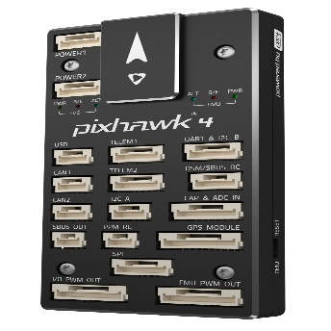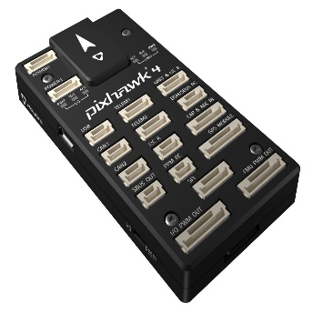

## **Quick Summary**

* Main FMU Processor: STM32F765
  + 32 Bit Arm® Cortex®-M7, 216MHz, 2MB memory, 512KB RAM
* IO Processor: STM32F100
  + 32 Bit Arm® Cortex®-M3, 24MHz, 8KB SRAM
* On-board sensors:
  + Accel/Gyro: ICM-20689
  + Accel/Gyro: BMI055
  + Magnetometer: IST8310
  + Barometer: MS5611
* GPS: ublox Neo-M8N GPS/GLONASS receiver; integrated magnetometer IST8310
* Interfaces:
  + 8-16 PWM outputs (8 from IO, 8 from FMU)
  + 3 dedicated PWM/Capture inputs on FMU
  + Dedicated R/C input for CPPM
  + Dedicated R/C input for Spektrum / DSM and S.Bus with analog / PWM RSSI input
  + Dedicated S.Bus servo output
  + 5 general purpose serial ports
  + 3 I2C ports
  + 4 SPI buses
  + Up to 2 CANBuses for dual CAN with serial ESC
  + Analog inputs for voltage / current of 2 batteries
* Power System:
  + Power module output: 4.9~5.5V
  + USB Power Input: 4.75~5.25V
  + Servo Rail Input: 0~36V
* Weight and Dimensions:
  + Weight: 15.8g
  + Dimensions: 44x84x12mm
* Other Characteristics:
  + Operating temperature: -40 ~ 85°c

Additional information can be found in the [Pixhawk 4 Technical Data Sheet](https://github.com/PX4/px4_user_guide/raw/master/assets/flight_controller/pixhawk4/pixhawk4_technical_data_sheet.pdf).

## **Purchase**

Order from [Holybro](https://shop.holybro.com/pixhawk-4beta-launch_p1089.html).

## **Connectors**

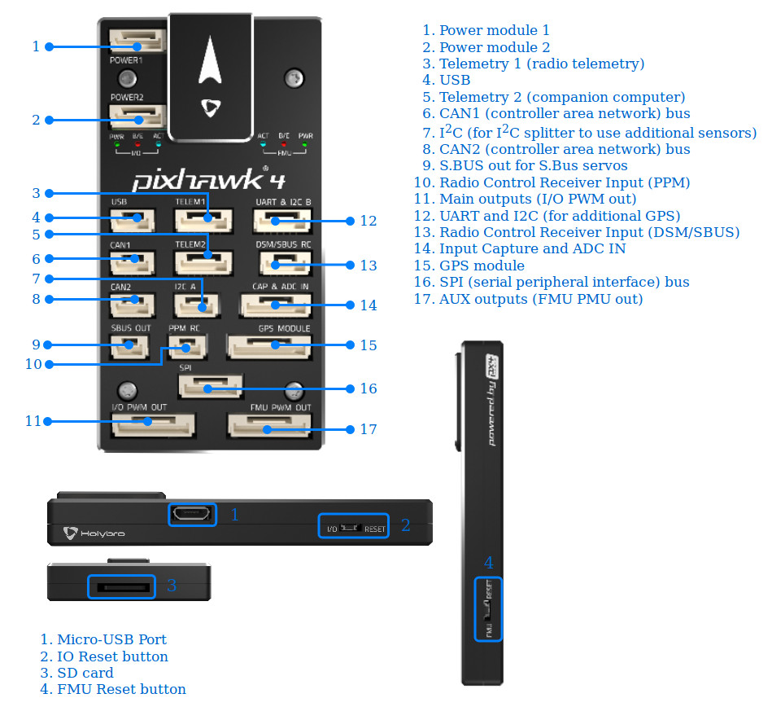

The **DSM/SBUS RC** and **PPM RC** ports are for RC receivers only. These are powered! NEVER connect any servos, power supplies or batteries (or to any connected receiver).

## **Pinouts**

Download *Pixhawk 4* pinouts from [here](http://www.holybro.com/manual/Pixhawk4-Pinouts.pdf).

## **Dimensions**

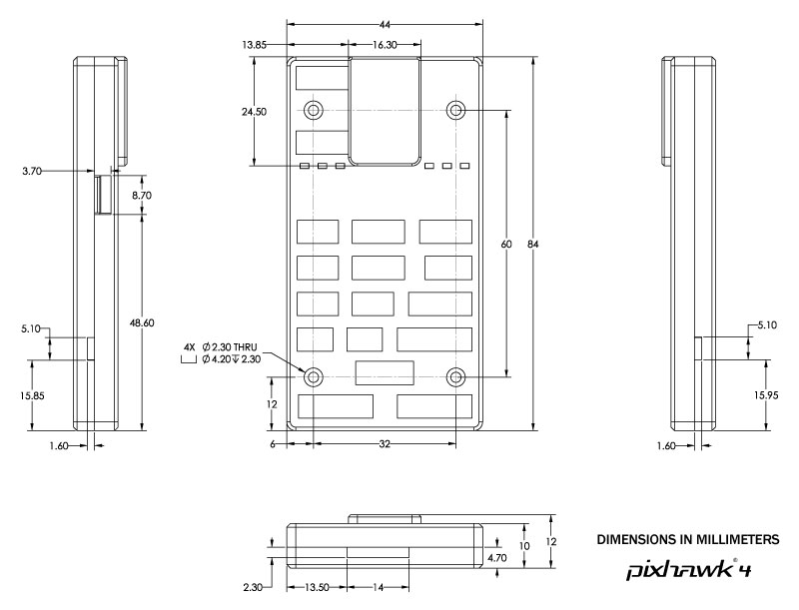

## **Voltage Ratings**

*Pixhawk 4* can be triple-redundant on the power supply if three power sources are supplied. The three power rails are: **POWER1**, **POWER2** and **USB**.

The output power rails **FMU PWM OUT** and **I/O PWM OUT** (0V to 36V) do not power the flight controller board (and are not powered by it). You must supply power to one of **POWER1**, **POWER2** or **USB** or the board will be unpowered.

**Normal Operation Maximum Ratings**

Under these conditions all power sources will be used in this order to power the system:

1. **POWER1** and **POWER2** inputs (4.9V to 5.5V)
2. **USB** input (4.75V to 5.25V)

**Absolute Maximum Ratings**

Under these conditions the system will not draw any power (will not be operational), but will remain intact.

1. **POWER1** and **POWER2** inputs (operational range 4.1V to 5.7V, 0V to 10V undamaged)
2. **USB** input (operational range 4.1V to 5.7V, 0V to 6V undamaged)
3. Servo input: VDD_SERVO pin of **FMU PWM OUT** and **I/O PWM OUT** (0V to 42V undamaged)

## **Assembly/Setup**

The [Pixhawk 4 Wiring Quick Start](https://docs.px4.io/en/assembly/quick_start_pixhawk4.html) provides instructions on how to assemble required/important peripherals including GPS, Power Management Board etc.

## **Building Firmware**

make px4fmu-v5_default upload

## **Debug Port**

The system's serial console and SWD interface runs on the **FMU Debug** port, while the I/O console and SWD interface can be accessed via **I/O Debug** port. In order to access these ports, the user must remove the *Pixhawk 4* casing.

Both ports have standard serial pinout and can be connected to a standard FTDI cable (3.3V, but it's 5V tolerant) or a [Dronecode probe](https://kb.zubax.com/display/MAINKB/Dronecode+Probe+documentation). The pinout uses the standard Dronecode debug connector pinout. Please refer to the [wiring](https://dev.px4.io/en/debug/system_console.html) page for details of how to wire up this port.

## **Peripherals**

* [Digital Airspeed Sensor](https://drotek.com/shop/en/home/848-sdp3x-airspeed-sensor-kit-sdp33.html)
* [Telemetry Radio Modules](https://docs.px4.io/en/telemetry/)
* [Rangefinders/Distance sensors](https://docs.px4.io/en/sensor/rangefinders.html)

## **Supported Platforms / Airframes**

Any multicopter / airplane / rover or boat that can be controlled with normal RC servos or Futaba S-Bus servos. The complete set of supported configurations can be seen in the [Airframes Reference](https://docs.px4.io/en/airframes/airframe_reference.html).

## **Further info**

* [Pixhawk 4 Technical Data Sheet](https://github.com/PX4/px4_user_guide/raw/master/assets/flight_controller/pixhawk4/pixhawk4_technical_data_sheet.pdf)
* [FMUv5 reference design pinout](https://docs.google.com/spreadsheets/d/1-n0__BYDedQrc_2NHqBenG1DNepAgnHpSGglke-QQwY/edit#gid=912976165).

# **Pixhawk 4 Mini**

The *Pixhawk® 4 Mini* autopilot is designed for engineers and hobbyists who are looking to tap into the power of *Pixhawk 4* but are working with smaller drones. *Pixhawk 4 Mini* takes the FMU processor and memory resources from the *Pixhawk 4* while eliminating interfaces that are normally unused. This allows the *Pixhawk 4 Mini* to be small enough to fit in a 250mm racer drone.

*Pixhawk 4 Mini* was designed and developed in collaboration with Holybro® and Auterion®. It is based on the [Pixhawk](https://pixhawk.org/) **FMUv5** design standard and is optimized to run PX4 flight control software.

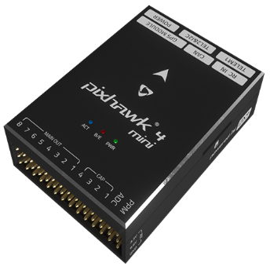

## **Quick Summary**

* Main FMU Processor: STM32F765
  + 32 Bit Arm® Cortex®-M7, 216MHz, 2MB memory, 512KB RAM
* On-board sensors:
  + Accel/Gyro: ICM-20689
  + Accel/Gyro: BMI055
  + Magnetometer: IST8310
  + Barometer: MS5611
* GPS: ublox Neo-M8N GPS/GLONASS receiver; integrated magnetometer IST8310
* Interfaces:
  + 8 PWM outputs
  + 4 dedicated PWM/Capture inputs on FMU
  + Dedicated R/C input for CPPM
  + Dedicated R/C input for Spektrum / DSM and S.Bus with analog / PWM RSSI input
  + 3 general purpose serial ports
  + 2 I2C ports
  + 3 SPI buses
  + 1 CANBuses for CAN ESC
  + Analog inputs for voltage / current of battery
  + 2 additional analog input
* Power System:
  + Power Brick Input: 4.75~5.5V
  + USB Power Input: 4.75~5.25V
  + Servo Rail Input: 0~24V
  + Max current sensing: 120A
* Weight and Dimensions:
  + Dimensions: 38x55x15.5mm
* Other Characteristics:
  + Operating temperature: -40 ~ 85°c

Additional information can be found in the [*Pixhawk 4 Mini* Technical Data Sheet](https://github.com/PX4/px4_user_guide/raw/master/assets/flight_controller/pixhawk4mini/pixhawk4mini_technical_data_sheet.pdf).

## **Purchase**

Available soon.

## **Interfaces**

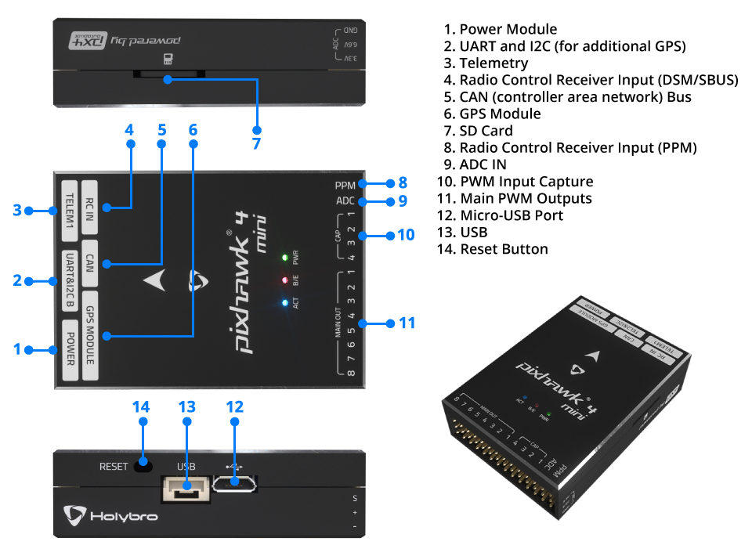

The **RC IN** and **PPM** ports are for RC receivers only. These are powered! NEVER connect any servos, power supplies or batteries (or to any connected receiver).

## **Pinouts**

Download *Pixhawk 4 Mini* pinouts from [here](https://github.com/PX4/px4_user_guide/raw/master/assets/flight_controller/pixhawk4mini/pixhawk4mini_pinouts.pdf).

## **Dimensions**

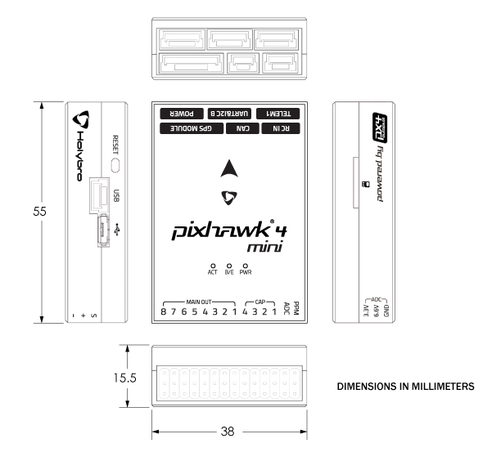

## **Voltage Ratings**

*Pixhawk 4 Mini* can have power supply redundancy — if two power sources are supplied. The power rails are: **POWER** and **USB**.

The output power rail of **MAIN OUT** does not power the flight controller board (and is not powered by it). You must [supply power](https://docs.px4.io/en/assembly/quick_start_pixhawk4_mini.html#voltageratings) to one of **POWER** or **USB** or the board will be unpowered.

**Normal Operation Maximum Ratings**

Under these conditions all power sources will be used in this order to power the system:

1. **POWER** (4.75V to 5.5V)
2. **USB** input (4.75V to 5.25V)

**Absolute Maximum Ratings**

Under these conditions the system will remain intact.

1. **POWER** input (0V to 6V undamaged)
2. **USB** input (0V to 6V undamaged)
3. Servo input: VDD_SERVO pin of **MAIN OUT** (0V to 24V undamaged)

## **Assembly/Setup**

The [*Pixhawk 4 Mini* Wiring Quick Start](https://docs.px4.io/en/assembly/quick_start_pixhawk4_mini.html) provides instructions on how to assemble required/important peripherals including GPS, Power Management Board, etc.

## **Building Firmware**

make px4fmu-v5_default upload

## **Debug Port**

The system's serial console and SWD interface run on the **FMU Debug** port. In order to access these ports, the user must remove the *Pixhawk 4 Mini* casing.

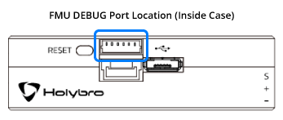

The port has a standard serial pinout and can be connected to a standard FTDI cable (3.3V, but it's 5V tolerant) or a [Dronecode probe](https://kb.zubax.com/display/MAINKB/Dronecode+Probe+documentation). The pinout uses the standard Dronecode debug connector pinout. Please refer to the [wiring](https://dev.px4.io/en/debug/system_console.html) page for details of how to wire up this port.

## **Peripherals**

* [Digital Airspeed Sensor](https://drotek.com/shop/en/home/848-sdp3x-airspeed-sensor-kit-sdp33.html)
* [Telemetry Radio Modules](https://docs.px4.io/en/telemetry/)
* [Rangefinders/Distance sensors](https://docs.px4.io/en/sensor/rangefinders.html)

## **Supported Platforms**

Motors and servos are connected to the **MAIN OUT** ports in the order specified for your vehicle in the [Airframe Reference](https://docs.px4.io/en/airframes/airframe_reference.html). This reference lists the output port to motor/servo mapping for all supported air and ground frames (if your frame is not listed in the reference then use a "generic" airframe of the correct type).

*Pixhawk 4 Mini* does not have AUX ports. The board cannot be used with frames that require more than 8 ports or which use AUX ports for motors or control surfaces. It can be used for airframes that use AUX for non-essential peripherals (e.g. "feed-through of RC AUX1 channel").

## **Further info**

* [*Pixhawk 4 Mini* Technical Data Sheet](https://github.com/PX4/px4_user_guide/raw/master/assets/flight_controller/pixhawk4mini/pixhawk4mini_technical_data_sheet.pdf)
* [FMUv5 reference design pinout](https://docs.google.com/spreadsheets/d/1-n0__BYDedQrc_2NHqBenG1DNepAgnHpSGglke-QQwY/edit#gid=912976165).

# **Pixhack v5**

*Pixhack v5*® is an advanced autopilot designed and made by CUAV®. The board is based on the [Pixhawk-project](https://pixhawk.org/) **FMUv5** open hardware design. It runs PX4 on the [NuttX](http://nuttx.org/) OS, and is fully compatible with PX4 firmware. It is intended primarily for academic and commercial developers.

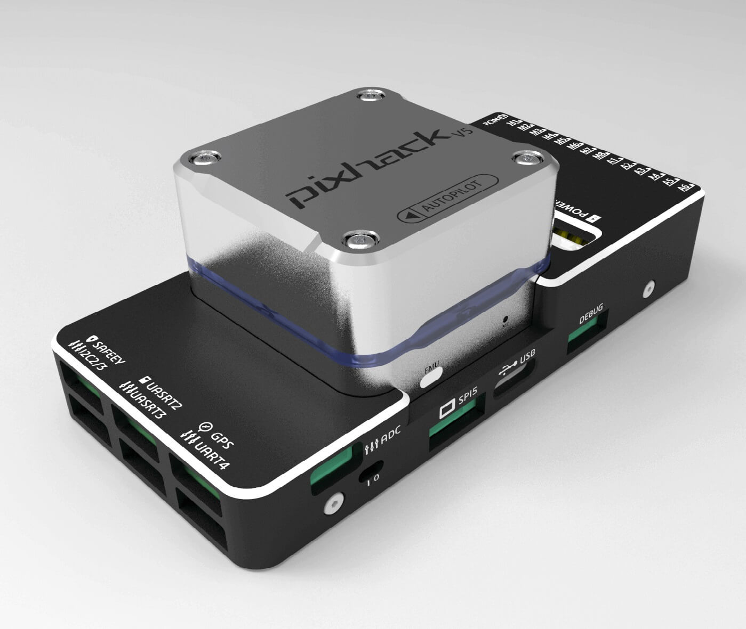

## **Quick Summary**

* Main FMU Processor: STM32F765
  + 32 Bit Arm® Cortex®-M7, 216MHz, 2MB memory, 512KB RAM
* IO Processor: STM32F100
  + 32 Bit Arm® Cortex®-M3, 24MHz, 8KB SRAM
* On-board sensors:
  + Accelerometer/Gyroscope: ICM-20689
  + Accelerometer/Gyroscope: BMI055
  + Magnetometer: IST8310
  + Barometer: MS5611
* Interfaces:
  + 8-14 PWM outputs (6 from IO, 8 from FMU)
  + 3 dedicated PWM/Capture inputs on FMU
  + Dedicated R/C input for CPPM
  + Dedicated R/C input for ppm/DSM and S.Bus
  + analog / PWM RSSI input
  + S.Bus servo output
  + 5 general purpose serial ports
  + 4 I2C ports
  + 4 SPI buses
  + 2 CANBuses with serial ESC
  + Analog inputs for voltage / current of 2 batteries
* Power System:
  + Power: 4.3~5.4V
  + USB Input: 4.75~5.25V
  + Servo Rail Input: 0~36V
* Weight and Dimensions:
  + Weight: 90g
  + Dimensions: 44x84x12mm
* Other Characteristics:
  + Operating temperature: -20 ~ 80°C （Measured value）

## **Purchase**

Order from [CUAV](https://cuav.taobao.com/index.htm?spm=2013.1.w5002-16371268426.2.411f26d9E18eAz).

## **Connection**

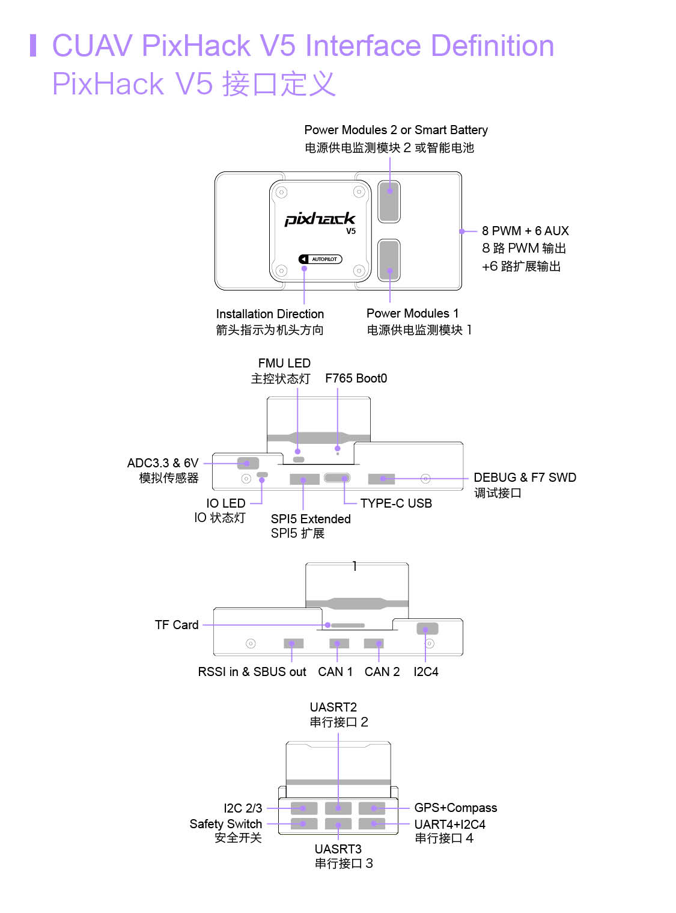

The RCIN interface is limited to powering the rc receiver and cannot be connected to any power/load.

## **Voltage Ratings**

*Pixhack v5* can be triple-redundant on the power supply if three power sources are supplied. The three power rails are: **POWER1**, **POWER2** and **USB**.

The output power rails **FMU PWM OUT** and **I/O PWM OUT** (0V to 36V) do not power the flight controller board (and are not powered by it). You must supply power to one of **POWER1**, **POWER2** or **USB** or the board will be unpowered.

**Normal Operation Maximum Ratings**

Under these conditions all power sources will be used in this order to power the system:

1. **POWER1** and **POWER2** inputs (4.3V to 5.4V)
2. **USB** input (4.75V to 5.25V)

## **Building Firmware**

make px4fmu-v5_default upload

## **Debug Port**

The system's serial console and SWD interface operate on the **FMU Debug** port. Simply connect the FTDI cable to the Debug & F7 SWD connector. To access the I/O Debug port, the user must remove the Pixhack v5 shell. Both ports have standard serial pins and can be connected to a standard FTDI cable (3.3V, but 5V tolerant).

The pinout is as shown.

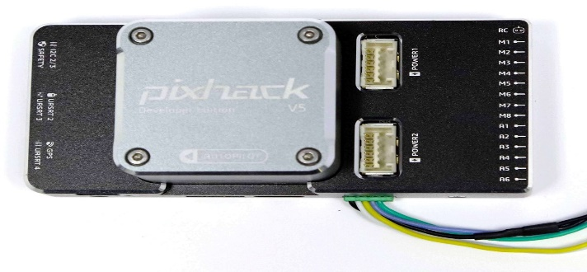

|  |  |
| --- | --- |
| **pin** | **pixhack v5 debug** |
| 1 | GND |
| 2 | FMU-SWCLK |
| 3 | FMU-SWDIO |
| 4 | UART7_RX |
| 5 | UART7_TX |
| 6 | VCC |

## **Peripherals**

* [Digital Airspeed Sensor](https://item.taobao.com/item.htm?spm=a1z10.3-c-s.w4002-16371268452.37.6d9f48afsFgGZI&id=9512463037)
* [Telemetry Radio Modules](https://cuav.taobao.com/category-158480951.htm?spm=2013.1.w5002-16371268426.4.410b7a821qYbBq&search=y&catName=%CA%FD%B4%AB%B5%E7%CC%A8)
* [Rangefinders/Distance sensors](https://docs.px4.io/en/sensor/rangefinders.html)

## **Supported Platforms / Airframes**

Any multicopter / airplane / rover or boat that can be controlled with normal RC servos or Futaba S-Bus servos. The complete set of supported configurations can be seen in the [Airframes Reference](https://docs.px4.io/en/airframes/airframe_reference.html).

## **Further info**

* [FMUv5 reference design pinout](https://docs.google.com/spreadsheets/d/1-n0__BYDedQrc_2NHqBenG1DNepAgnHpSGglke-QQwY/edit#gid=912976165).
* [Pixhack v5 docs](http://doc.cuav.net/flight-controller/pixhack-v5/en/)
* [CUAV Github](https://github.com/cuav)

# **Pixhawk Mini (Discontinued)**

This product is no longer manufactured or available from 3DR.

The 3DR® *Pixhawk® Mini* autopilot is a next-generation evolution of the Pixhawk (designed by 3DR in collaboration with HobbyKing®). It is about 1/3rd the size of the original Pixhawk and has more powerful processors and sensors.

The Pixhawk Mini is based on the PX4 open-hardware project and has been optimized for the PX4 flight stack.

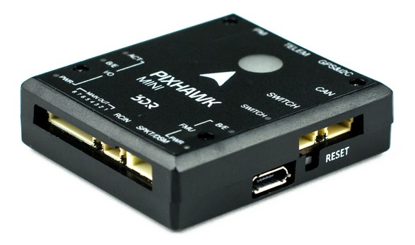

Wiring information is available [below](https://word-edit.officeapps.live.com/we/wordeditorframe.aspx?ui=ko-KR&rs=ko-KR&hid=3332D2m9bUuag20MK63/JA.0&WOPISrc=https%3A%2F%2Fwopi.onedrive.com%2Fwopi%2Ffiles%2FD12DB2555512DF7%213514&wdnd=1&wdPreviousSession=b0f5fe38-091f-46aa-87a6-9d78776ffd49&wdNewAndOpenCt=1555559441554&wdo=4&wdOrigin=wacFileNew&wdPreviousCorrelation=18bb11ab-d52b-455c-9c81-6fe434d118d9&wde=docx&sc=host%3D%26qt%3DFolders&mscc=1&wdp=0#wiring).

## **Specifications**

**Processors:**

* **Main Processor:** STM32F427 Rev 3
* **IO Processor:** STM32F103

**Sensors:**

* **Accel/Gyro/Mag:** MPU9250
  + [deprecated](https://github.com/PX4/Firmware/pull/7618) by the PX4 firmware
* **Accel/Gyro:** ICM20608
* **Barometer:** MS5611

**Voltage ratings:**

* **Power module output:** 4.1~5.5V
* **Max input voltage:** 45V (10S LiPo)
* **Max current sensing:** 90A
* **USB Power Input:** 4.1`5.5V
* **Servo Rail Input:** 0~10V

**Interfaces:**

* 1 x UART Serial Port (for GPS)
* Spektrum DSM/DSM2/DSM-X® Satellite Compatible RC input
* Futaba S BUS® Compatible RC input
* PPM Sum Signal RC Input
* I2C (for digital sensors)
* CAN (for digital motor control with compatible controllers)
* ADC (for analog sensors)
* Micro USB Port

**Weight and dimensions:**

* **Dimensions:** 38x43x12mm
* **Weight:** 15.8g

**GPS module (supplied with kit):**

* **GNSS receiver:** ublox® Neo-M8N; compass HMC5983
* **Weight:** 22.4g
* **Dimensions:** 37x37x12mm

## Connector assignments

<To be added.>

## **Features**

Key features of the Pixhawk Mini are:

* Advanced 32 bit ARM Cortex® M4 Processor running NuttX RTOS
* 8 PWM/servo outputs
* Multiple connectivity options for additional peripherals (UART, I2C, CAN)
* Redundant power supply inputs and automatic failover
* Integrated safety switch and optional external safety button for easy motor activation
* Multicolor LED indicator
* Integrated multi-tone piezo audio indicator
* microSD card for long-time high-rate logging
* Easy-to-use Micro JST connectors

The Pixhawk Mini is shipped with new **GPS module**:

* Based on the uBlox M8N
* Concurrent reception of up to 3 GNSS (GPS, Galileo, GLONASS, BeiDou)
* Industry leading –167 dBm navigation sensitivity
* Security and integrity protection
* Supports all satellite augmentation systems
* Advanced jamming and spoofing detection
* Product variants to meet performance and cost requirements

## **Kit package**

The 3DR *Pixhawk Mini* is shipped with the following contents:

|  |  |
| --- | --- |
| **Component** | **Image** |
| Pixhawk Mini Autopilot | Pixhawk Mini |
| GPS module | Compass+GPS module |
| Quad Power Distribution Board | Quad Power Distribution Board |
| 8 Channel PWM Breakout board | 8 Channel PWM Breakout board |
| 4-pin cable (for I2C) | 4-pin cable (for I2C) |
| RC-in cable for PPM/SBUS | RC-in cable for PPM/SBUS |
| 6 to 6/4 ‘Y’ adapter for GPS and additional I2C devices | 6 to 6/4 ‘Y’ adapter |
| 6 pin cable (2) (for power distribution board and for compass/gps) | 6 pin cable |
| 6 pin JST to DF13 for legacy telemetry radio | 6 pin JST to DF13 |
| Safety switch | Safety switch |
| 8 Channel PWM Breakout cable | 8 Channel PWM Breakout cable |
| Mounting foam | Mounting foam |
| I2C breakout board ? - not listed parts on handout | - |

## **Optional accessories**

* Telemetry Radio Sets: 915 MHz (USA), 433 MHz (European)
* When installing the 3DR telemetry radios, use the connectors that come with Pixhawk Mini, rather than those that come with the radios.
* 3DR 10S Power Module
* WiFi Telemetry Radio
* Digital Airspeed Sensor

## **Compatibility**

### **RC radio**

* PPM output RC receivers
* Spektrum DSM RC receivers
* Futaba S BUS RC receivers

### **ESCs**

* All standard PWM input ESC’s

## **Connector pin assignments (pin outs)**

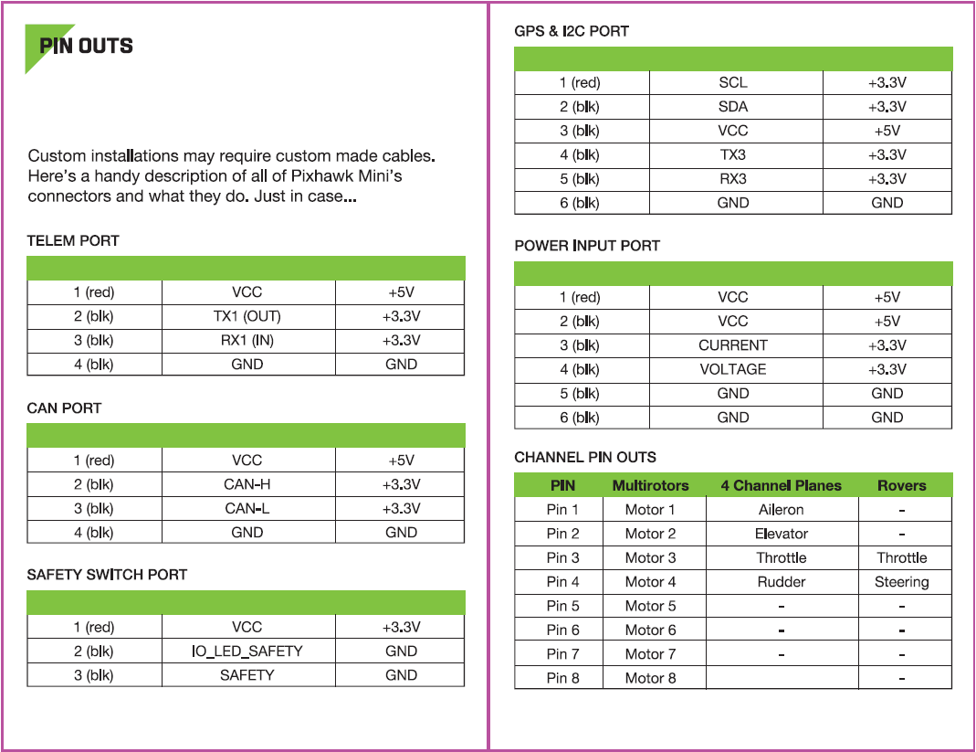

## **Product comparisons**

### **Pixhawk Mini vs Pixhawk (original)**

* One-third the size - from 50x81.5x15.5mm to 38x43x12mm.
* Rev 3 processor for full utilization of 2MB flash memory.
* Improved sensors, both primary and secondary IMU MPU9250 and ICM20608 respectively. The result is more stable, more reliable flight and navigation.
* GPS+Compass module included. Features the Neo M8N with GLONASS support; compass HMC5983. Expect faster and stronger GPS lock.
* Micro JST connectors instead of DF-13. These are much easier to work with.
* Integrated piezo speaker and safety switch.
* Natively supports 4S batteries with the included PDB.

### **Pixhawk Mini vs Pixfalcon**

* Improved sensors, both primary and secondary IMU MPU9250 and ICM20608 respectively. Expect better vibration handling and reliability.
* CAN interface for UAVCAN support.
* Includes 8-channel breakout servo rail for planes and other vehicles requiring powered PWM output.
* Includes I2C breakout board for a total of 5 I2C connections.
* Similar size.

Pixhawk Mini features an advanced processor and sensor technology from ST Microelectronics® and a NuttX real-time operating system, delivering excellent performance, flexibility, and reliability for controlling any autonomous vehicle.

## **Known issues**

* Some Pixhawk Minis have a [hardware defect](https://github.com/PX4/Firmware/issues/7327#issuecomment-317132917) that makes the internal MPU9250 IMU unreliable.
  + The problem is only present in older hardware revisions, because [it was fixed at some point by the manufacturer](https://github.com/PX4/Firmware/issues/7327#issuecomment-372393609).
  + To check whether a specific board is affected or not, leave the board disconnected for some time, then power it on and try to start the mpu9250 driver from the PX4 command line. If the board is affected, the driver will not start.
  + The MPU9250 is [disabled by default](https://github.com/PX4/Firmware/pull/7618) on the PX4 firmware.
  + The defective Pixhawk Minis will not calibrate without an external magnetometer or an attached GPS, even indoor.
  + When using an external GPS, [this is not a problem](https://github.com/PX4/Firmware/pull/7618#issuecomment-320270082) because the secondary ICM20608 provides the accelerometer and the gyro, while the external GPS provides the magnetometer.

## **Wiring Quick Start**

The *Pixhawk Mini* is no longer manufactured or available from 3DR.

This quick start guide shows how power the [Pixhawk Mini](https://word-edit.officeapps.live.com/we/pixhawk_mini.html) and connect its most important peripherals.

### **Standard Wiring Chart**

The image below shows standard *quadcopter* wiring using the *Pixhawk Mini Kit* and 3DR Telemetry Radios (along with ESC, motor, battery and a ground control station running on a phone). We'll go through each main part in the following sections.

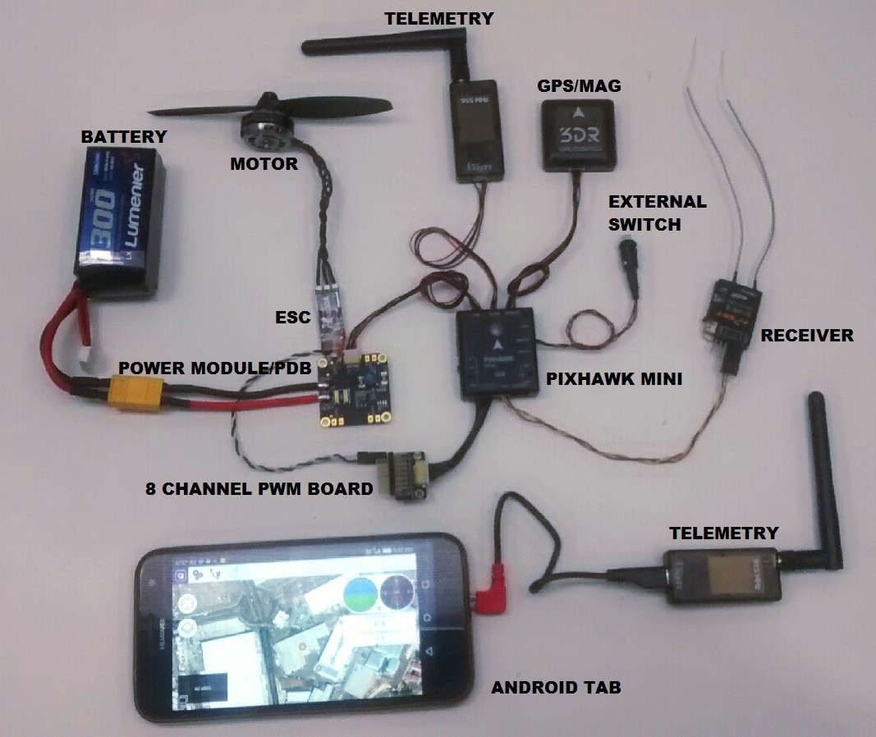

The output wiring/powering is slightly different for other types of vehicles. This is covered in more detail below for VTOL, Plane, Copter.

### **Mount and Orient Controller**

The *Pixhawk Mini* should be mounted on the frame using vibration-damping foam pads (included in the kit). It should be positioned as close to your vehicle’s center of gravity as possible, oriented top-side up with the arrow points towards the front of the vehicle.

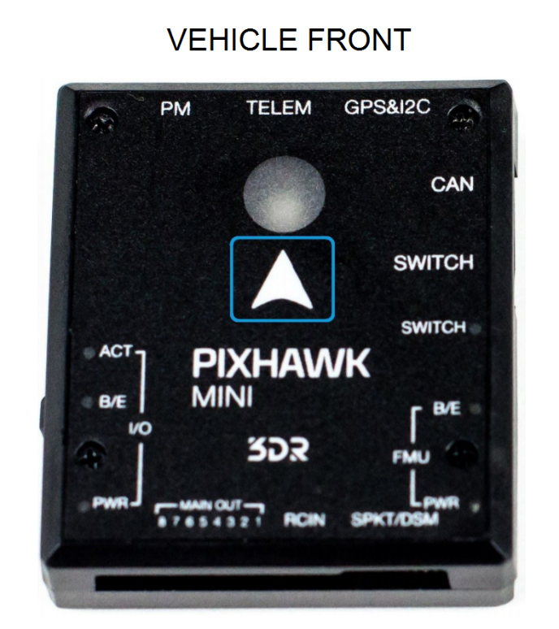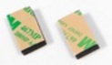

If the controller cannot be mounted in the recommended/default orientation (e.g. due to space constraints) you will need to configure the autopilot software with the orientation that you actually used: [Flight Controller Orientation](https://word-edit.officeapps.live.com/config/flight_controller_orientation.html).

### **GPS + Compass**

Attach the 3DR GPS + Compass to the Pixhawk Mini's **GPS&I2C** port (top right) using the supplied 6 pin cable. The GPS/Compass should be mounted on the frame as far away from other electronics as possible, facing the front of the vehicle (separating the compass from other electronics will reduce interference).

NOTE - INSERT IMAGE SHOWING BOTH PORTS? OR FRONT-FACING image of GPS&I2C

The compass must be calibrated before it is first used: [Compass Calibration](https://word-edit.officeapps.live.com/config/compass.html)

### **Power**

The image below shows typical power-supply wiring when using *Pixhawk Mini* in a Quadcopter. This uses the *Quad Power Distribution Board* that comes in the kit to supply both the Pixhawk Mini and the ESC/Motor from the battery (and can also power other accessories).

The *Quad Power Distribution Board* includes a power module (PM) that is suitable for batteries <= 4S. The *3DR 10S Power Module* (Discontinued) is recommended if you need more power.

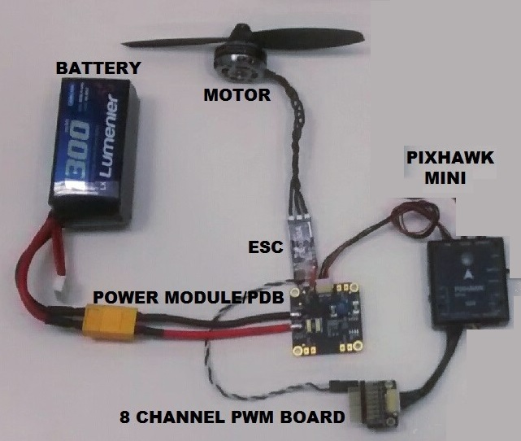

The *Pixhawk Mini* is powered through the **PM** port. When using a power module (as in this case) the port will also read analog voltage and current measurements.

Up to 4 ESCs can be separately powered from the power distribution board (though in this case we only have one connected).

The control signals come from MAIN OUT. In this case there is only one control channel, which is connected to the ESC via the *8 Channel PWM Breakout Board*.

The Pixhawk Mini output rail (MAIN OUT) cannot power attached devices (and does not need to in the circuit as shown). For vehicles where MAIN OUT is attached to devices that draw power (e.g. a servo used in a plane) then you will need to power the rail using a BEC (battery elimination circuit). The included breakout board allows one channel to provide power on the other outputs.

### **Radio Control**

Pixhawk Mini supports many different radio receiver models:

* Spektrum and DSM receivers connect to the **SPKT/DSM** input.

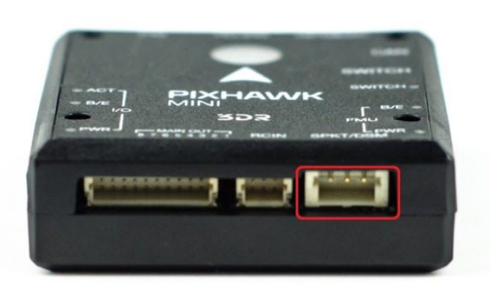

* PPM-SUM and S.BUS receivers connect to the **RCIN** port.

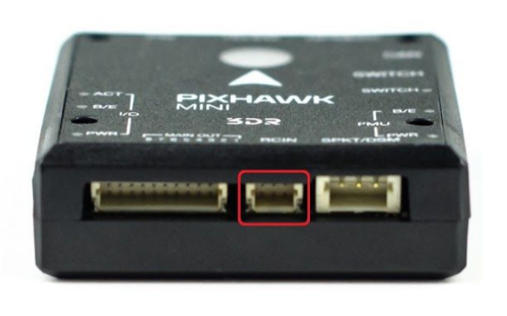

* PPM and PWM receivers that have an *individual wire for each channel* must connect to the **RCIN** port *via a PPM encoder* [like this one](http://www.getfpv.com/radios/radio-accessories/holybro-ppm-encoder-module.html) (PPM-Sum receivers use a single signal wire for all channels).

For more information about selecting a radio system, receiver compatibility, and binding your transmitter/receiver pair, see: [Remote Control Transmitters & Receivers](https://word-edit.officeapps.live.com/getting_started/rc_transmitter_receiver.html).

### **Safety switch (optional)**

The controller has an integrated safety switch that you can use for motor activation once the autopilot is ready to take off. If this switch is hard to access on a particular vehicle you can attach the (optional) external safety button, as shown below.

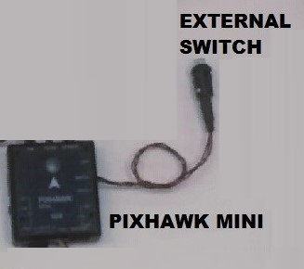

### **Telemetry Radios**

### **Motors**

The mappings between MAIN/AUX output ports and motor/servos for all supported air and ground frames are listed in the [Airframe Reference](https://word-edit.officeapps.live.com/airframes/airframe_reference.html).

The mapping is not consistent across frames (e.g. you can't rely on the throttle being on the same output for all plane frames). Make sure to use the correct mapping for your vehicle.

If your frame is not listed in the reference then use a "generic" airframe of the correct type.

Notes:

* The output rail must be separately powered, as discussed in the [Power](https://word-edit.officeapps.live.com/we/wordeditorframe.aspx?ui=ko-KR&rs=ko-KR&hid=3332D2m9bUuag20MK63/JA.0&WOPISrc=https%3A%2F%2Fwopi.onedrive.com%2Fwopi%2Ffiles%2FD12DB2555512DF7%213514&wdnd=1&wdPreviousSession=b0f5fe38-091f-46aa-87a6-9d78776ffd49&wdNewAndOpenCt=1555559441554&wdo=4&wdOrigin=wacFileNew&wdPreviousCorrelation=18bb11ab-d52b-455c-9c81-6fe434d118d9&wde=docx&sc=host%3D%26qt%3DFolders&mscc=1&wdp=0#power) section above.
* Pixhawk Mini cannot be used for QuadPlane VTOL airframes. This is because QuadPlane requires 9 outputs (4 Main, 5 AUX) and the Pixhawk Mini only has 8 outputs (8 Main).

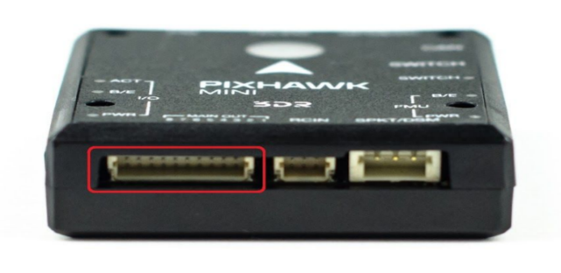

### **Other Peripherals**

The wiring and configuration of other components is covered within the topics for individual [peripherals](https://word-edit.officeapps.live.com/peripherals/).

### **Configuration**

General configuration information is covered in: [Autopilot Configuration](https://word-edit.officeapps.live.com/config/).

QuadPlane specific configuration is covered here: [QuadPlane VTOL Configuration](https://word-edit.officeapps.live.com/config_vtol/vtol_quad_configuration.html)

# **AUAV-X2 Autopilot (Discontinued)**

This board has been discontinued and is no longer commercially available.

The [AUAV®](http://www.auav.com/) *AUAV-X2 autopilot* is based on the [Pixhawk®-project](https://pixhawk.org/) **FMUv2** open hardware design. It runs PX4 on the [NuttX](http://nuttx.org/) OS.

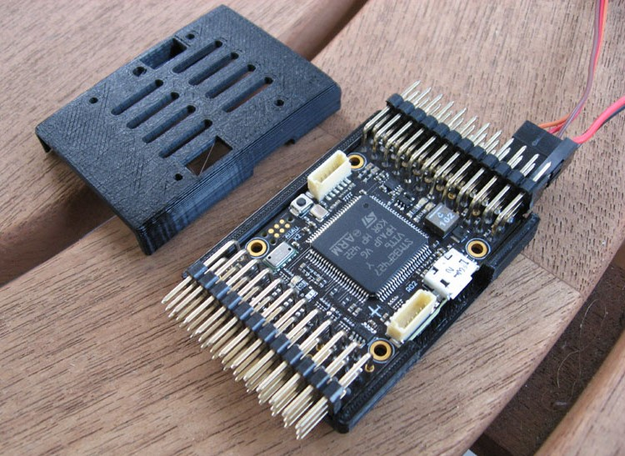

## **Quick Summary**

* Main System-on-Chip: [STM32F427](http://www.st.com/web/en/catalog/mmc/FM141/SC1169/SS1577/LN1789)
  + CPU: STM32F427VIT6 ARM microcontroller - Revision 3
  + IO: STM32F100C8T6 ARM microcontroller
* Sensors:
  + Invensense MPU9250 9DOF
  + Invensense ICM-20608 6DOF
  + MEAS MS5611 barometer
* Dimensions/Weight
  + Size: 36mm x 50mm
  + Mounting Points: 30.5mm x 30.5mm 3.2mm diameter
  + Weight: 10.9g
* Power OR-ing schematic with reverse voltage protection. 5V power module is required!

## **Connectivity**

* 2.54mm headers:
* GPS (USART4)
* i2c
* RC input
* PPM input
* Spektrum input
* RSSI input
* sBus input
* sBus output
* Power input
* Buzzer output
* LED output
* 8 x Servo outputs
* 6 x Aux outputs
* USART7 (Console)
* USART8 (OSD)

## **Availability**

No longer in production. This has been superceded by the [mRo X2.1](https://docs.px4.io/en/flight_controller/mro_x2.1.html). mRobotics is the  
distributor for the AUAV Products from August 2017.

## **Key Links**

* [User Manual](http://arsovtech.com/wp-content/uploads/2015/08/AUAV-X2-user-manual-EN.pdf)
* [DIY Drones Post](http://diydrones.com/profiles/blogs/introducing-the-auav-x2-1-flight-controller)

## **Wiring Guide**

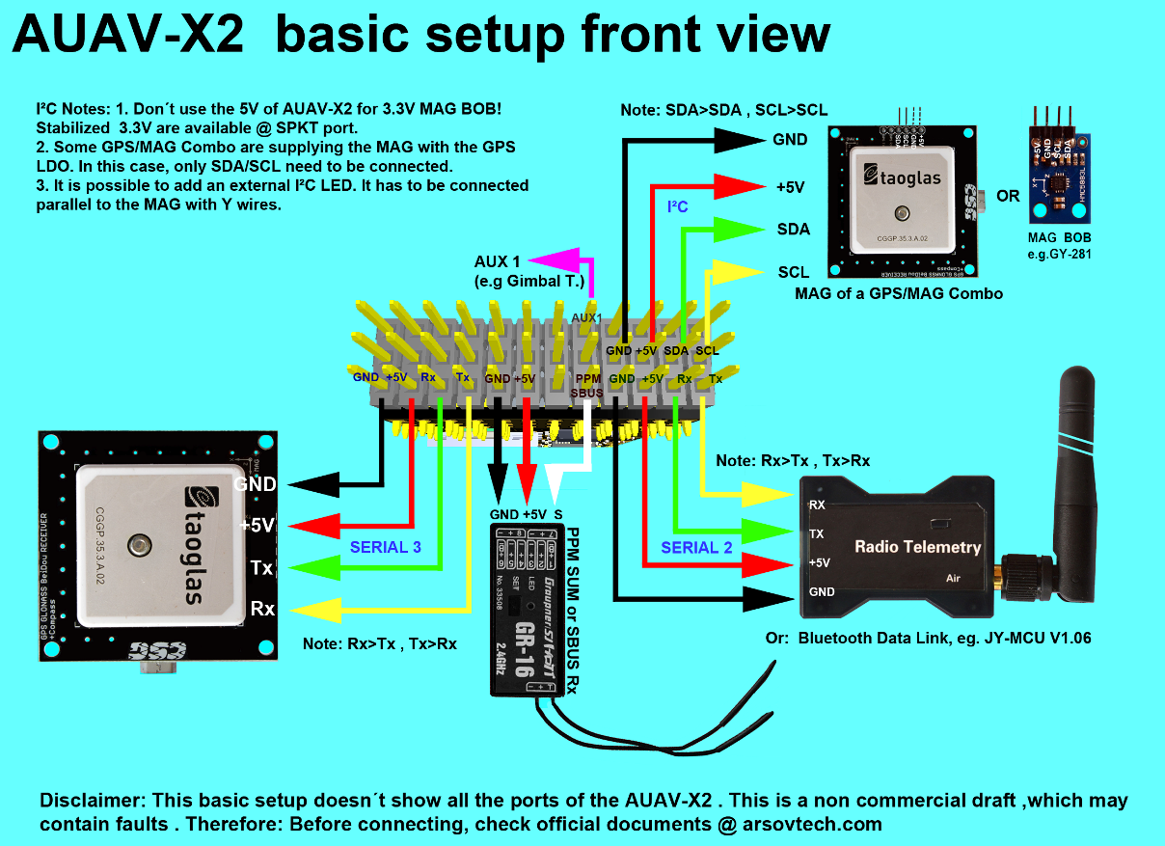

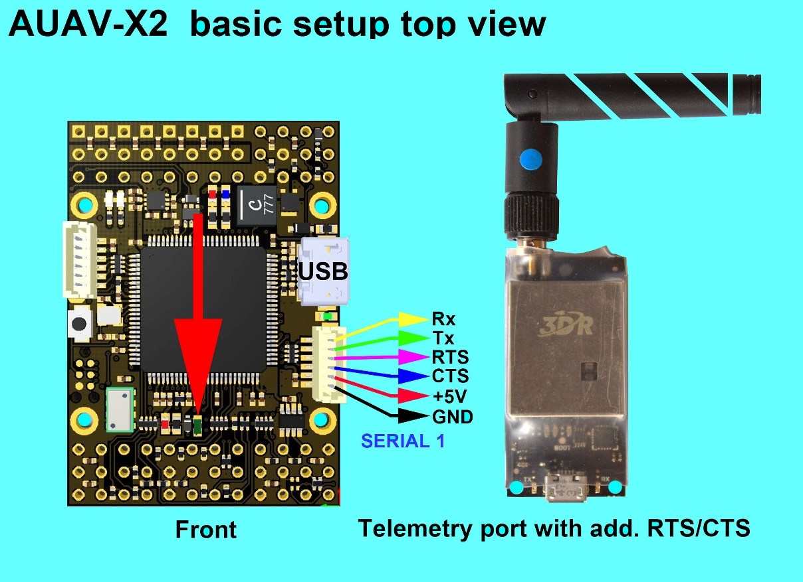

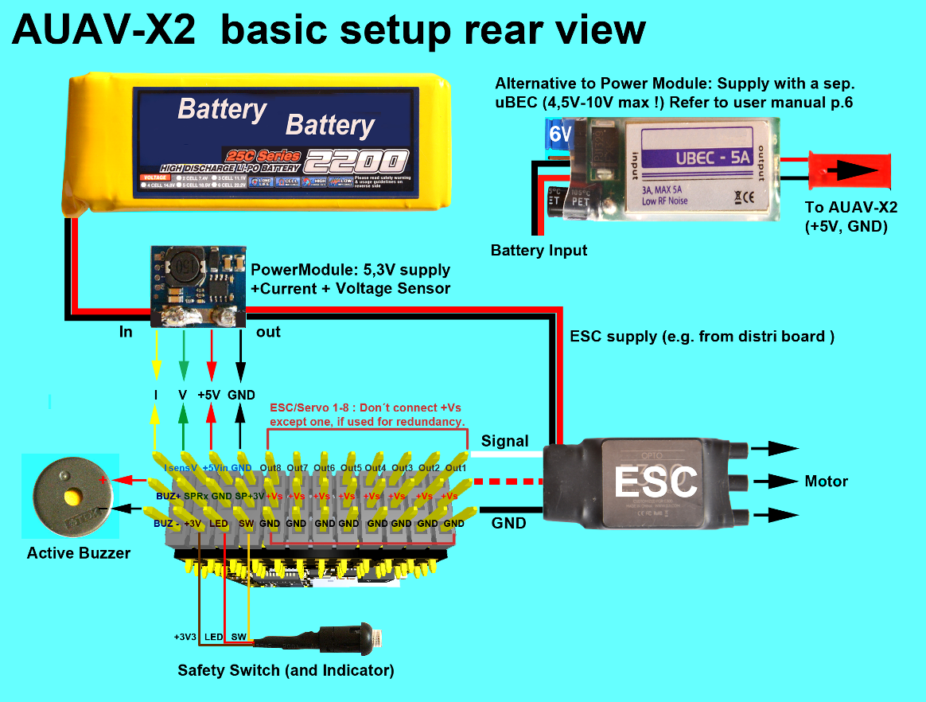

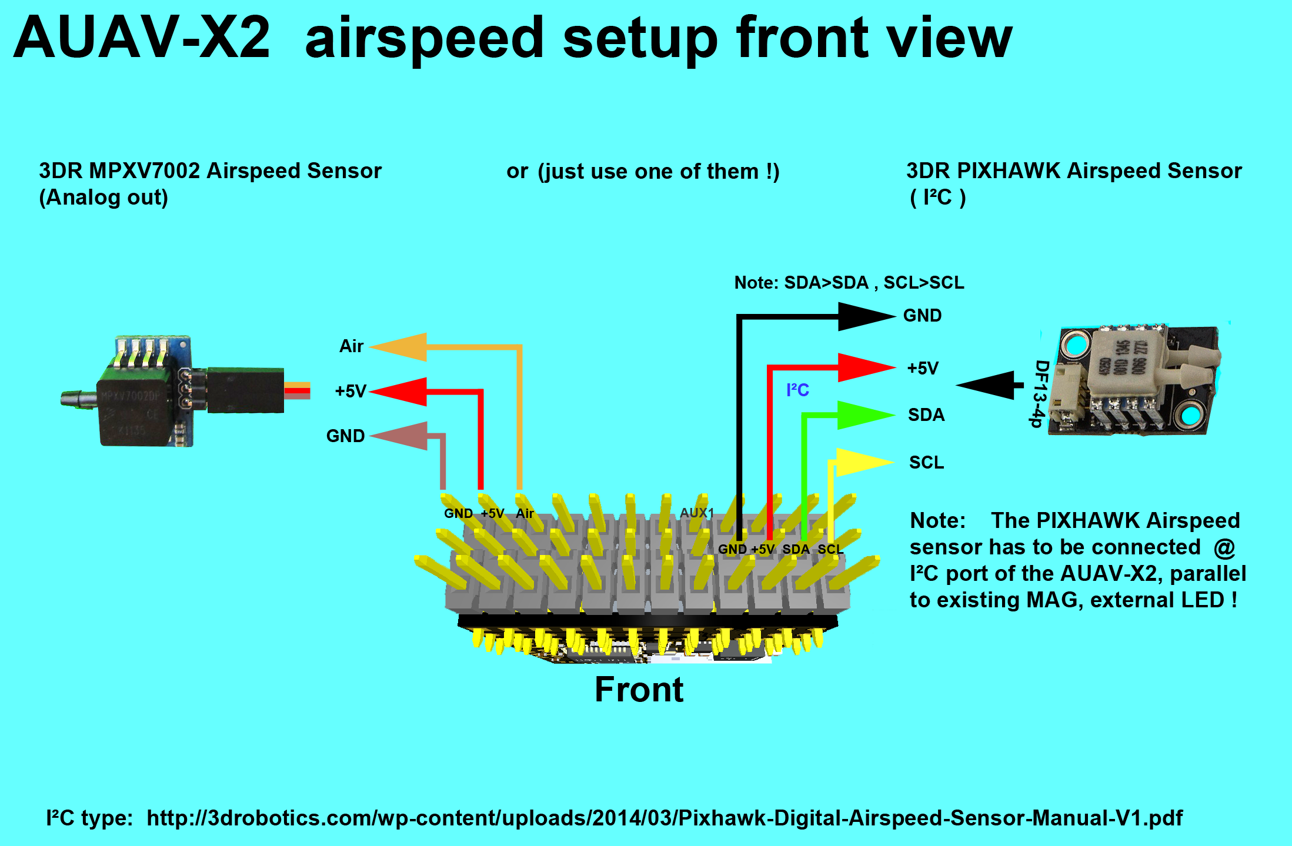

## **Schematics**

The board is based on the [Pixhawk project](https://pixhawk.org/) **FMUv2** open hardware design.

* [FMUv2 + IOv2 schematic](https://raw.githubusercontent.com/PX4/Hardware/master/FMUv2/PX4FMUv2.4.5.pdf) -- Schematic and layout

As a CC-BY-SA 3.0 licensed Open Hardware design, all schematics and design files are [available](https://github.com/PX4/Hardware).**Silicon Errata**

This page lists known issues with silicon (hardware) errata of 3rd-party parts (micro controller, sensors, etc.) used on the Pixhawk board series. Depending on the type of silicon error, these cannot be fixed in software and might impose specific limitations.

## **FMUv2 / Pixhawk Silicon Errata**

### **STM32F427VIT6 (errata)**

Flash Bank 2 and full speed USB device exclusive.

Silicon revisions up to rev 2 (revision 3 is the first not affected) can produce errors / data corruption when accessing the 2nd flash bank while there is activity on PA12, which is one of the USB data lines. There is no workaround / software fix for this, except to not use the flash bank #2. Since USB is needed to program the device, Pixhawk revisions built with silicon revisions < rev 3 can only use up to 1MB of the 2MB flash of the microprocessor.

The errata is fixed in later versions, but this may not be detected if you are using an older bootloader. See [Bootloader Update](https://docs.px4.io/en/advanced_config/bootloader_update.html) for more information.

## **FMUv1 / Pixhawk Silicon Errata**

No known issues.

# **(Air)Mind Series**

AirMind® have created two new controller series branched from the [Pixhawk Series](https://docs.px4.io/en/flight_controller/pixhawk_series.html).

* [MindPX](https://docs.px4.io/en/flight_controller/mindpx.html) - revised schematic and structure, and been further enhanced with new features to make un-manned vehicle more smart and friendly to use.
* [MindRacer](https://docs.px4.io/en/flight_controller/mindracer.html) - a fully stackable flight platform for miniature UAVs.
  + This is a platform, which currently has two RTF vehicles: [MindRacer 210](https://docs.px4.io/en/flight_controller/mindracer210.html) and [NanoMind 110](https://docs.px4.io/en/flight_controller/nanomind110.html)

# MindPX Hardware

The AirMind® [MindPX](http://mindpx.net/) series is a new generation autopilot system branched from Pixhawk®.

# MindPX Controller

## **Quick Summary**

The main hardware documentation is [here](http://mindpx.net/assets/accessories/Specification9.18_3_pdf.pdf).

MindPX is a new generation autopilot system branched from Pixhawk®, been revised in schematic and structure, and been further enhanced with new features to make un-manned vehicle more smart and more friendly to use.

MindPX increases total PWM output channels to 16 (8 main outputs + 8 aux outputs).  
This means that MindPX can support more complicated VTOL configurations and more fine control. It is especially meaningful for those FMU-V4 based flight controllers as MindPX implements main and aux output in one single FMU.

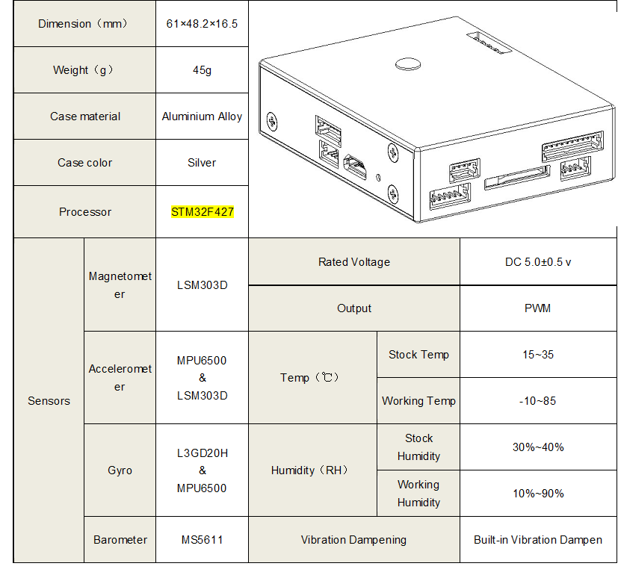

* Main System-on-Chip: STM32F427
  + CPU: 32bits, 168 MHz ARM Cortex® M4 with FPU
  + RAM: 256 KB SRAM
  + 2MB Flash
  + ST Micro LSM303D 14 bit accelerometer/magnetometer
  + MEAS MS5611 barometer
  + InvenSense® MPU6500 integrated 6-axis sensors
* Highlighted features:
  + CNC processed aluminum alloy case, light and solid
  + Built-in isolated IMU redundancy
  + Total 16 PWM output channel (8 main + 8 aux)
  + 1 extra I2C port for flow connection.
  + 1 extra USB port for companion computer connection (built-in UART-to-USB converter)
  + Exposed debug port for development

## **Quick Start**

### **Mounting**

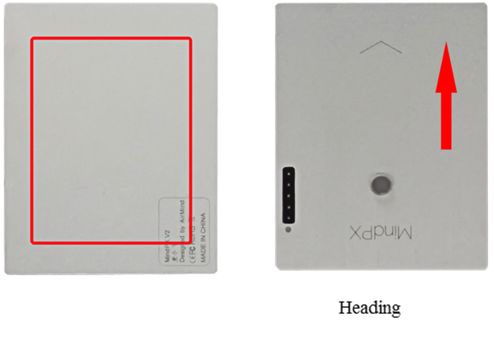

### **Wiring**

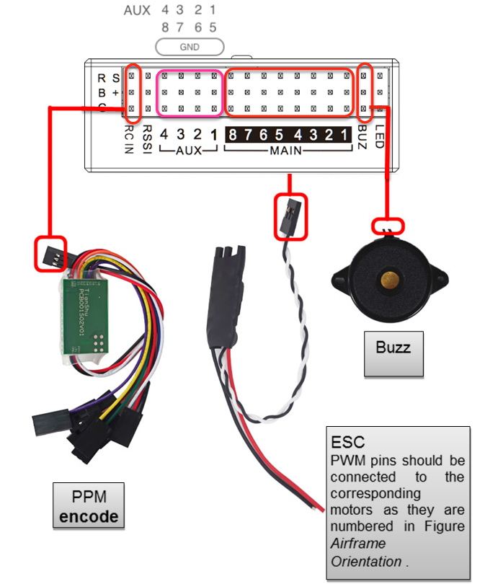

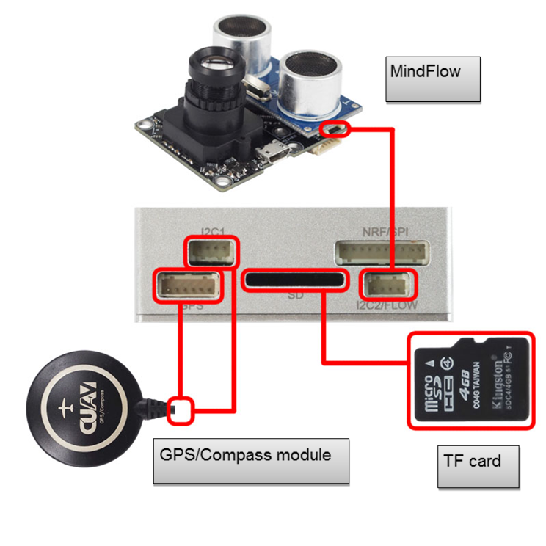

### **Pin**

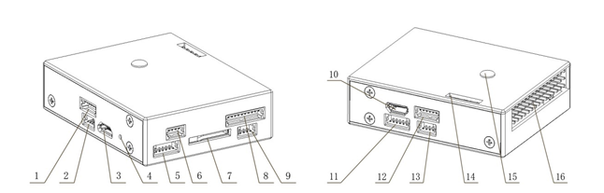

| **Num.** | **Description** | **Num.** | **Description** |
| --- | --- | --- | --- |
| 1 | Power | 9 | I2C2 (MindFLow) |
| 2 | Debug (refresh bootloader) | 10 | USB2 (Serial 2 to USB) |
| 3 | USB1 (refresh firmware) | 11 | UART4,5 |
| 4 | Reset | 12 | UART1 (Telemetry) |
| 5 | UART3 (GPS) | 13 | CAN |
| 6 | I2C1(external compass) | 14 | ADC |
| 7 | TF card slot | 15 | Tricolor Light |
| 8 | NRF/SPI(Remote Control) | 16 | Looper |

### **Radio Receiver**

MindPX supports a wide variety of radio receivers (since V2.6) including: PPM/SBUS/DSM/DSM2/DSMX. MindPX also support FrSky® bi-direction telemetry D and S.Port.

For detailed Pin diagram, please refer to the [User Guide](http://mindpx.net/assets/accessories/UserGuide9.18_2_pdf.pdf).

### **How to build**

Please follow [Getting Started](https://dev.px4.io/en/setup/getting_started.html) and [Building the Code](https://dev.px4.io/en/setup/building_px4.html). The target for MindPX is nuttx_mindpx-v2_default:

make nuttx_mindpx-v2_default

### **Companion PC connection**

MindPX has a USB-TO-UART Bridge IC on the board. A micro-USB to USB type A cable is used for the connection. Connect micro-USB end to the 'OBC' port of MindPX and USB type A end to companion computer.

And the max BAUD rate is the same with px4 family, which is up to 921600.

### **User Guide**

The user guide is [here](http://mindpx.net/assets/accessories/UserGuide9.18_2_pdf.pdf).

## **Where to buy**

MindRacer is available at [AirMind Store](http://drupal.xitronet.com/?q=catalog) on internet. You can also find MindRacer at Amazon® or eBay®.

## **Support**

Please visit [http://www.mindpx.org](http://www.mindpx.org/) for more information. Or you can send email to [support@mindpx.net](mailto:support@mindpx.net) for any inquiries or help.

# MindRacer Hardware

The AirMind® [MindRacer](http://mindpx.net/) series is a fully stackable flight platform for miniature UAVs..

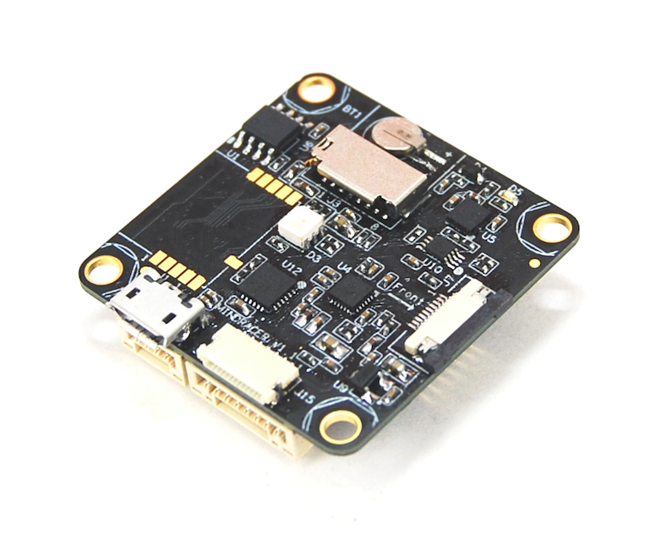

## **Quick Summary**

MindRacer is a fully stackable flight platform for miniature UAVs. Based on [MindPX](https://docs.px4.io/en/flight_controller/mindpx.html), MindRacer further scales down in formfactor while focused on providing modularity. MindRacer is a platform rather than a flight controller.

MindRacer implements the SEP(soldering-elimination-port) and WEP(wiring-elimination-protocol) concepts. Before SEP and WEP, soldering and wiring are always the major pain and efficiency killer during UAV manufacturing and tuning.

The main hardware documentation is [here](http://mindpx.net/assets/accessories/mindracer_spec_v1.2.pdf).

* Ultra mini size, weight ~6g
* High performance STM32F427 168MHz floating point processor, super fast throttle response
* Support OneShot ESC
* Support PPM/SBUS/DSM radio receivers, support D.Port/S.Port/Wifi telemetry
* On board flight data recorder
* Support IMU isolation
* DroneCode® standard compliance connector

| **Item** | **Description** |
| --- | --- |
| Flight controller/Processor | F427VIT6 |
| Weight | ~6g |
| Dimension | 35x35mm |
| PWM Outputs | maximum 6 |
| IMU | 10DOF |
| IMU isolation | YES/Optional |
| Radio Receiver | S.BUS/PPM/DSM/DSM2/DSMX/SUMD |
| Telemetry | FrSky® D.Port, S.Port, Wifi, 3DR radio |
| On board TF card for flight data recording | YES |
| OneShot ESC Support | YES |
| Expansion Slots | 2x7(pin)x2 |
| On board Real time clock | YES |
| Connector | JST GH(compliance with DroneCode standard) |

## **Quick Start**

### **Pin-out Map**

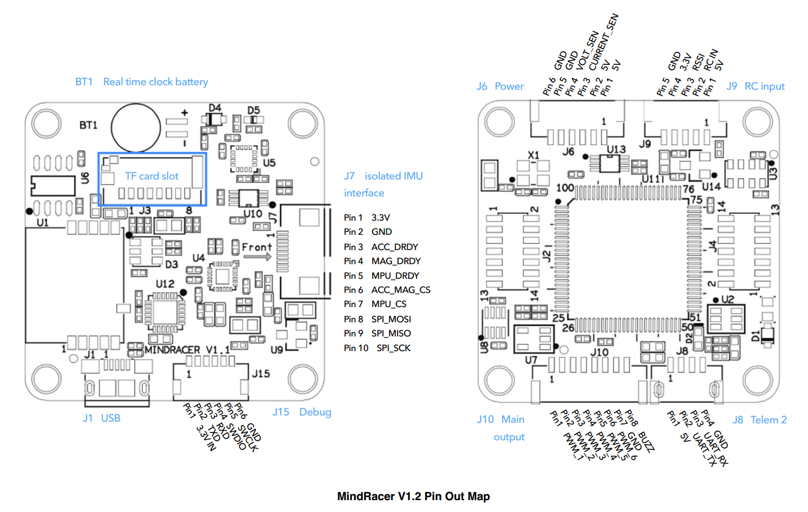

### **How to Build**

Please follow [Getting Started](https://dev.px4.io/en/setup/getting_started.html) and [Building the Code](https://dev.px4.io/en/setup/building_px4.html). The target for MindPX is nuttx_mindpx-v2_default (it's compatible with MindPX):

make nuttx_mindpx-v2_default

### **Companion PC Connection**

MindRacer has an attached Adapt IO board.

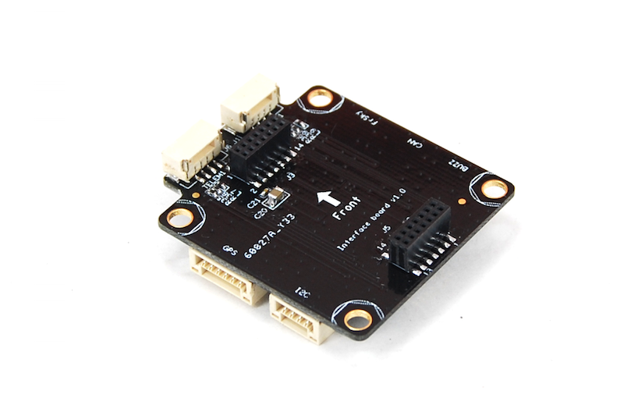

MindRacer has a built-in UART-to-USB converter. To connect a companion computer, stack MindRacer on an interface board, and connect the companion computer to the USB port on the interface board.

And the max BAUD rate is the same with px4 family, which is up to 921600.

### **User Guide**

The user guide is [here](http://mindpx.net/assets/accessories/mindracer_user_guide_v1.2.pdf)

## **Where to Buy**

MindRacer is available at [AirMind Store](http://drupal.xitronet.com/?q=catalog). You can also find MindRacer at Amazon® or eBay®.

## **Support**

Please visit [http://www.mindpx.org](http://www.mindpx.org/) for more information. Or you can send email to [support@mindpx.net](mailto::support@mindpx.net) for any inquiries or help.

# MindRacer BNF & RTF

MindRacer BNF (Bind-n-Fly) & RTF (Ready-to-Fly) includes two models currently:

* [MindRacer 210](https://docs.px4.io/en/flight_controller/mindracer210.html)
* [NanoMind 110](https://docs.px4.io/en/flight_controller/nanomind110.html)

## MindRacer 210

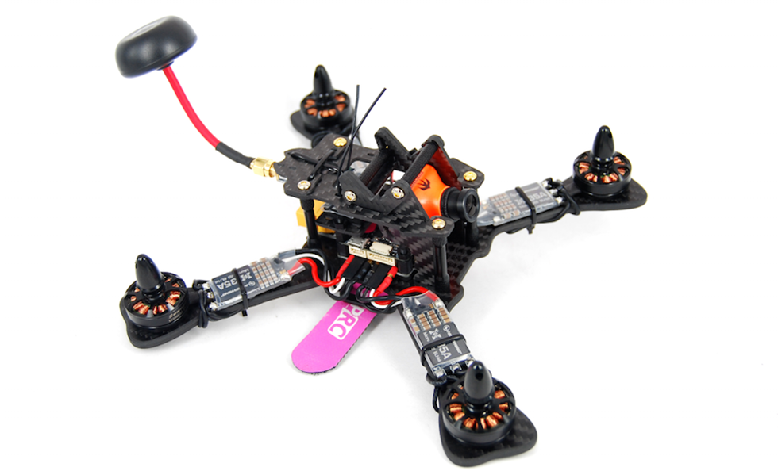

### **Summary**

A ready-to-fly racing beast running full PX4/MindPX stack. Can reach maximum 10:1 thrust-to-weight ratio!

MR210 uses MindRacer as flight controller. MR210 is a fully modularized, stackable RTF racing drone. The soldering-free SEP/WEP sockets allow pilots to quickly replace broken parts without the needs for soldering iron. Pilots can further easily customize the build by adding-to or replacing stacking parts to make a more powerful drone.

### Highlights

1. True 'X', 4mm thick, 210mm diagonal carbon fiber frame.
2. Stackable SEP/WEP sockets for soldering-free ESC connection and parts replacement.
3. 30A/4S/OneShot enabled BLHeli ESC.
4. 5V universal voltage supply for all avionics including camera and VTX.
5. DroneCode® standard compliant JST GH connectors.
6. Have options for PPM/S.Bus/Specktrum DSM receiver

### User Guide

The user guide is [here](http://mindpx.net/assets/accessories/MR210usermanual_pdf.pdf).

### Where to buy

MindRacer 210 is available at [AirMind Store](http://drupal.xitronet.com/?q=catalog). You can also find MindRacer at Amazon® or eBay®.

### Support

Please visit [http://www.mindpx.org](http://www.mindpx.org/) for more information. Or you can send email to [support@mindpx.net](mailto:support@mindpx.net) for any inquiries or help.

## NanoMind 110

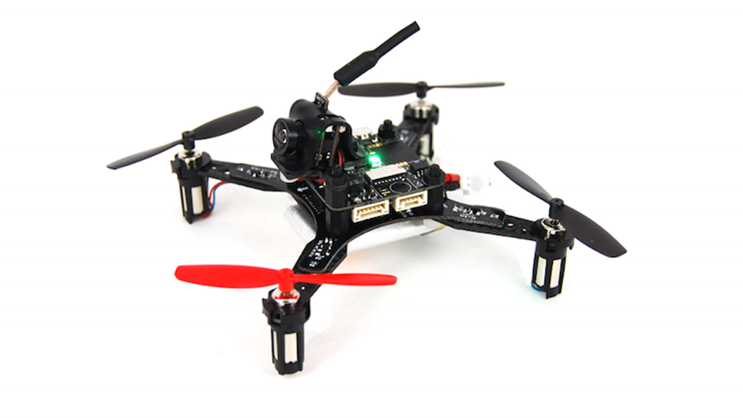

### Summary

Nano size (110mm diagonal) ready-to-fly quad copter for indoor flight/racing. NanoMind uses MindRacer as flight controller, which runs full PX4/MindPX flight stack.

### Highlights

1. 36g empty weight, with maximum 80g take-off Weight, heavy lifter.
2. 6~7 minutes flight time.
3. built-in options for PPM/S.Bus/Specktrum DSM receiver.
4. Soldering-free, fully stackable structure with SEP/WEP sockets for easy stacking and functional expansion.

### User Guide

The user guide is [here](http://mindpx.net/assets/accessories/NanoMind_110_user_manual.pdf).

### Flight video

<https://youtu.be/bLtKa--Buic>

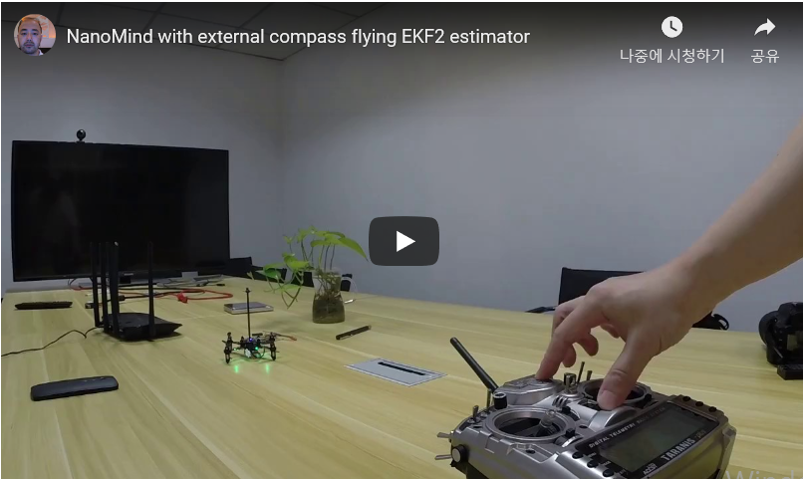

### Where to buy

NanoMind 110 is available at [AirMind® Store](http://drupal.xitronet.com/?q=catalog). You can also find MindRacer at Amazon® or eBay®.

### Support

Please visit [http://www.mindpx.org](http://www.mindpx.org/) for more information. Or you can send email to [support@mindpx.net](mailto:support@mindpx.net) for any inquiries or help.

# Omnibus F4 SD

The Omnibus F4 SD is a controller board designed for racers. In contrast to a typical racer board it has some additional features, such as an SD card and a faster CPU.

These are the main differences compared to a [Pixracer](https://docs.px4.io/en/flight_controller/pixracer.html):

* Lower price
* Fewer IO ports (though it's still possible to attach a GPS or a Flow sensor for example)
* Requires external pull up resistor on the I2C bus for external GPS, see [I2C](https://docs.px4.io/en/flight_controller/omnibus_f4_sd.html#i2c) below.
* Less RAM (192 KB vs. 256 KB) and FLASH (1 MB vs. 2 MB)
* Same board dimensions as a Pixracer, but slightly smaller form factor (because it has less connectors)
* Integrated OSD (not yet implemented in software)

Note that an SD card is required for parameter storage.

All the usual PX4 features can still be used for your racer!

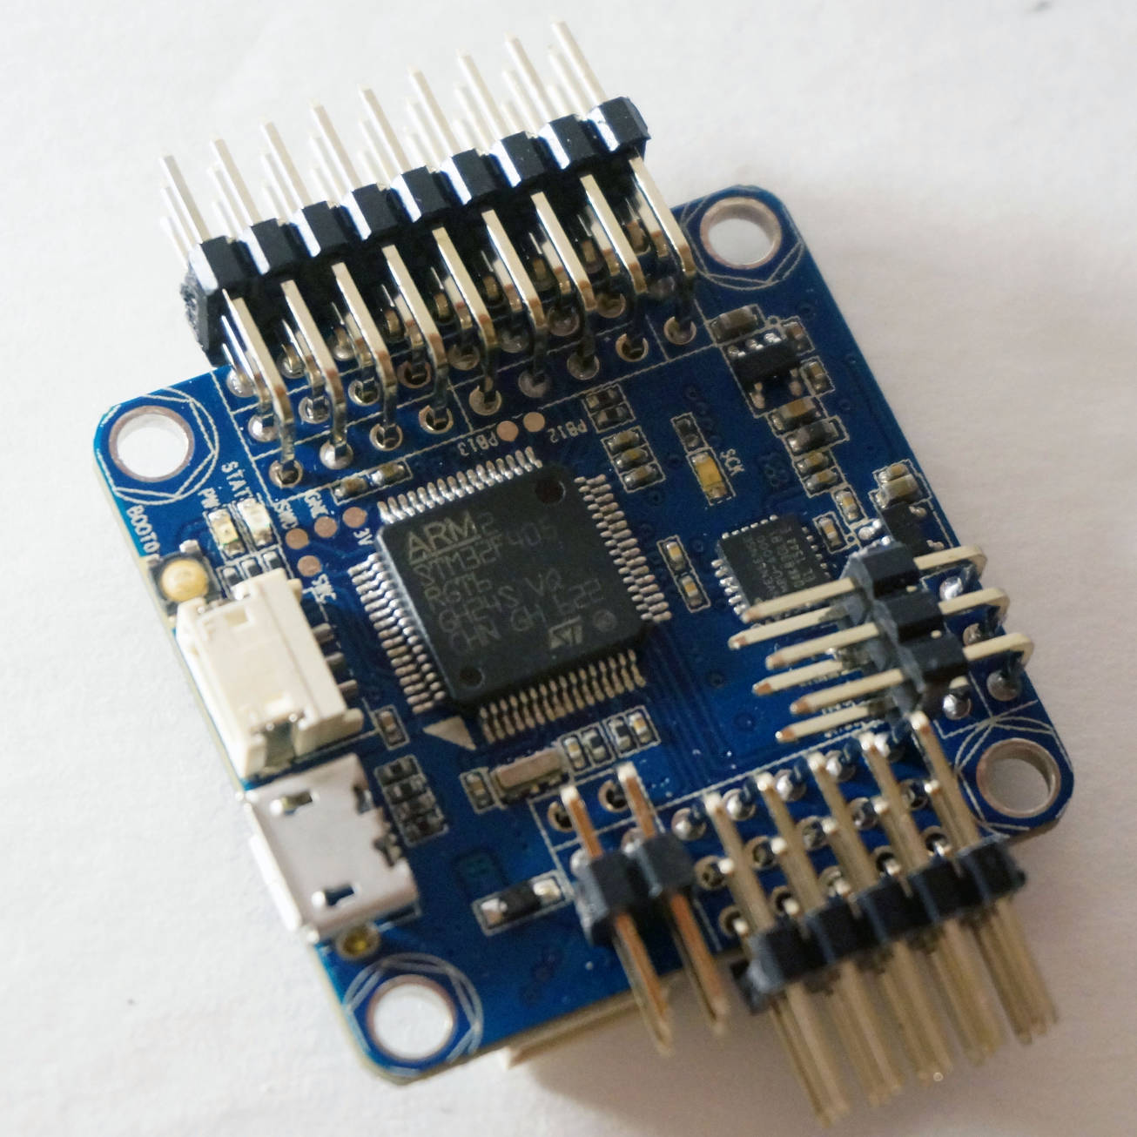

## Key Features

* Main System-on-Chip: [STM32F405RGT6](https://www.st.com/en/microcontrollers/stm32f405rg.html)
  + CPU: 168 MHz ARM Cortex M4 with single-precision FPU
  + RAM: 192 KB SRAM
  + FLASH: 1 MB
* Standard racer form factor: 36x36 mm with standard 30.5 mm hole pattern
* MPU6000 Accel / Gyro
* BMP280 Baro (not all boards have it mounted)
* microSD (logging and parameters)
* Futaba S.BUS and S.BUS2 / Spektrum DSM2 and DSMX / Graupner SUMD / PPM input / Yuneec ST24
* OneShot PWM out (configurable)
* built-in current sensor
* built-in OSD chip (AB7456 via SPI, not supported yet)

## Where to Buy

The board is produced by different vendors, with some variations (e.g. with or without a barometer).

PX4 is compatible with boards that support the Betaflight OMNIBUSF4SD target (if OMNIBUSF4SD is present on the product page the board should work with PX4).

Any Omnibus F4 labeled derivative (e.g. clone) should work as well. However, power distribution on these boards is of varying quality.

These are the boards tested and known to work:

* [Hobbywing XRotor Flight Controller F4](http://www.hobbywing.com/goods.php?id=590)

This board fits on top of the [Hobbywing XRotor Micro 40A 4in1 ESC](http://www.hobbywing.com/goods.php?id=588) without soldering. This ESC board also provides power for the Omnibus board.

Purchase from:

* + [Hobbywing XRotor F4 Flight Controller w/OSD](https://www.getfpv.com/hobbywing-xrotor-f4-flight-controller-w-osd.html) (getfpv)
* Original Airbot Omnibus F4 SD

Purchase from:

* + [Airbot (CN manufacturer)](https://store.myairbot.com/omnibusf4prov3.html)
  + [Ready To Fly Quads (US reseller)](http://www.readytoflyquads.com/flip-32-f4-omnibus-v2-pro)

Accessories include:

* [ESP8266 WiFi Module](https://docs.px4.io/en/telemetry/esp8266_wifi_module.html) for MAVLink telemetry. You need to connect these pins: GND, RX, TX, VCC and CH-PD (CH-PD to 3.3V). The baud rate is 921600.

## Connectors

Boards from different vendors (based on this design) can have significantly different layout. Layouts/Silkscreens for various versions are shown below.

### Airbot Omnibus F4 SD

Below are silkscreens for the Airbot Omnibus F4 SD (V1), showing both top and bottom.

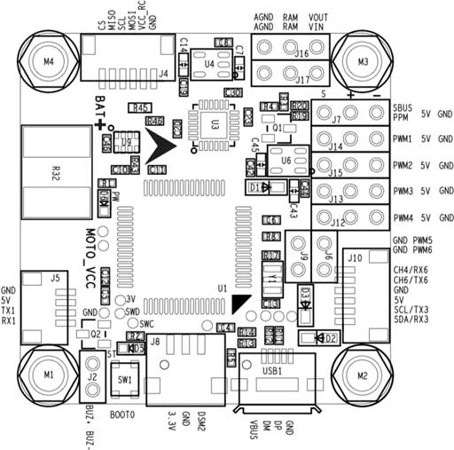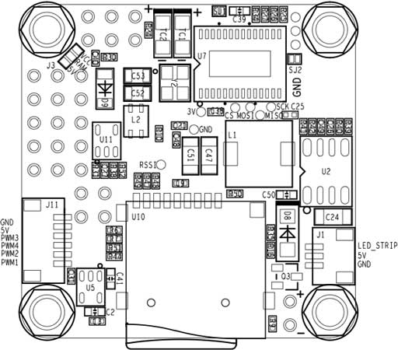

### Hobbywing XRotor Flight Controller F4

Below are silkscreens for the Hobbywing XRotor Flight Controller F4.

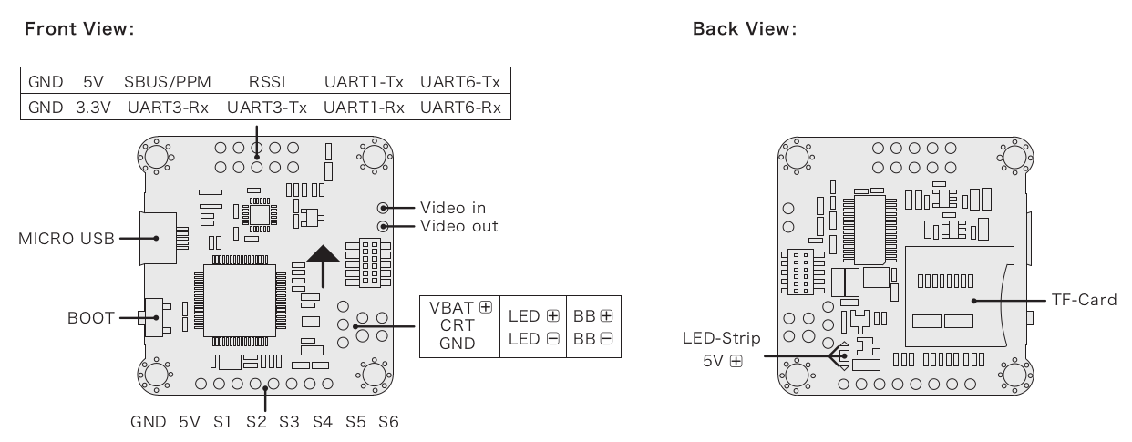

## Pinouts

### Radio Control

RC is connected to one of the following ports:

* UART1
* SBUS/PPM port (via inverter, internally goes to UART1)

Some Omnibus F4 boards have a jumper connecting either or both the MCU SBUS and PPM to a single pin header. Set your jumper or solder bridge to the appropriate MCU pin before use.

### UARTs

* UART6: GPS port
  + TX: MCU pin PC6
  + RX: MCU pin PC7
  + Airbot Omnibus F4 SD Pinout is on Port J10 (TX6/RX6):

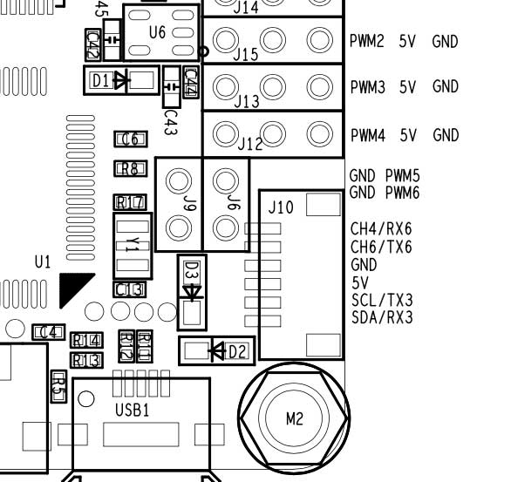

* UART4
  + TX: MCU pin PA0
  + RX: MCU pin PA1
  + 57600 baud
  + This can be configured as the TELEM 2 port.
  + Airbot Omnibus F4 SD Pinout:
    - TX: RSSI pin
    - RX: PWM out 5

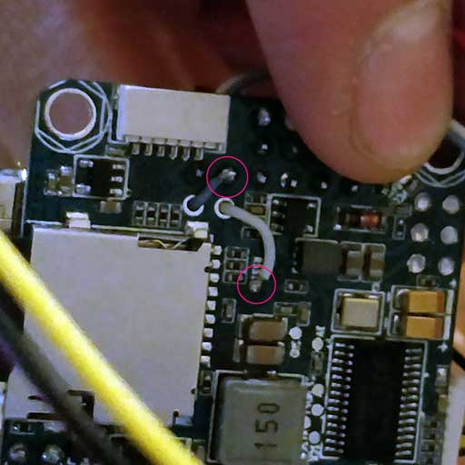

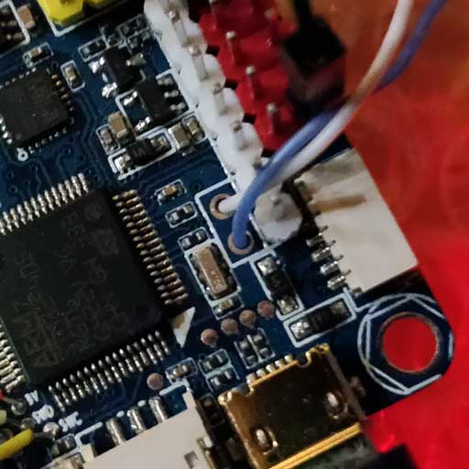

### I2C

There is one I2C port available via:

* SCL: MCU pin PB10 (might be labeled as TX3)
* SDA: MCU pin PB11 (might be labeled as RX3)

You will need external pullups on both signals (clock and data). You can use 2.2k pullups for example to attach an external mag.

* Airbot Omnibus F4 SD Pinout is on Port J10 (SCL [clock] / SCA [data]): 

Here is an example implementation. I used a Spektrum plug to get 3.3v from the DSM port, connecting only 3.3v + to each line via 2.2k resistor.

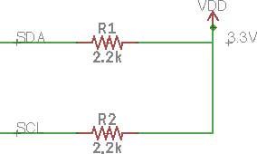

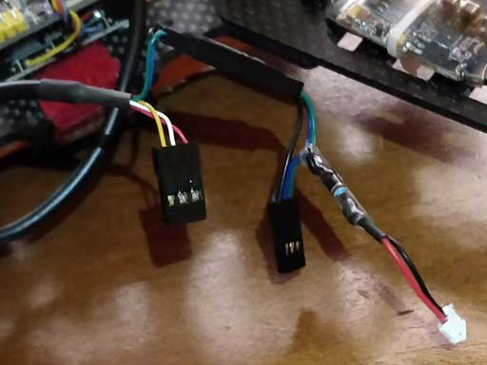

## RC Telemetry

The Omnibus supports telemetry to the RC Transmitter using [FrSky Telemetry](https://docs.px4.io/en/peripherals/frsky_telemetry.html) or [CRSF Crossfire Telemetry](https://docs.px4.io/en/flight_controller/omnibus_f4_sd.html#crsf_telemetry).

### CRSF Crossfire Telemetry

TBS CRSF Crossfire telemetry is used to send telemetry data from the flight controller (the vehicle's attitude, battery, flight mode and GPS data) to the RC transmitter (Taranis).

Benefits over FrSky telemetry include:

* Only a single UART is needed for RC and telemetry.
* The CRSF protocol is optimized for low latency.
* 150 Hz RC update rate.
* The signals are uninverted and thus no (external) inverter logic is required.

For Omnibus we recommend the [TBS Crossfire Nano RX](http://team-blacksheep.com/products/prod:crossfire_nano_rx), since it is specifically designed for small Quads.

On the handheld controller (e.g. Taranis) you will also need a [Transmitter Module](http://team-blacksheep.com/shop/cat:rc_transmitters#product_listing). This can be plugged into the back of the RC controller.

The referenced links above contains the documentation for the TX/RX modules.

#### Setup

Connect the Nano RX and Omnibus pins as shown:

| **Omnibus UART1** | **Nano RX** |
| --- | --- |
| TX | Ch2 |
| RX | Ch1 |

Nothing else needs to be configured on PX4 flight controller side - the RC protocol is auto-detected.

Next update the TX/RX modules to use the CRSF protocol and set up telemetry. Instructions for this are provided in the [TBS Crossfire Manual](https://www.team-blacksheep.com/tbs-crossfire-manual.pdf) (search for 'Setting up radio for CRSF').

## Schematics

The schematics are provided by [Airbot](https://myairbot.com/): [OmnibusF4-Pro-Sch.pdf](http://bit.ly/obf4pro).

## Build & Upload Instructions

The board comes pre-installed with [Betaflight](https://github.com/betaflight/betaflight/wiki). Before PX4 firmware can be installed, the PX4 bootloader needs to be built and uploaded.

### Download

Download and build the [Bootloader](https://github.com/PX4/Bootloader) via:

git clone --recursive https://github.com/PX4/Bootloader.git

cd Bootloader

make omnibusf4sd_bl

### Flash

You can flash the PX4 bootloader via the [dfu-util](http://dfu-util.sourceforge.net/) or the graphical [dfuse](https://www.st.com/en/development-tools/stsw-stm32080.html) tool on windows.

Don't be afraid to try flashing using any of the below methods. The STM32 MCU cannot be bricked. DFU cannot be overwritten by flashing and will always allow you to install a new firmware, even if flashing fails.

#### Enter DFU mode

Both methods require the board to be in DFU mode. To enter DFU mode, hold the boot button down while connecting the USB cable to your computer. The button can be released after the board is powered up.

#### dfu-util

dfu-util -a 0 --dfuse-address 0x08000000 -D build/omnibusf4sd_bl/omnibusf4sd_bl.bin

Reboot the flight controller and it let it boot without holding the boot button.

#### dfuse

See the dfuse manual is here: <https://www.st.com/resource/en/user_manual/cd00155676.pdf>

Flash the omnibusf4sd_bl.bin file.

#### PX4 Firmware

Build and flash the PX4 Firmware with the following build target:

make omnibus-f4sd_default upload

### Installing other firmwares

If you later on want to switch back to Betaflight, you can easily do that:

* Backup the parameters by copying the **params** file on the SD card (or use another SD card)
* Keep the **bootloader** button pressed while attaching the USB cable
* Then flash Betaflight as usual with the Betaflight-configurator

## Configuration

Make sure to insert an SD card as the parameters are stored there.

In addition to the [basic configuration](https://docs.px4.io/en/config/), the following parameters are important:

| **Parameter** | **Setting** |
| --- | --- |
| [SYS_HAS_MAG](https://docs.px4.io/en/advanced_config/parameter_reference.html#SYS_HAS_MAG) | This should be disabled since the board does not have an internal mag. You can enable it if you attach an external mag. |
| [SYS_HAS_BARO](https://docs.px4.io/en/advanced_config/parameter_reference.html#SYS_HAS_BARO) | Disable this if your board does not have a barometer. |
| [MOT_ORDERING](https://docs.px4.io/en/advanced_config/parameter_reference.html#MOT_ORDERING) | If you use a 4-in-1 ESC with Betaflight/Cleanflight motor assignment, this parameter can be set accordingly. |
|  |  |

## Further Info

A review with further information of the board can be found [here](https://nathan.vertile.com/blog/2016/10/12/omnibusf4/).

[This page](https://blog.dronetrest.com/omnibus-f4-flight-controller-guide/) also provides a nice overview with pinouts and setup instructions.

# Snapdragon Flight Autopilot

The Qualcomm Snapdragon Flight platform is a high-end autopilot / onboard computer which runs the PX4 Flight Stack on the DSP on the QuRT real time operating system using the [DSPAL API](https://github.com/ATLFlight/dspal) for POSIX compatibility. In comparison to [Pixhawk](https://docs.px4.io/en/flight_controller/pixhawk.html) it adds a camera and WiFi and high-end processing power, and different IO.

More information about the Snapdragon Flight platform is in the official [Qualcomm® Snapdragon™ Flight Kit](https://www.intrinsyc.com/qualcomm-snapdragon-flight-details/) documentation.

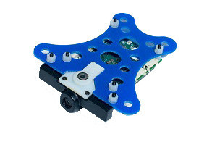

## Quick Summary

* System-on-Chip: [Snapdragon 801](https://www.qualcomm.com/products/snapdragon/processors/801)
  + CPU: Quad-core 2.26 GHz Krait
  + DSP: Hexagon DSP (QDSP6 V5A) – 801 MHz+256KL2 (running the flight code)
  + GPU: Qualcomm® Adreno™ 330 GPU
  + RAM: 2GB LPDDR3 PoP @931 MHz
* Storage: 32GB eMMC Flash
* Video: Sony IMX135 on Liteon Module 12P1BAD11
  + 4k@30fps 3840×2160 video capture to SD card with H.264 @ 100Mbits (1080p/60 with parallel FPV), 720p FPV
* Optic Flow: Omnivision OV7251 on Sunny Module MD102A-200
  + 640x480 @ 30/60/90 fps
* Wifi: Qualcomm® VIVE™ 1-stream 802.11n/ac with MU-MIMO † Integrated digital core
* BT/WiFi: BT 4.0 and 2G/5G WiFi via QCA6234
  + 802.11n, 2×2 MIMO with 2 uCOAX connectors on-board for connection to external antenna
* GPS: Telit Jupiter SE868 V2 module (use of an external u-Blox module is recommended by PX4 instead)
  + uCOAX connector on-board for connection to external GPS patch antenna
  + CSR SiRFstarV @ 5Hz via UART
* Accelerometer / Gyro / Mag: Invensense MPU-9250 9-Axis Sensor, 3x3mm QFN, on bus SPI1
* Baro: Bosch BMP280 barometric pressure sensor, on bus I2C3
* Power: 5VDC via external 2S-6S battery regulated down to 5V via APM adapter
* Availability: [Intrinsyc Store](http://shop.intrinsyc.com/products/snapdragon-flight-dev-kit)

## Connectivity

* One USB 3.0 OTG port (micro-A/B)
* Micro SD card slot
* Gimbal connector (PWB/GND/BLSP)
* ESC connector (2W UART)
* I2C
* 60-pin high speed Samtec QSH-030-01-L-D-A-K expansion connector
  + 2x BLSP ([BAM Low Speed Peripheral](http://www.inforcecomputing.com/public_docs/BLSPs_on_Inforce_6540_6501_Snapdragon_805.pdf))
  + USB

## Recommended Wiring

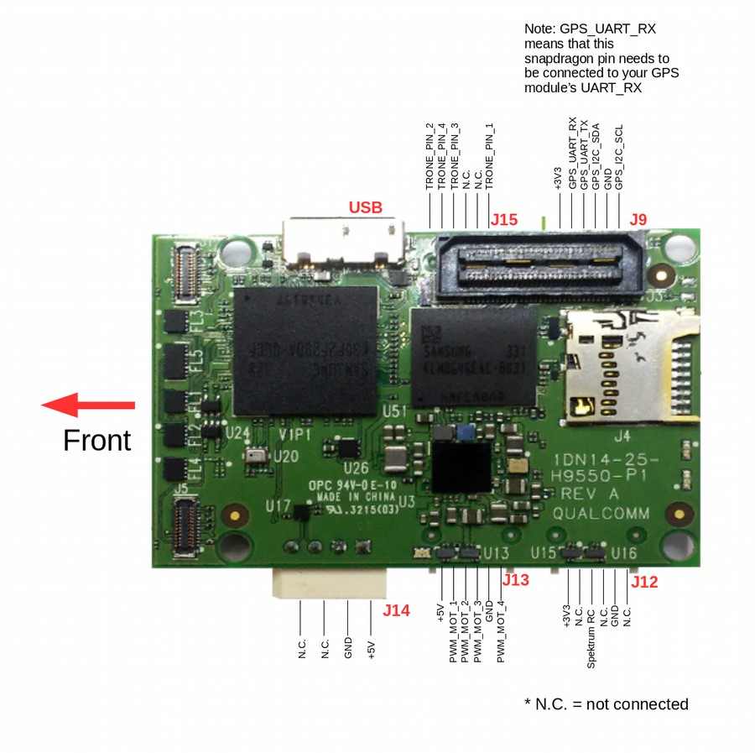

## Pinouts

Although the Snapdragon uses DF13 connectors, the pinout is different from Pixhawk.

Detailed pinout information can be found here: [Qualcomm Developer Network](https://developer.qualcomm.com/hardware/snapdragon-flight/board-pin-outs).

### WiFi

* WLAN0, WLAN1 (+BT 4.0): U.FL connector: [Taoglas adhesive antenna (DigiKey)](http://www.digikey.com/product-detail/en/FXP840.07.0055B/931-1222-ND/3877414)

### Connectors

The default mapping of the serial ports is as follows:

| **Device** | **Description** |
| --- | --- |
| /dev/tty-1 | J15 (next to USB) |
| /dev/tty-2 | J13 (next to power module connector) |
| /dev/tty-3 | J12 (next to J13) |
| /dev/tty-4 | J9 (next to J15) |

For a custom UART to BAM mapping, create a file called **blsp.config** and adb push it to **/usr/share/data/adsp**. For example, to keep the default mapping, your **blsp.config** should look as follows:

tty-1 bam-9 2-wire

tty-2 bam-6 2-wire

tty-3 bam-8 2-wire

tty-4 bam-2 2-wire

Be sure to include the text "2-wire" at the end of each line to allow the UART to use only the TX and RX pins specified in the tables below. If 2-wire is not specified (or if the file is not present on the target) the UART will default to using 4-wire mode and will require an additional two pins for RTS/CTS flow control.  
This will cause a problem for any other type of I/O on the same connector, since the pins will be configured as RTS and CTS signals. If, for example, J9 (described below) was being used to connect to both a UART and an I2C device, the I2C signals on pin 4 and pin 6 would be configured as RTS and CTS signals, overriding the I2C SDA and SCL signals.

#### J9 / GPS

| **Pin** | **2-wire UART + I2C** | **4-wire UART** | **SPI** | **Comment** |  |
| --- | --- | --- | --- | --- | --- |
| 1 | 3.3V | 3.3V | 3.3V |  |  |
| 2 | UART2_TX | UART2_TX | SPI2_MOSI | Output (3.3V) |  |
| 3 | UART2_RX | UART2_RX | SPI2_MISO | Input (3.3V) |  |
| 4 | I2C2_SDA | UART2_RTS | SPI2_CS | (3.3V) |  |
| 5 | GND | GND | GND |  |  |
| 6 | I2C2_SCL | UART2_CTS | SPI2_CLK | (3.3V) |  |

#### 

#### J12 / Gimbal bus

| **Pin** | **2-wire UART + GPIO** | **4-wire UART** | **SPI** | **Comment** |
| --- | --- | --- | --- | --- |
| 1 | 3.3V | 3.3V | 3.3V |  |
| 2 | UART8_TX | UART8_TX | SPI8_MOSI | Output (3.3V) |
| 3 | UART8_RX | UART8_RX | SPI8_MISO | Input (3.3V) |
| 4 | APQ_GPIO_47 | UART8_RTS | SPI8_CS | (3.3V) |
| 5 | GND | GND | GND |  |
| 6 | APQ_GPIO_48 | UART8_CTS | SPI8_CLK | (3.3V) |

#### 

#### J13 / ESC bus

| **Pin** | **2-wire UART + GPIO** | **4-wire UART** | **SPI** | **Comment** |
| --- | --- | --- | --- | --- |
| 1 | 5V | 5V | 5V |  |
| 2 | UART6_TX | UART6_TX | SPI6_MOSI | Output(5V) |
| 3 | UART6_RX | UART6_RX | SPI6_MISO | Input(5V) |
| 4 | APQ_GPIO_29 | UART6_RTS | SPI6_CS | (5V) |
| 5 | GND | GND | GND |  |
| 6 | APQ_GPIO_30 | UART6_CTS | SPI6_CLK | (5V) |

#### 

#### J14 / Power

| **Pin** | **Signal** | **Comment** |
| --- | --- | --- |
| 1 | 5V DC | Power input |
| 2 | GND |  |
| 3 | I2C3_SCL | (5V) |
| 4 | I2C3_SDA | (5V) |

#### J15 / Radio Receiver / Sensors

| **Pin** | **2-wire UART + I2C** | **4-wire UART** | **SPI** | **Comment** |
| --- | --- | --- | --- | --- |
| 1 | 3.3V | 3.3V | 3.3V |  |
| 2 | UART9_TX | UART9_TX | SPI9_MOSI | Output |
| 3 | UART9_RX | UART9_RX | SPI9_MISO | Input |
| 4 | I2C9_SDA | UART9_RTS | SPI9_CS |  |
| 5 | GND | GND | GND |  |
| 6 | I2C9_SCL | UART9_CTS | SPI9_CLK |  |

## 

## Dimensions

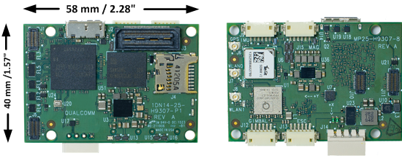

# Snapdragon Hardware Setup Example

This guide shows a Lumenier QAV-R 250 frame build with Qualcomm Snapdragon Flight and custom hardware mounts. The setup uses a conventional PWM ESC board and therefore needs to be built with the eagle_default make target (see instructions [here](https://dev.px4.io/en/setup/building_px4.html#qurt--snapdragon-based-boards)).

The PX4 development team has built, tested and documented this specific setup.

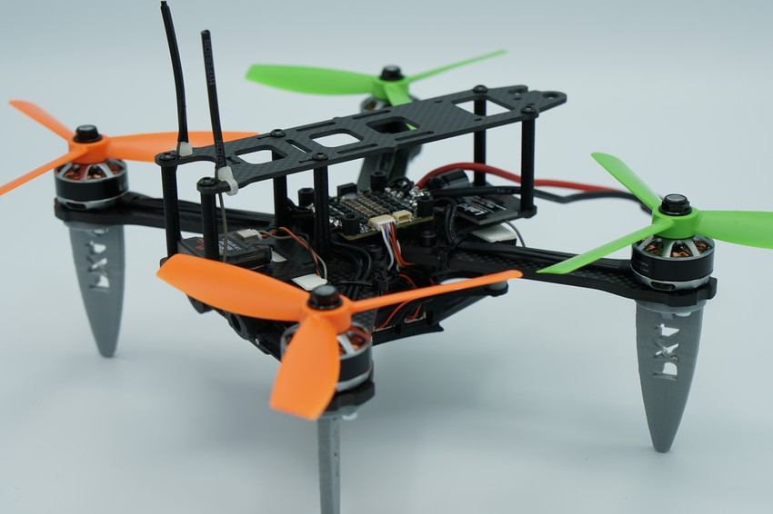

## Components

* Flight Controller: [Snapdragon Flight](https://www.intrinsyc.com/vertical-development-platforms/qualcomm-snapdragon-flight/)
* Stereo-vision add-on kit ([available here](https://www.intrinsyc.com/vertical-development-platforms/qualcomm-snapdragon-flight/))
* Frame: [Lumenier QAV-R 250](https://www.getfpv.com/qav-r-fpv-racing-quadcopter-5.html)
* ESC: [Hobbywing 4in1 40A](https://www.getfpv.com/hobbywing-xrotor-micro-4-in-1-blheli-s-dshot600-esc.html)
* Motors: [Lumenier RX2206 2350KV](https://www.getfpv.com/lumenier-rx2206-11-2350kv-motor.html)
* Receiver: [Spektrum RC FPV Racing Serial Receiver](https://www.spektrumrc.com/Products/Default.aspx?ProdID=SPM4648)
* Wi-Fi Antenna: [Laird Multiband](https://www.lairdtech.com/products/maf95056-nanoblade-internal-embedded-antenna-2400-2500-4900-6000-mhz)
* GPS module (optional): [mRo GPS + Compass module](https://store.mrobotics.io/mRo-GPS-u-Blox-Neo-M8N-HMC5983-Compass-p/gps002-mr.htm)
* Distance sensor (optional): [TeraRanger One](http://www.teraranger.com/product/teraranger-one-distance-sensor-for-drones-and-robotics)
* Distance sensor adapter (required only when using TeraRanger): [I2C Adapter](http://www.teraranger.com/product/adapters-for-oneduo/)
* Custom printed parts: [Legs, Mounting brackets](https://drive.google.com/drive/u/0/folders/1MOunJae4ZLu6-bZ_-JvcPQUc9Aa5fe1U)

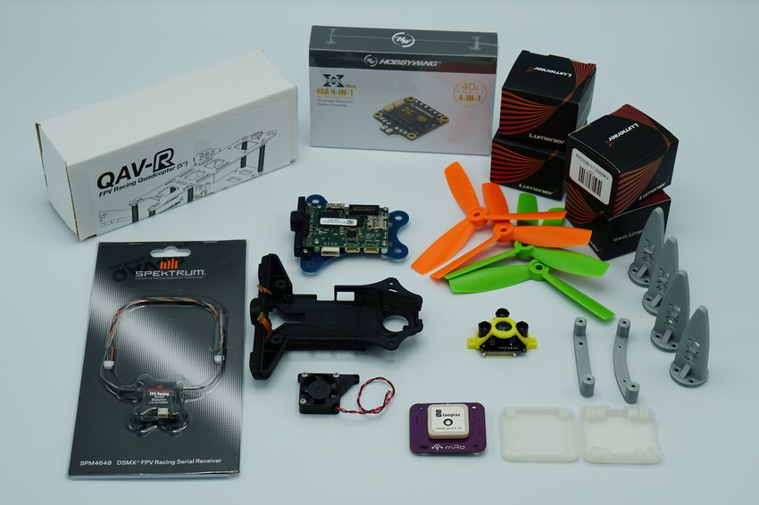

## Wiring

Although the Snapdragon uses DF13 connectors, the [pinout](https://docs.px4.io/en/flight_controller/snapdragon_flight.html#pinouts) is different from Pixhawk.



## Building the Frame

The Lumenier QAV-R250 can be assembled normally, ignoring the side-plates intended for the FPV camera mount. In order to mount the motors along with the custom printed legs, you will need longer screws than the ones provided with the motors. Regular M3x10mm screws will do.

Snapdragon is very susceptible to frame vibrations. Make sure to tighten all screws well, but not so much that you damage the windings in the plastic nut on the other end.

The Hobbywing 4in1 ESC fits the frame tidily as seen in the picture below.

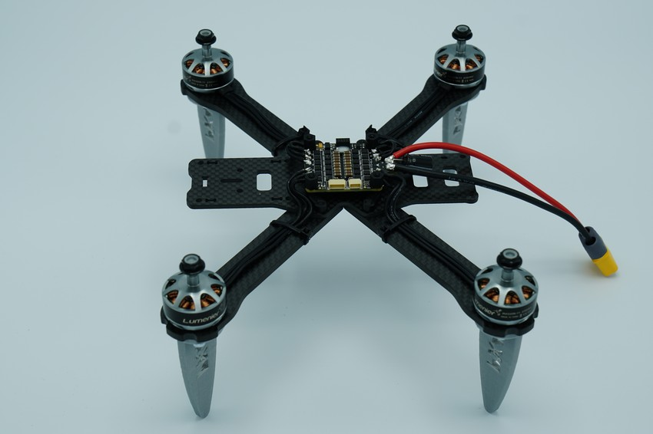

To attach the Snapdragon Flight to the frame, first port it over to the stereo-vision add-on kit's mounting plate. This task is quite delicate, make sure not to damage the cameras when taking them out of the old plastic housing. We recommend attaching the Wi-Fi antenna's uFL connector during this step, as it will become incredibly difficult to do so once the Snapdragon is in its new housing.

We are using the stereo-vision add-on kit, as it is easier to mount to the QAV-250 and we may be using stereo-vision in the future. However, currently the stereo-functionality is not being enabled.

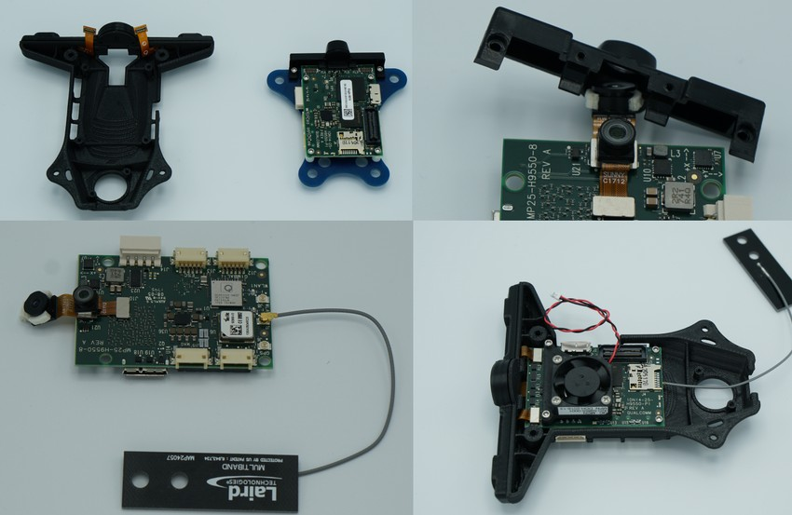

After the Snapdragon is mounted on the new housing, screw on the two custom printed brackets using the spare M3 screws of the Lumenier frame. Again, since you are putting metal screws into plastic, don't tighten them to the extend that you damage the plastic and the screws no longer have any traction.

Finally, attach the brackets to the frame using double-sided tape. We achieved best performance when using two strips of vibration-dampening foam in between the carbon frame and the custom mounting brackets for the stereo-vision part. Cutting two strips out of the piece provided with the QAV-R frame works well.

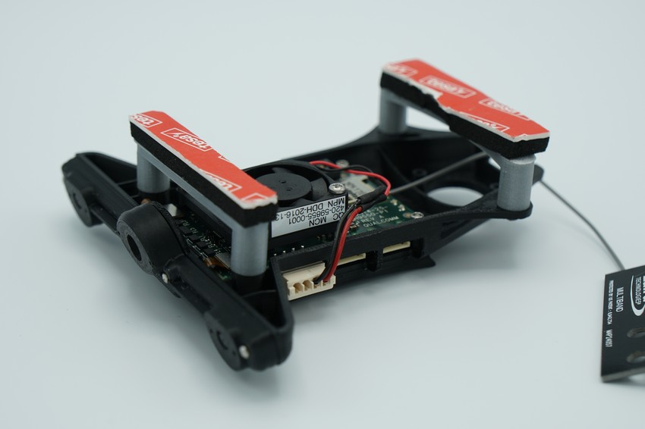

You can additionally mount the GPS module and TeraRanger module, but they are not required for normal VIO-based flight. More information about range finders can be found [here](https://docs.px4.io/en/sensor/rangefinders.html#teraranger-rangefinders). You can now attach the Snapdragon module to the QAV frame and connect the ESC and receiver.

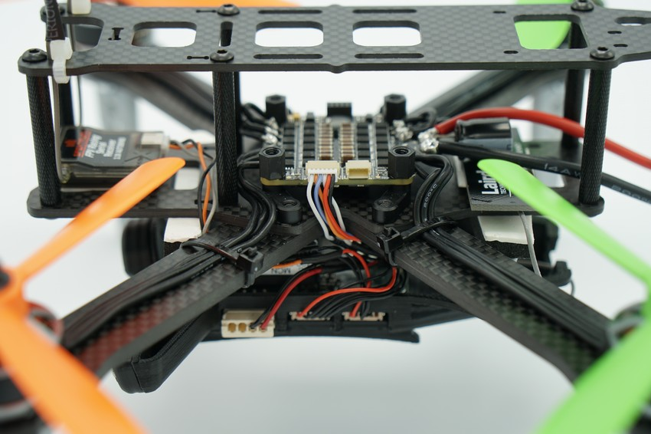

# **Snapdragon Development Environment Installation**

This topic explains how to set up the Qualcomm Snapdragon Flight development toolchain on a Linux computer.

The firmware for the Qualcomm Snapdragon Flight must be built manually (Firmware is not supplied for automatic download via QGroundControl).

## Set up Development Environment

To set up the development environment:

1. Add your user to the dialout group:

sudo usermod -a -G dialout $USER

1. Log out and back in.
2. Download the [ubuntu_sim_common_deps.sh](https://raw.githubusercontent.com/PX4/Devguide/master/build_scripts/ubuntu_sim_common_deps.sh) script and run it on your machine:

cd ~

wgethttps://raw.githubusercontent.com/PX4/Devguide/master/build_scripts/ubuntu_sim_common_deps.sh ~

sudo chmod +x ubuntu_sim_common_deps.sh

./ubuntu_sim_common_deps.sh

## Cross-toolchain & Hexagon SDK

To install the Cross-Toolchain and Hexagon SDK:

1. Start by installing some dependencies:

sudo apt-get install android-tools-adb android-tools-fastboot \

fakechroot fakeroot unzip xz-utils wget python python-empy -y

1. Clone the cross_toolchain repo:

git clone https://github.com/ATLFlight/cross_toolchain.git

cd cross_toolchain

1. Download the Hexagon SDK v3.0 from [here](https://developer.qualcomm.com/software/hexagon-dsp-sdk/tools) to your cross_toolchain/downloads location (you will need to create an account if you don't have one).
2. Download the latest version of the qrlSDK file from [here](https://support.intrinsyc.com/projects/snapdragon-flight/files) to your cross_toolchain/downloads location (you need to create an account if you don't have one).
3. Run the installer:

./installsdk.sh --APQ8074 --arm-gcc --qrlSDK

1. The installer tells you to set a few environment variables. Append these to your ~/.bashrc:

export HEXAGON_SDK_ROOT=/home/<YOUR_LINUX_USERNAME>/Qualcomm/Hexagon_SDK/3.0

export HEXAGON_TOOLS_ROOT=/home/<YOUR_LINUX_USERNAME>/Qualcomm/HEXAGON_Tools/7.2.12/Tools

export HEXAGON_ARM_SYSROOT=/home/<YOUR_LINUX_USERNAME>/Qualcomm/qrlinux_sysroot

export ARM_CROSS_GCC_ROOT=/home/<YOUR_LINUX_USERNAME>/Qualcomm/ARM_Tools/gcc-4.9-2014.11

Don't forget to source it:

source ~/.bashrc

# Installing Software on the Snapdragon

To get the platform running with the complete VIO system running, multiple pieces are required. The following is an overview of the different versions used. Detailed installation instructions are provided below.

| **Software** | **Tested version** | **Link/commit ID** |
| --- | --- | --- |
| ROS | indigo | [here](http://wiki.ros.org/indigo) |
| MAVROS | 0.23.1 | [here](https://github.com/mavlink/mavros/tree/0.23.1) |
| MAVLink | release/kinetic/mavlink/2018.5.5-0 | [here](https://github.com/mavlink/mavlink-gbp-release/tree/upstream/2018.5.5) |
| PX4 | master | [here](https://github.com/PX4/Firmware) |
| Snap VIO | master | [here](https://github.com/PX4/ros-examples) |
| Snapdragon-Linux | 3.1.3.1 | [here](https://support.intrinsyc.com/projects/snapdragon-flight/files) |
| DSP Firmware | 3.1.3.1 | [here](https://support.intrinsyc.com/projects/snapdragon-flight/files) |
| Qualcomm MV | 1.0.2 | [here](https://developer.qualcomm.com/sdflight-tools) |

## Prevent Bricking

To prevent the system from hanging on boot because of anything wrong with the ADSP firmware, do the following changes before going any further. Plug your snapdragon into your computer via USB and open the android debug shell:

adb shell

Note that the Snapdragon Flight needs to be powered by an external power source. The power over USB is not sufficient. As always, take your props off before you apply power!

Edit the file **/usr/local/qr-linux/q6-admin.sh**:

vim /usr/local/qr-linux/q6-admin.sh

Comment out the following lines:

# Wait for adsp.mdt to show up

#while [ ! -s /lib/firmware/adsp.mdt ]; do

# sleep 0.1

#done

Finally:

# Don't leave until ADSP is up

#while [ "`cat /sys/kernel/debug/msm_subsys/adsp`" != "2" ]; do

# sleep 0.1

#done

## Update Linux Image

Updating the Linux image on your Snapdragon will erase everything.

Get the latest Flight_x.x_JFlash.zip from [here](https://support.intrinsyc.com/projects/snapdragon-flight/files) and unzip it. In the unzipped folder is a script that has to be used to update the Linux image. Power your Snapdragon Flight, connect it using a micro USB cable and run:

sudo ./jflash.sh

## Update DSP Processor Firmware

Get the latest **Flight_x.x_qcom_flight_controller_hexagon_sdk_add_on.zip** from [here](https://support.intrinsyc.com/projects/snapdragon-flight/files) and unzip it.

In the unzipped folder, run:

./installfcaddon.sh

adb shell

sudo reboot

## Clone PX4 Firmware & Build

On your PC, clone the PX4 firmware repo and build it as described below.

If you haven't yet cloned the Firmware repo:

cd ~

mkdir src

cd src

git clone git@github.com:PX4/Firmware.git

Once you're in your local copy of the Firmware:

cd Firmware

git submodule update --init --recursive

export FC_ADDON=<location-of-extracted-flight-controller-addon>

make clean

make eagle_default

make eagle_default upload

adb push ROMFS/px4fmu_common/mixers/quad_x.main.mix /usr/share/data/ad네

## Install ROS

Set up your Snapdragon Flight to connect to your local Wi-Fi network so you can easily clone git repositories directly onto it. To do so, open an adb shell and edit the file /etc/wpa_supplicant/wpa_supplicant.conf and add your local network settings:

adb shell

vim /etc/wpa_supplicant/wpa_supplicant.conf

There, add your Wi-Fi settings:

network={

ssid="my existing network ssid"

psk="my existing password"

}

Finally, set the system to station mode. Also, editing the station network interface config file will keep your ssh terminal from lagging: (all inside adb shell)

/usr/local/qr-linux/wificonfig.sh -s station

echo 'wireless-power off' |sudo tee -a /etc/network/interfaces.d/.qca6234.cfg.station

sudo reboot

Now, to install ROS, start by setting your locale, **sources.list** and keys (in adb or ssh shell)

export LANGUAGE=en_US.UTF-8

export LANG=en_US.UTF-8

sudo locale-gen en_US.UTF-8

sudo dpkg-reconfigure locales

sudo update-locale LANG=C LANGUAGE=C LC_ALL=C LC_MESSAGES=POSIX

sudo sh -c 'echo "deb http://packages.ros.org/ros/ubuntu trusty main" > /etc/apt/sources.list.d/ros-latest.list'

sudo apt-key adv --keyserver hkp://ha.pool.sks-keyservers.net:80 --recv-key 421C365BD9FF1F717815A3895523BAEEB01FA116

sudo apt-get update

sudo apt-get install ros-indigo-ros-base #(yields error)

sudo apt-get -f -o Dpkg::Options::="--force-overwrite" install

Edit your ~/.bashrc to source the ros environment:

sudo chown -R linaro /home/linaro

echo "source /opt/ros/indigo/setup.bash" >> /home/linaro/.bashrc

source .bashrc

## Install some Extra Packages

Before you can use ROS, you will need to initialize rosdep. Rosdep enables you to easily install system dependencies for source you want to compile and is required to run some core components in ROS:

sudo rosdep init

rosdep update

After installing ROS, the OpenCL library gets installed by ROS as well which causes a conflict with camera pipeline. To fix this, do the following:

sudo dpkg -r libhwloc-plugins

sudo dpkg -r ocl-icd-libopencl1:armhf

Now, set up your workspace:

source .bashrc

mkdir -p /home/linaro/ros_ws/src

cd ros_ws/src

catkin_init_workspace

cd ..

## Create a Swap Directory on the Snapdragon

In order not to run out of memory during compilation of MAVROS, you need to create a swap file:

sudo fallocate -l 1G /mnt/1GB.swap

sudo mkswap /mnt/1GB.swap

sudo swapon /mnt/1GB.swap

echo '/mnt/1GB.swap none swap sw 0 0' |sudo tee -a /etc/fstab

## Install MAVROS & MAVLink

In order to get MAVROS and MAVLink running, you need to install some Python tools and then clone the code and check out the proper commits for compatibility.

sudo apt-get install python-pip

sudo apt-get install python-rosinstall

sudo apt-get update

sudo apt-get install python-rosinstall-generator

sudo apt-get install python-catkin-tools

rosinstall_generator --rosdistro kinetic mavlink | tee /tmp/mavros.rosinstall

rosinstall_generator --rosdistro kinetic --upstream mavros | tee -a /tmp/mavros.rosinstall

wstool init src

wstool merge -t src /tmp/mavros.rosinstall

wstool update -t src -j4

rosdep update

sudo rosdep install --rosdistro indigo --from-paths src --ignore-src -y

cd src/mavros

git checkout 0.23.1

cd ../mavlink

git checkout release/kinetic/mavlink/2018.5.5-0

cd ../..

catkin build

echo 'source /home/linaro/ros_ws/devel/setup.bash' >> /home/linaro/.bashrc

source ../bashrc

catkin build is necessary because it creates the /home/linaro/ros_ws/devel directory. This is where the generated libraries and the executables will be generated. It also generates a new bash setup script which includes the appropriate environment variables for using the "ros_ws" workspace.

### Install geographiclib

MAVROS requires geographiclib to be installed on the system. Follow these steps to install it on the Snapdragon:

mkdir -p /usr/share/geographiclib

/home/linaro/ros_ws/src/mavros/mavros/scripts/install_geographiclib_datasets.sh

mkdir /usr/share/geographiclib/GeographicLib

cd /usr/share/geographiclib

mv geoids/ GeographicLib/

## Install Snap VIO

First, download (to your PC) version 1.0.2 Snapdragon Machine Vision SDK from [here](https://developer.qualcomm.com/sdflight-tools). The package name will be: **mv<version>.deb**.

Push the deb package to the snapdragon and install it:

adb push mv<version>.deb /home/linaro

adb shell sync

adb shell

dpkg -i /home/linaro/mv<version>.deb

mkdir /opt/qcom-licenses

The Machine Vision SDK will need a license file to run. Obtain a research and development license file from [here](https://developer.qualcomm.com/sdflight-key-req). The license file needs to be placed in the following folder on target: **/opt/qcom-licenses/**.

Push the license file to the target using the following command:

adb push snapdragon-flight-license.bin /opt/qcom-licenses/

adb shell sync

Now, we are ready to clone the snap vislam node:

adb shell

cd ~/ros_ws/src

git clone https://github.com/PX4/ros-examples

catkin build

# Configure Snapdragon

This topic explains how to configure the Qualcomm Snapdragon Flight.

## Autostart PX4 and Snap VIO

In order to boot both the ROS node and PX4 automatically on bootup, edit the **/etc/rc.local** file on the Snapdragon Flight to look like this (note that the first line must change too!):

#!/bin/bash -e

#

# rc.local

#

# This script is executed at the end of each multiuser runlevel.

# Make sure that the script will "exit 0" on success or any other

# value on error.

#

# In order to enable or disable this script just change the execution

# bits.

#

# By default this script does nothing.

# Generate the SSH keys if non-existent

test -f /etc/ssh/ssh_host_dsa_key || dpkg-reconfigure openssh-server

# Prepare the ROS environment

cd /home/linaro

source /opt/ros/indigo/setup.bash

source /home/linaro/ros_ws/devel/setup.bash

# Launch the mavros vislam node but add some delay otherwise startup is not reliable

sleep 5

roslaunch snapdragon_mavros_vislam mavros_vislam.launch > /dev/null &

# Launch PX4 autopilot in VIO configuration but add some delay otherwise startup is not reliable

sleep 5

./px4 /home/linaro/ros_ws/src/ros-examples/px4_configs/ekf2/mainapp.conf > /dev/null &

exit 0

## Put Snapdragon back into Access Point Mode

The Snapdragon Flight was set to station mode in the [ROS Setup](https://docs.px4.io/en/flight_controller/snapdragon_flight_software_installation.html#install-ros). This could be a problem if you want to fly it outdoors where your home Wi-Fi is no longer available, so we recommend putting it back into access point mode.

/usr/local/qr-linux/wificonfig.sh -s softap

sudo reboot

## Adjust Parameters

| **Parameter Name** | **Recommended Value** |
| --- | --- |
| EKF2_HEIGHT_MODE | 3 VISION |
| EKF2_AID_MASK | 24 (VISION POS, VISION YAW) |
| MPC_THR_HOVER | 25 % |
| MC_PITCHRATE_P | 0.03 |
| MC_PITCHRATE_D | 0.001 |
| MC_ROLLRATE_P | 0.03 |
| MC_ROLLRATE_D | 0.001 |
| MC_RAWRATE_P | 0.08 |
| EKF2_IMU_POS_Z | 0.030m |
| EKF2_EV_POS_Z | 0.03m |
| PWM_MIN | 1150us |

# Snapdragon Advanced

This page is a collection of useful commands and instructions which might come in handy when working with the Snapdragon platform.

## Connect to Snapdragon

### Over FTDI

Connect the small debug header shipped with the Snapdragon and the FTDI cable.

On Linux, open a console using:

screen /dev/ttyUSB0 115200

Change USB0 to whatever it happens to be. Check /dev/ or /dev/serial/by-id.

### Over ADB (Android Debug Bridge)

Connect the Snapdragon over USB2.0 and power it up using the power module. When the Snapdragon is running the, the LED will be slowly blinking (breathing) in blue.

Make sure the board can be found using adb:

adb devices

If you cannot see the device, it is most likely a USB device permission issue. Follow the instructions

To get a shell, do:

adb shell

### DSP Debug Monitor

You can also run mini-dm provided by hexagon to see the output of the DSP:

${HEXAGON_SDK_ROOT}/tools/debug/mini-dm/Linux_Debug/mini-dm

Alternatively, especially on Mac, you can also use [nano-dm](https://github.com/kevinmehall/nano-dm).

## Serial ports

Not all POSIX calls are currently supported on QURT. Therefore, some custom ioctl are needed.

The APIs to set up and use the UART are described in [dspal](https://github.com/PX4/dspal/blob/master/include/dev_fs_lib_serial.h).

## Wi-Fi settings

These are notes for advanced developers.

Connect to the Linux shell (see [console instructions](https://dev.px4.io/en/debug/system_console.html#snapdragon-flight-wiring-the-console)).

### Access point mode

If you want the Snapdragon to be a wifi access point (AP mode), edit the file: **/etc/hostapd.conf** and set:

ssid=EnterYourSSID

wpa_passphrase=EnterYourPassphrase

The passphrase must be at least 8 characters

Then configure AP mode:

/usr/local/qr-linux/wificonfig.sh -s softap

Reboot

### Station mode

If you want the Snapdragon to connect to your existing wifi, edit the file: **/etc/wpa_supplicant/wpa_supplicant.conf** and add your network settings:

network={

ssid="my existing network ssid"

psk="my existing password"

}

Then configure station mode:

/usr/local/qr-linux/wificonfig.sh -s station

Reboot

## Using the cameras on the Snapdragon Flight

The Snapdragon Flight board has a downward facing gray-scale camera which can be used for optical flow based position stabilization and a forward facing RGB camera. The [snap_cam](https://github.com/PX4/snap_cam) repo offers a way to run and stream the different cameras and calculate the optical flow.

Besides a camera, optical flow requires a downward facing distance sensor. Here, the use of the TeraRanger One is discussed.

### Optical Flow

The optical flow is computed on the application processor and sent to PX4 through MAVLink. Clone and compile the [snap_cam](https://github.com/PX4/snap_cam) repo according to the instructions in its README.

Run the optical flow application (90 frames per second and auto exposure) as root:

./optical_flow -f 90 -a

The optical flow application requires IMU MAVLink messages from PX4. You may have to add an additional MAVLink instance to PX4 by adding the following to your **mainapp.config**:

mavlink start -u 14557 -r 1000000 -t 127.0.0.1 -o 14558

mavlink stream -u 14557 -s HIGHRES_IMU -r 250

### TeraRanger One Setup

To connect the TeraRanger One (TROne) to the Snapdragon Flight, the TROne I2C adapter must be used. The TROne must be flashed with the I2C firmware by the vendor.

The TROne is connected to the Snapdragon Flight through a custom DF13 4-to-6 pin cable. We recommend using connector J15 (next to USB), as all others are already in use (RC, ESCs, GPS). The wiring is as follows:

| **4 pin** | **<->** | **6 pin** |
| --- | --- | --- |
| 1 |  | 1 |
| 2 |  | 6 |
| 3 |  | 4 |
| 4 |  | 5 |

The TROne must be powered with 10 - 20V.

### Camera Streaming in QGroundControl

To watch the live stream of either camera qcamvid can be used. Run the following command on the Snapdragon Flight to stream the hires camera for 10 minutes without recording with a 720p resolution.

qcamvid -c hires -r 720p -s -t 600

Use qcamvid -h to have a look at all the options.

To watch the live stream in QGroundControl, it has to be built with gstreamer (see [here](https://github.com/mavlink/qgroundcontrol/tree/master/src/VideoStreaming)).

Once installed and conneted to the Snapdragon Flight's network, the following changes have to be made in QGroundControl.

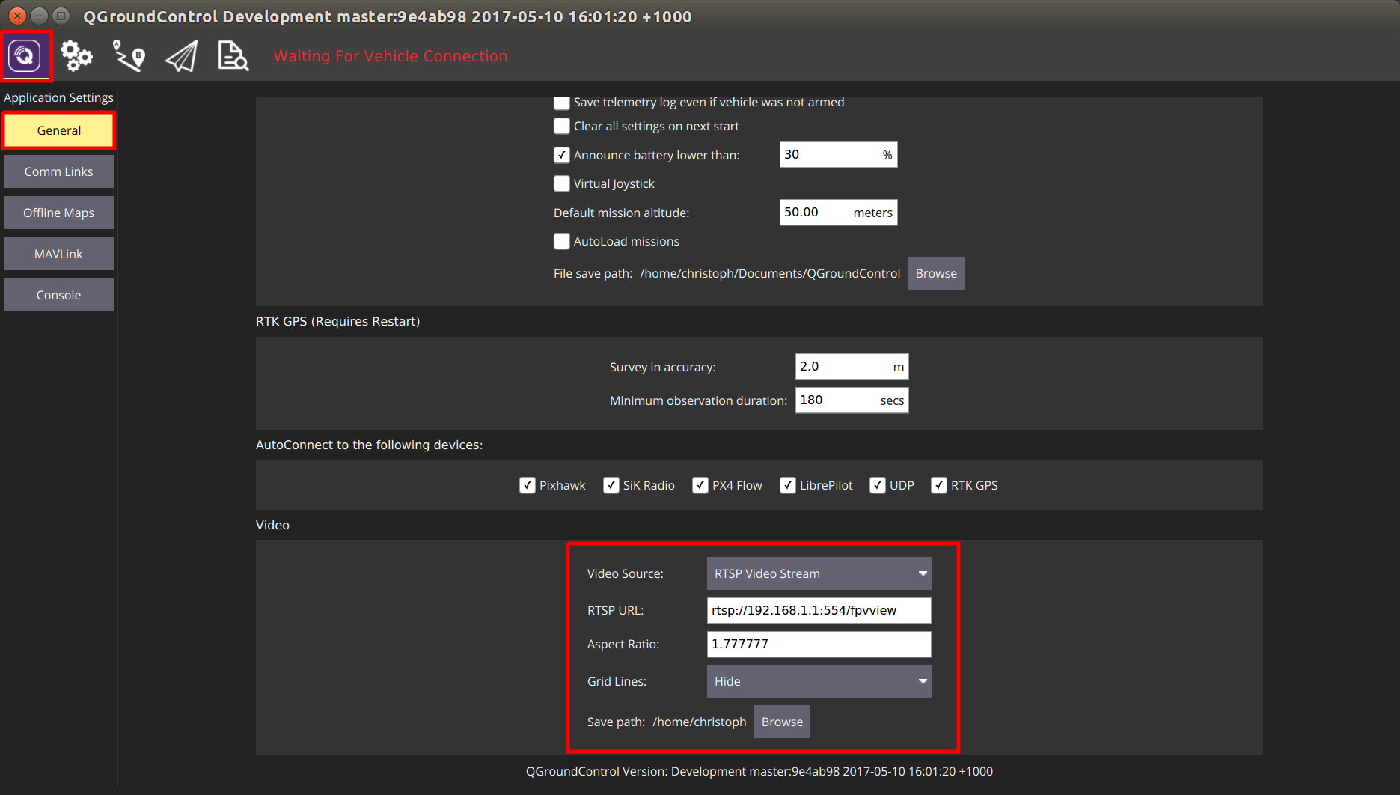

## Accessing I/O Data

Low level bus data can be accessed from code running on the aDSP, using a POSIX-like API called DSPAL. The header files for this API are maintained on [github](https://github.com/ATLFlight/dspal) and are commented with Doxygen formatted documentation in each header file. A description of the API's supported and links to the applicable header files is provided below.

### API Overview

* [Serial:](https://github.com/ATLFlight/dspal/blob/master/include/dev_fs_lib_serial.h)
* [I2C:](https://github.com/ATLFlight/dspal/blob/master/include/dev_fs_lib_i2c.h)
* [SPI:](https://github.com/ATLFlight/dspal/blob/master/include/dev_fs_lib_spi.h)
* [GPIO:](https://github.com/ATLFlight/dspal/blob/master/include/dev_fs_lib_gpio.h)
* Timers: [qurt_timer.h](https://developer.qualcomm.com/software/hexagon-dsp-sdk/tools)
* Power Control: [HAP_power.h](https://developer.qualcomm.com/software/hexagon-dsp-sdk/tools)

### Sample Source Code

The unit test code to verify each DSPAL function also represent good examples for how to call the functions.  
This code is also on [github](https://github.com/ATLFlight/dspal/tree/master/test/dspal_tester)

### Setting the Serial Data Rate

The serial API does not conform to the termios convention for setting data rate through the tcsetattr() function. IOCTL codes are used instead and are described in the header file linked above.

### Timers

Additional functions for more advanced aDSP operations are available with the prefix qurt_.  
Timer functions, for example, are available with the qurt_timer prefix and are documented in the **qurt_timer.h** header file included with the [Hexagon SDK](https://developer.qualcomm.com/software/hexagon-dsp-sdk/tools).

### Setting the Power Level

Using the HAP functions provided by the Hexagon SDK, it is possible to set the power level of the aDSP.  
This will often lead to reduced I/O latencies. More information on these API's is available in the **HAP_power.h** header file available in the [Hexagon SDK](https://developer.qualcomm.com/software/hexagon-dsp-sdk/tools).

## Troubleshooting

### adb does not work

* Check [permissions](https://docs.px4.io/en/flight_controller/snapdragon_flight_advanced.html#usb-permissions)
* Make sure you are using a working Micro-USB cable.
* Try a USB 2.0 port.
* Try front and back ports of your computer.

### USB permissions

1. Create a new permissions file

sudo -i gedit /etc/udev/rules.d/51-android.rules

1. Paste this content, which enables most known devices for ADB access:

SUBSYSTEM=="usb", ATTRS{idVendor}=="0bb4", MODE="0666", GROUP="plugdev"

SUBSYSTEM=="usb", ATTRS{idVendor}=="0e79", MODE="0666", GROUP="plugdev"

SUBSYSTEM=="usb", ATTRS{idVendor}=="0502", MODE="0666", GROUP="plugdev"

SUBSYSTEM=="usb", ATTRS{idVendor}=="0b05", MODE="0666",GROUP="plugdev"

SUBSYSTEM=="usb", ATTRS{idVendor}=="413c", MODE="0666", GROUP="plugdev"

SUBSYSTEM=="usb", ATTRS{idVendor}=="0489", MODE="0666", GROUP="plugdev"

SUBSYSTEM=="usb", ATTRS{idVendor}=="091e", MODE="0666", GROUP="plugdev"

SUBSYSTEM=="usb", ATTRS{idVendor}=="18d1", MODE="0666", GROUP="plugdev"

SUBSYSTEM=="usb", ATTRS{idVendor}=="0bb4", MODE="0666", GROUP="plugdev"

SUBSYSTEM=="usb", ATTRS{idVendor}=="12d1", MODE="0666", GROUP="plugdev"

SUBSYSTEM=="usb", ATTRS{idVendor}=="24e3", MODE="0666", GROUP="plugdev"

SUBSYSTEM=="usb", ATTRS{idVendor}=="2116", MODE="0666", GROUP="plugdev"

SUBSYSTEM=="usb", ATTRS{idVendor}=="0482", MODE="0666", GROUP="plugdev"

SUBSYSTEM=="usb", ATTRS{idVendor}=="17ef", MODE="0666", GROUP="plugdev"

SUBSYSTEM=="usb", ATTRS{idVendor}=="1004", MODE="0666", GROUP="plugdev"

SUBSYSTEM=="usb", ATTRS{idVendor}=="22b8", MODE="0666", GROUP="plugdev"

SUBSYSTEM=="usb", ATTRS{idVendor}=="0409", MODE="0666", GROUP="plugdev"

SUBSYSTEM=="usb", ATTRS{idVendor}=="2080", MODE="0666", GROUP="plugdev"

SUBSYSTEM=="usb", ATTRS{idVendor}=="0955", MODE="0666", GROUP="plugdev"

SUBSYSTEM=="usb", ATTRS{idVendor}=="2257", MODE="0666", GROUP="plugdev"

SUBSYSTEM=="usb", ATTRS{idVendor}=="10a9", MODE="0666", GROUP="plugdev"

SUBSYSTEM=="usb", ATTRS{idVendor}=="1d4d", MODE="0666", GROUP="plugdev"

SUBSYSTEM=="usb", ATTRS{idVendor}=="0471", MODE="0666", GROUP="plugdev"

SUBSYSTEM=="usb", ATTRS{idVendor}=="04da", MODE="0666", GROUP="plugdev"

SUBSYSTEM=="usb", ATTRS{idVendor}=="05c6", MODE="0666", GROUP="plugdev"

SUBSYSTEM=="usb", ATTRS{idVendor}=="1f53", MODE="0666", GROUP="plugdev"

SUBSYSTEM=="usb", ATTRS{idVendor}=="04e8", MODE="0666", GROUP="plugdev"

SUBSYSTEM=="usb", ATTRS{idVendor}=="04dd", MODE="0666", GROUP="plugdev"

SUBSYSTEM=="usb", ATTRS{idVendor}=="0fce", MODE="0666", GROUP="plugdev"

SUBSYSTEM=="usb", ATTRS{idVendor}=="0930", MODE="0666", GROUP="plugdev"

SUBSYSTEM=="usb", ATTRS{idVendor}=="19d2", MODE="0666", GROUP="plugdev"

1. Set up the right permissions for the file:

sudo chmod a+r /etc/udev/rules.d/51-android.rules

1. Restart the daemon

sudo udevadm control --reload-rules

sudo service udev restart

sudo udevadm trigger

If it still doesn't work, check [this answer on StackOverflow](http://askubuntu.com/questions/461729/ubuntu-is-not-detecting-my-android-device#answer-644222).

### Board doesn't start / is boot-looping / is bricked

If you can still connect to the board using the serial console and get to a prompt such as:

root@linaro-developer:~#

You can get into fastboot (bootloader) mode by entering:

reboot2fastboot

If the serial console is not possible, you can try to connect the Micro USB cable, and enter:

adb wait-for-device && adb reboot bootloader

Then power cycle the board. If you're lucky, adb manages to connect briefly and can send the board into fastboot.

To check if it's in fastboot mode, use:

fastboot devices

Once you managed to get into fastboot mode, you can try [above teps](https://docs.px4.io/en/flight_controller/snapdragon_flight_advanced.html#upgradingreplacing-the-linux-image) to update the Android/Linux image.

If you happen to have a [P2 board](https://docs.px4.io/en/flight_controller/snapdragon_flight_advanced.html#do-i-have-a-p1-or-p2-board), you should be able to reset the Snapdragon to the recovery image by starting up the Snapdragon while shorting the two pins next to where J3 is written (The two rectangular pins in-between the corner hole and the MicroSD card slot almost at the edge of the board.

If everything fails, you probably need to request help from intrinsyc.

### No space left on device

Sometimes make eagle_default upload fails to upload:

failed to copy 'px4' to '/home/linaro/px4': No space left on device

This can happen if ramdumps fill up the disk. To clean up, do:

rm -rf /var/log/ramdump/*

Also, the logs might have filled the space. To delete them, do:

rm -rf /root/log/*

### Undefined PLT symbol

#### _FDtest

If you see the following output on mini-dm when trying to start the px4 program, it means that you need to [update the ADSP firmware](https://docs.px4.io/en/flight_controller/snapdragon_flight_advanced.html#updating-the-adsp-firmware):

[08500/03] 05:10.960 HAP:45:undefined PLT symbol _FDtest (689) /libpx4muorb_skel.so 0303 symbol.c

#### Something Else

If you have changed the source, presumably added functions and you see undefined PLT symbol ... it means that the linking has failed.

* Do the declaration and definition of your function match one to one?
* Is your code actually getting compiled? Is the module listed in the [cmake config](https://github.com/PX4/Firmware/blob/master/cmake/configs/qurt_eagle_default.cmake)?
* Is the (added) file included in the CMakeLists.txt?
* Try adding it to the POSIX build and running the compilation. The POSIX linker will inform you about linking errors at compile/linking time.

### krait update param XXX failed on startup

ERROR [platforms__posix__px4_layer] krait update param 297 failed

ERROR [platforms__posix__px4_layer] krait update param 646 failed

px4 starting.

ERROR [muorb] Initialize Error calling the uorb fastrpc initalize method..

ERROR [muorb] ERROR: FastRpcWrapper Not Initialized

If you get errors like the above when starting px4, try

* [upgrading the Linux image](https://docs.px4.io/en/flight_controller/snapdragon_flight_advanced.html#upgradingreplacing-the-linux-image)
* and [updating the ADSP firmware](https://docs.px4.io/en/flight_controller/snapdragon_flight_advanced.html#updating-the-adsp-firmware). Also try to do this from a native Linux installation instead of a virtual machine. There have been [reports](https://github.com/PX4/Firmware/issues/5303) where it didn't seem to work when done in a virtual machine.
* then [rebuild the px4 software](https://dev.px4.io/en/setup/building_px4.html), by first completely deleting your existing Firmware repo and then recloning it [as described here](https://dev.px4.io/en/setup/building_px4.html#downloading-the-software-and-first-build)
* and finally [rebuild and re-run it](https://dev.px4.io/en/setup/building_px4.html#qurt--snapdragon-based-boards)
* make sure the executable bit of /usr/local/qr-linux/q6-admin.sh is set: adb shell chmod +x /usr/local/qr-linux/q6-admin.sh

### ADSP restarts

If the mini-dm console suddenly shows a whole lot of INIT output, the ADSP side has crashed. The reasons for it are not obvious, e.g. it can be some segmentation fault, null pointer exception, etc..

The mini-dm console output typically looks like this:

[08500/02] 20:32.332 Process Sensor launched with ID=1 0130 main.c

[08500/02] 20:32.337 mmpm_register: MMPM client for USM ADSP core 12 0117 UltrasoundStreamMgr_Mmpm.cpp

[08500/02] 20:32.338 ADSP License DB: License validation function with id 164678 stored. 0280 adsp_license_db.cpp

[08500/02] 20:32.338 AvsCoreSvc: StartSvcHandler Enter 0518 AdspCoreSvc.cpp

[08500/02] 20:32.338 AdspCoreSvc: Started successfully 0534 AdspCoreSvc.cpp

[08500/02] 20:32.342 DSPS INIT 0191 sns_init_dsps.c

[08500/02] 20:32.342 INIT DONE 0224 sns_init_dsps.c

[08500/02] 20:32.342 Sensors Init : waiting(1) 0160 sns_init_dsps.c

[08500/02] 20:32.342 INIT DONE 0224 sns_init_dsps.c

[08500/02] 20:32.342 THRD CREATE: Thread=0x39 Name(Hex)= 53, 4e, 53, 5f, 53, 4d, 47, 52 0186 qurt_elite_thread.cpp

[08500/02] 20:32.343 THRD CREATE: Thread=0x38 Name(Hex)= 53, 4e, 53, 5f, 53, 41, 4d, 0 0186 qurt_elite_thread.cpp

[08500/02] 20:32.343 THRD CREATE: Thread=0x37 Name(Hex)= 53, 4e, 53, 5f, 53, 43, 4d, 0 0186 qurt_elite_thread.cpp

[08500/02] 20:32.343 THRD CREATE: Thread=0x35 Name(Hex)= 53, 4e, 53, 5f, 50, 4d, 0, 0 0186 qurt_elite_thread.cpp

[08500/02] 20:32.343 THRD CREATE: Thread=0x34 Name(Hex)= 53, 4e, 53, 5f, 53, 53, 4d, 0 0186 qurt_elite_thread.cpp

[08500/02] 20:32.343 THRD CREATE: Thread=0x33 Name(Hex)= 53, 4e, 53, 5f, 44, 45, 42, 55 0186 qurt_elite_thread.cpp

[08500/02] 20:32.343 Sensors Init : ///////////init once completed/////////// 0169 sns_init_dsps.c

[08500/02] 20:32.342 loading BLSP configuration 0189 blsp_config.c

[08500/02] 20:32.343 Sensors DIAG F3 Trace Buffer Initialized 0260 sns_init_dsps.c

[08500/02] 20:32.345 INIT DONE 0224 sns_init_dsps.c

[00053/03] 20:32.345 Unsupported algorithm service id 0 0953 sns_scm_ext.c

[08500/02] 20:32.346 INIT DONE 0224 sns_init_dsps.c

[08500/02] 20:32.347 INIT DONE 0224 sns_init_dsps.c

[08500/02] 20:32.347 INIT DONE 0224 sns_init_dsps.c

[08500/02] 20:32.546 HAP:159:unable to open the specified file path 0167 file.c

[08500/04] 20:32.546 failed to open /usr/share/data/adsp/blsp.config 0204 blsp_config.c

[08500/04] 20:32.546 QDSP6 Main.c: blsp_config_load() failed 0261 main.c

[08500/02] 20:32.546 Loaded default UART-BAM mapping 0035 blsp_config.c

[08500/02] 20:32.546 UART tty-1: BAM-9 0043 blsp_config.c

[08500/02] 20:32.546 UART tty-2: BAM-6 0043 blsp_config.c

[08500/02] 20:32.546 UART tty-3: BAM-8 0043 blsp_config.c

[08500/02] 20:32.546 UART tty-4: BAM-2 0043 blsp_config.c

[08500/02] 20:32.546 UART tty-5: BAM N/A 0048 blsp_config.c

[08500/02] 20:32.546 UART tty-6: BAM N/A 0048 blsp_config.c

[08500/02] 20:32.547 HAP:111:cannot find /oemconfig.so 0141 load.c

[08500/03] 20:32.547 HAP:4211::error: -1: 0 == dynconfig_init(&conf, "security") 0696 sigverify.c

[08500/02] 20:32.548 HAP:76:cannot find /voiceproc_tx.so 0141 load.c

[08500/02] 20:32.550 HAP:76:cannot find /voiceproc_rx.so 0141 load.c

### Do I have a P1 or P2 Board?

The silkscreen on the Snapdragon reads something like:

1DN14-25-

H9550-P1

REV A

QUALCOMM

If you see **H9550**, it means you have a P2 board!

**Please ignore that it says -P1.**

Presumably P1 boards don't have a factory partition/image and therefore can't be restored to factory state.

# Intel Aero Ready to Fly Drone

The [Intel Aero Ready to Fly Drone](https://software.intel.com/en-us/aero/drone-dev-kit)® is a UAV development platform. Part of this is the [Intel Aero Compute Board](https://software.intel.com/en-us/aero/dev-kit), running Linux on a Quad-core CPU. The other part is an STM32 microcontroller that is connected to it and that runs PX4 on NuttX. These are integrated in the same package on the Intel Aero Ready to Fly Drone, which also includes the vision accessory kit.

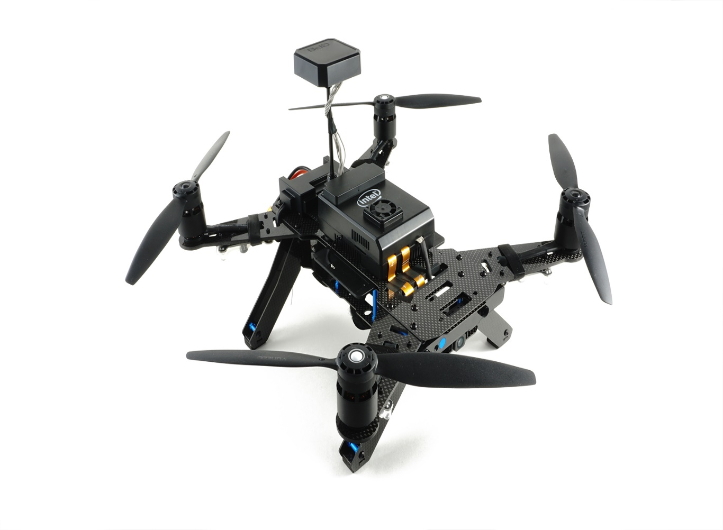

## Introduction

The main documentation on the [official wiki](https://github.com/intel-aero/meta-intel-aero/wiki) explains how to setup, update and connect to the board, and how to do development on the Linux side. The instructions in this topic concentrate on updating the firmware on the microcontroller from a development tree.

It's important to update to the latest image available since some instructions change between releases. You can check the BIOS and distro version by connecting to the board and running the following command:

get_aero_version.py

The instructions here are tested with the following version:

BIOS_VERSION = Aero-01.00.13

OS_VERSION = Poky Aero (Intel Aero Linux Distro) 1.5.1-dev (pyro)"

AIRMAP_VERSION = 1.8

FPGA_VERSION = 0xc1

## Setup Intel Aero using Ubuntu

In order to install Ubuntu on Intel Aero, the following equipment is needed:

1. Power supply (battery or network cable)
2. Micro HDMI to HDMI cable to attach a monitor
3. Micro USB3 to USB2 female adapter
4. USB Hub to attach mouse and keyboard

Follow the linked instructions from [Intel Aero wiki > Installing Ubuntu on Intel Aero](https://github.com/intel-aero/meta-intel-aero/wiki/90-%28References%29-OS-user-Installation#installing-ubuntu-on-intel-aero):

1. [Upgrade Yocto first](https://github.com/intel-aero/meta-intel-aero/wiki/90-%28References%29-OS-user-Installation#upgrade-yocto-first) (optional)
2. [OS](https://github.com/intel-aero/meta-intel-aero/wiki/90-%28References%29-OS-user-Installation#os)
3. [Intel Aero Repository](https://github.com/intel-aero/meta-intel-aero/wiki/90-%28References%29-OS-user-Installation#intel-aero-repository)

As soon as the steps under Intel Aero Repository (above) are completed the Aero kernel is installed. From this point forwards, always boot using this kernel.

Follow the instructions to flash the BIOS, FPGA and Flight Controller. Open the MAVLink router config file: **/etc/mavlink-router/main.conf**

Include the laptop IP as a UDP Endpoint by adding the following lines to the configuration file. The IP address must be set to the one of the laptop. To find the IP address of the laptop, execute: ifconfig.

[UdpEndpoint wifi]

Mode = Normal

Address = 192.168.8.255

After all those steps are completed, the drone should automatically connect to QGroundControl running on the laptop.

Next install ROS, by following the [instructions here](https://github.com/intel-aero/meta-intel-aero/wiki/05-Autonomous-drone-programming-with-ROS).

### RealSense Camera

1. RealSense SDK

Follow the steps to install the RealSense SDK listed on the [aero wiki](https://github.com/intel-aero/meta-intel-aero/wiki/90-%28References%29-OS-user-Installation#intel-realsense-sdk). When cloning the repository, the legacy branch needs to be used for the R200 model. If the D435 or D415 is used, the master branch needs to be cloned. All other steps are the same and the branches can be just switched back and forth if the camera is changed.

If the RealSense R200 is used, it can already be started over a ROS node using:

roslaunch realsense_camera r200_nodelet_default.launch

If any D400 series camera is used, follow the next step to install a different ROS wrapper.

1. ROS Wrapper for D400 series RealSense

Follow the instructions in [Install Intel RealSense ROS from Sources](https://github.com/intel-ros/realsense#step-3-install-intel-realsense-ros-from-sources) to install a catkin workspace and clone the RealSense software.

Install the udev rules using:

sudo cp config/99-realsense-libusb.rules /etc/udev/rules.d/

sudo udevadm control --reload-rules && udevadm trigger

Now the RealSense can be started over a ROS node using:

roslaunch realsense2_camera rs_camera.launch

### Obstacle Avoidance

To run the PX4 obstacle avoidance software, install catkin first:

apt install python-catkin-tools

Create a catkin workspace and initialize it. Then clone the avoidance repository into the source space, or use a symbolic link to the source space. Build the package and start the ROS node using:

catkin build local_planner

roslaunch local_planner local_planner_aero.launch

## Flashing PX4 software

After setting up the PX4 development environment, follow these steps update the PX4 software:

1. Do a full update of all software on the vehicle (<https://github.com/intel-aero/meta-intel-aero/wiki/Upgrade-To-Latest-Software-Release>)
2. Grab the [Firmware](https://github.com/PX4/Firmware)
3. Compile with make aerofc-v1_default
4. Configure the target hostname

If your system resolves link local names you don't have to do anything and you can skip this step. You can test it by trying to ssh into intel-aero.local after connecting to it either via WiFi or USB:

ssh root@intel-aero.local

If it doesn't work you can try giving the IP that will be used by the upload script:

# WiFi IP

export AERO_HOSTNAME=192.168.8.1

# Ethernet-over-USB IP

export AERO_HOSTNAME=192.168.7.2

1. Upload with: make aerofc-v1_default upload

## Connecting QGroundControl via Network

1. Make sure you are connected to the board with WiFi or USB Network
2. ssh to the board and make sure MAVLink forwarding runs. By default it automatically starts when booting. It can be started manually with:

systemctl start mavlink-router

1. Start QGroundControl and it should automatically connect.
2. Instead of starting QGroundControl, you can open a [NuttX shell](https://dev.px4.io/en/debug/system_console.html#mavlink-shell) with:

./Tools/mavlink_shell.py 0.0.0.0:14550

## Connecting LeddarOne Range Finder

Connect the [LeddarOne](https://docs.px4.io/en/sensor/leddar_one.html) to the Aero telemetry port. The pinout for the LeddarOne and Aero telemetry port are as follows.

| **Pin** | **AerofcTELEMETRY** | **LeddarOne** |
| --- | --- | --- |
| 1 | VCC | GND |
| 2 | TX | - |
| 3 | RX | VCC |
| 4 | SCL | RX |
| 5 | SDA | TX |
| 6 | GND | - |

To enable the rangefinder set the [SENS_EN_LEDDAR1](https://docs.px4.io/en/advanced_config/parameter_reference.html#SENS_EN_LEDDAR1) parameter to 1 and reboot the board (instructions for setting parameters [available here](https://docs.px4.io/en/advanced_config/parameters.html)).

If you need to restore the telemetry port to MAVLink, set SENS_EN_LEDDAR1=0 and reboot.

## Connecting Lidar Lite Range Finder

The Lidar Lite is not recommended for use with Intel Aero Ready to Fly Drone® due to measurements spikes.

The following instructions are for a [Lidar Lite](https://docs.px4.io/en/sensor/rangefinders.html#lidar-lite) V3 connected via I2C. The Intel® Aero Ready to Fly Drone has two ports with I2C: One labled COMPASS and the other TELEMETRY. The pinout for both of them can be found below. We recommend using the TELEMETRY port as it is not being used. If your TELEMETRY port is already occupied, a splitter can be used to share the I2C connection (works on any I2C port). Check the images below for the splitter setup.

In addition it is recommended to use a electrolytic capacitor for the Lidar Lite I2C connection to reduce spikes in the distance readings (see [here](https://static.garmin.com/pumac/LIDAR_Lite_v3_Operation_Manual_and_Technical_Specifications.pdf) on page 3).

The pinout for the Lidar Lite V3 and Aero telemetry port are as follows

| **Pin** | **Aerofc TELEMETRY** | **Lidar Lite V3** |
| --- | --- | --- |
| 1 | VCC | VCC |
| 2 | TX | - |
| 3 | RX | - |
| 4 | SCL | SCL |
| 5 | SDA | SDA |
| 6 | GND | GND |

| **pin** | **Aerofc COMPASS** | **Lidar Lite V3** |
| --- | --- | --- |
| 1 | VCC | VCC |
| 2 | SCL | - |
| 3 | SDA | - |
| 4 | GND | SCL |
| 5 | - | SDA |
| 6 | - | GND |

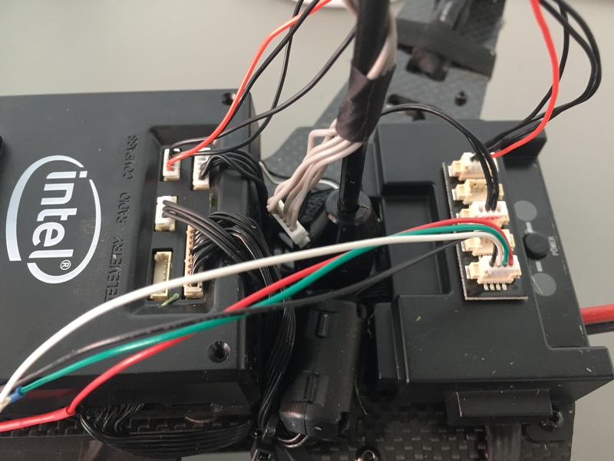

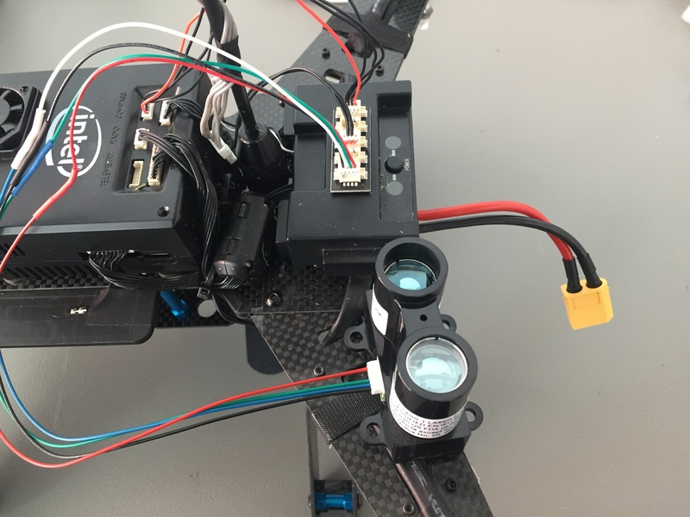

## Using Optical Flow on the Aero

The Intel Aero Ready to Fly Drone® comes with a preinstalled optical flow binary on the compute board (Linux OS version 1.6 or higher), which enables it to stably fly based on optical flow velocity estimation. In order to use optical flow, a range sensor has to be installed first (see above).

To use the optical flow, run the following command in a console on the vehicle's compute board:

systemctl start aero-optical-flow

If you want to start the optical flow binary at boot, use

systemctl enable aero-optical-flow #use disable to undo

In addition, the following parameter values should be set in the flight controller.

| **Parameter** | **Value** |
| --- | --- |
| [EKF2_AID_MASK](https://docs.px4.io/en/advanced_config/parameter_reference.html#EKF2_AID_MASK) | 2 |
| [EKF2_HGT_MODE](https://docs.px4.io/en/advanced_config/parameter_reference.html#EKF2_HGT_MODE) | 2 |

# Raspberry Pi 2/3 Navio2 Autopilot

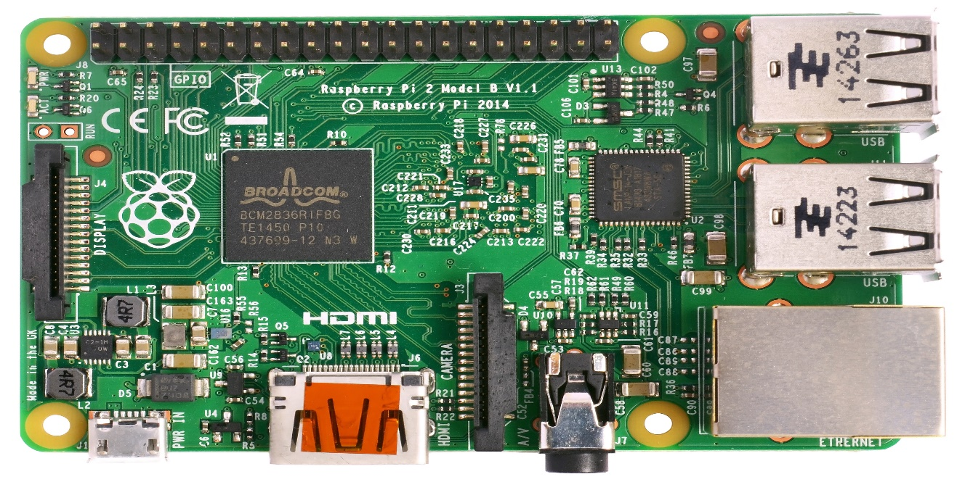

## Developer Quick Start

### OS Image

Use the [Emlid RT Raspbian image for Navio 2](https://docs.emlid.com/navio2/Navio-APM/configuring-raspberry-pi/). The default image will have most of the setup procedures shown below already done.

**Important**: make sure not to upgrade the system (more specifically the kernel). By upgrading, a new kernel can get installed which lacks the necessary HW support (you can check with ls /sys/class/pwm, the directory should not be empty).

### Setting up access

The Raspbian image has SSH setup already. Username is "pi" and password is "raspberry". You can connect to your RPi2/3 over a network (Ethernet is set to come up with DHCP by default) and then proceed to configure WiFi access. We assume that the username and password remain at their defaults for the purpose of this guide.

To setup the RPi2/3 to join your local wifi, follow [this guide](https://www.raspberrypi.org/documentation/configuration/wireless/wireless-cli.md).

Find the IP address of your Pi from your network, and then you can proceed to connect to it using SSH.

ssh pi@<IP-ADDRESS>

### Expand the Filesystem

After installing the OS and connecting to it, make sure to [expand the Filesystem](https://www.raspberrypi.org/documentation/configuration/raspi-config.md), so there is enough space on the SD Card.

### Disable Navio RGB Overlay

The existing Navio RGB overlay claims GPIOs used by PX4 for RGB Led. Edit /boot/config.txt by commenting the line enabling the navio-rgb overlay.

#dtoverlay=navio-rgb

### Changing hostnames

To avoid conflicts with any other RPis on the network, we advise you to change the default hostname to something sensible. We used "px4autopilot" for our setup. Connect to the Pi via SSH and follow the below instructions.

Edit the hostname file:

sudo nano /etc/hostname

Change raspberry to whatever hostname you want (one word with limited characters apply)

Next you need to change the hosts file:

sudo nano /etc/hosts

Change the entry 127.0.1.1 raspberry to 127.0.1.1 <YOURNEWHOSTNAME>

Reboot the Pi after this step is completed to allow it to re-associate with your network.

### Setting up Avahi (Zeroconf)

To make connecting to the Pi easier, we recommend setting up Avahi (Zeroconf) which allows easy access to the Pi from any network by directly specifying its hostname.

sudo apt-get install avahi-daemon

sudo insserv avahi-daemon

Next, setup the Avahi configuration file

sudo nano /etc/avahi/services/multiple.service

Add this to the file :

<?xml version="1.0" standalone='no'?>

<!DOCTYPE service-group SYSTEM "avahi-service.dtd">

<service-group>

<name replace-wildcards="yes">%h</name>

<service>

<type>_device-info._tcp</type>

<port>0</port>

<txt-record>model=RackMac</txt-record>

</service>

<service>

<type>_ssh._tcp</type>

<port>22</port>

</service>

</service-group>

Restart the daemon

sudo /etc/init.d/avahi-daemon restart

And that's it. You should be able to access your Pi directly by its hostname from any computer on the network.

You might have to add .local to the hostname to discover it.

### Configuring a SSH Public-Key

In order to allow the PX4 development environment to automatically push executables to your board, you need to configure passwordless access to the RPi. We use the public-key authentication method for this.

To generate new SSH keys enter the following commands (Choose a sensible hostname such as <YOURNANME>@<YOURDEVICE>. Here we have used pi@px4autopilot)

These commands need to be run on the HOST development computer!

ssh-keygen -t rsa -C pi@px4autopilot

Upon entering this command, you'll be asked where to save the key. We suggest you save it in the default location ($HOME/.ssh/id_rsa) by just hitting Enter.

Now you should see the files id_rsa and id_rsa.pub in your .ssh directory in your home folder:

ls ~/.ssh

authorized_keys id_rsa id_rsa.pub known_hosts

The id_rsa file is your private key. Keep this on the development computer. The id_rsa.pub file is your public key. This is what you put on the targets you want to connect to.

To copy your public key to your Raspberry Pi, use the following command to append the public key to your authorized_keys file on the Pi, sending it over SSH:

cat ~/.ssh/id_rsa.pub | ssh pi@px4autopilot 'cat >> .ssh/authorized_keys'

Note that this time you will have to authenticate with your password ("raspberry" by default).

Now try ssh pi@px4autopilot and you should connect without a password prompt.

If you see a message "Agent admitted failure to sign using the key." then add your RSA or DSA identities to the authentication agent, ssh-agent and the execute the following command:

ssh-add

If this did not work, delete your keys with rm ~/.ssh/id* and follow the instructions again.

### Testing file transfer

We use SCP to transfer files from the development computer to the target board over a network (WiFi or Ethernet).

To test your setup, try pushing a file from the development PC to the Pi over the network now. Make sure the Pi has network access, and you can SSH into it.

echo "Hello" > hello.txt

scp hello.txt pi@px4autopilot:/home/pi/

rm hello.txt

This should copy over a "hello.txt" file into the home folder of your RPi. Validate that the file was indeed copied, and you can proceed to the next step.

### Native builds (optional)

You can run PX4 builds directly on the Pi if you desire. This is the native build. The other option is to run builds on a development computer which cross-compiles for the Pi, and pushes the PX4 executable binary directly to the Pi. This is the cross-compiler build, and the recommended one for developers due to speed of deployment and ease of use.

For cross-compiling setups, you can skip this step.

The steps below will setup the build system on the Pi to that required by PX4. Run these commands on the Pi itself!

sudo apt-get update

sudo apt-get install cmake python-empy

Then clone the Firmware directly onto the Pi.

### Building the code

Continue with our [standard build system installation](https://dev.px4.io/en/setup/dev_env_linux.html).

# Aerotenna OcPoC-Zynq Mini Flight Controller

The [OcPoC-Zynq Mini](https://aerotenna.com/ocpoc-zynq/) is a FPGA+ARM SoC based flight control platform. OcPoC-Zynq's enhanced I/O flexibility and increased processing power makes it a great solution for commercial UAS developers and researchers. The FPGA's I/O flexibility allows for rapid sensor integration and customization of the flight controller hardware, allowing for capabilities such as triple redundancy in GPS, magnetometers, and IMUs. OcPoC-Zynq maintains also lightweight, compact footprint, leaving more space and weight on the airframe for sensor and peripheral expansion.

Main documentation is available on [Aerotenna's User Hub](https://aerotenna.readme.io/docs/ocpoc-mini-zynq-specifications) for hardware setup, FAQs, and various tutorials including FPGA and kernel development.

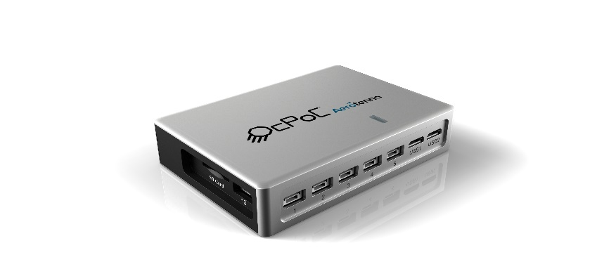

## Quick Summary

* Main FPGA+ARM System-on-Chip: Xilinx Zynq Z-7010
  + CPU: 667 MHz Dual-Core ARM A9
  + FPGA: Artix®-7 with 28K Logic Cells
  + RAM: 512 MB DDR3
  + Flash: 128 MB
  + SD Card: 16 GB
* IMU: 2x MPU9250 9-DOF
* Baro: 1x MS5611
* Power: 5-30 VDC
  + OcPoC regulates internally to 5V
  + 2S-6S LiPo battery is typical power source on airframe
  + For bench testing, the console "USB1" port supplies 5V
* 16x Programmable 3-pin GPIOs
* 10x Programmable I/Os on JST-GH connectors supporting the following interfaces:
  + I2C
  + USB-OTG
  + USB-UART
  + SPI
  + CSI
  + GSI
  + CAN
* Availability: [Aerotenna Store](https://aerotenna.com/shop/ocpoc-zynq-mini/)

## Pinouts and SD Card Setup

Pinouts for the default OcPoC-Zynq configuration and full step-by-step instructions for first time setup are available on [Aerotenna's User Hub](https://aerotenna.readme.io/docs/ocpoc-mini-zynq-specifications).

## Building PX4 for OcPoC-Zynq

After setting up the PX4 development environment and cloning the [PX4 Firmware](https://github.com/PX4/Firmware), you can build PX4 for OcPoC-Zynq with the following commands:

* For Aerotenna's default ubuntu-armhf root file system:
* make posix_ocpoc_ubuntu
* For Petalinux:
* make posix_ocpoc_cross

See the user hub page [PX4 on OcPoC Zynq Mini](https://aerotenna.readme.io/docs/px4-setup) for full step-by-step instructions for first time setup of PX4 on OcPoC-Zynq. Note: At the present time PX4 firmware must be built from source as no pre-built binaries for OcPoC-Zynq are supplied through QGroundControl.

# Crazyflie 2.0

The Crazyflie line of micro quads was created by Bitcraze AB. An overview of the Crazyflie 2.0 can be [found here](https://www.bitcraze.io/crazyflie-2/).

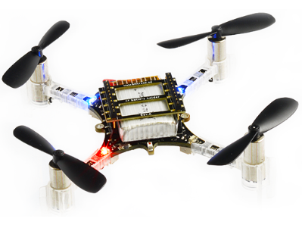

## Quick Summary

The main hardware documentation is here: <https://wiki.bitcraze.io/projects:crazyflie2:index>

* Main System-on-Chip: STM32F405RG
  + CPU: 168 MHz ARM Cortex M4 with single-precision FPU
  + RAM: 192 KB SRAM
* nRF51822 radio and power management MCU
* MPU9250 Accel / Gyro / Mag
* LPS25H barometer

## Where to Buy

* [Crazyflie 2.0](https://store.bitcraze.io/collections/kits/products/crazyflie-2-0).
* [Crazyradio PA 2.4 GHz USB dongle](https://store.bitcraze.io/collections/kits/products/crazyradio-pa): used for wireless communication between QGroundControl and Crazyflie 2.0.
* [Breakout deck](https://store.bitcraze.io/collections/decks/products/breakout-deck): breakout expansion board for connecting new peripherals.
* [Flow deck](https://store.bitcraze.io/collections/decks/products/flow-deck): contains an optical flow sensor to measure movements of the ground and a distance sensor to measure the distance to the ground. This will be useful for precise altitude and position control.
* [Z-ranger deck](https://store.bitcraze.io/collections/decks/products/z-ranger-deck) has the same distance sensor as the Flow deck to measure the distance to the ground. This will be useful for precise altitude control.
* [SD-card deck](https://store.bitcraze.io/collections/decks/products/sd-card-deck): used for high speed onboard logging to a micro SD card.
* [Logitech Joystick](https://www.logitechg.com/en-ch/product/f310-gamepad).

## Flashing PX4

After setting up the PX4 development environment, follow these steps to install the PX4 Autopilot on the Crazyflie 2.0:

1. Download the source code of the PX4 Bootloader:

git clone https://github.com/PX4/Bootloader.git

1. Navigate into the top directory of the source code and compile it using:

make crazyflie_bl

1. Put the Crazyflie 2.0 into DFU mode by following these steps:
   * Ensure it is initially unpowered.
   * Hold down the reset button (see figure below...). 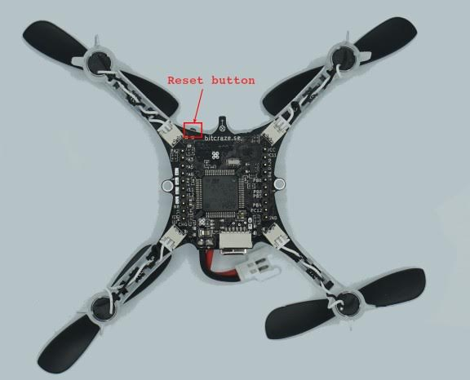
   * Plug into computer's USB port.
   * After a second, the blue LED should start blinking and after 5 seconds should start blinking faster.
   * Release button.
2. Install dfu-util:

sudo apt-get update

sudo apt-get install dfu-util

1. Flash bootloader using dfu-util and unplug Crazyflie 2.0 when done:

sudo dfu-util -d 0483:df11 -a 0 -s 0x08000000 -D ./build/crazyflie_bl/crazyflie_bl.bin

When powering on the Crazyflie 2.0 the yellow LED should blink.

1. Download the source code of the PX4 autopilot:

git clone https://github.com/PX4/Firmware.git

1. Navigate into the top directory of the source code and compile it using:

make crazyflie_default upload

1. When prompted to plug in device, plug in Crazyflie 2.0. The yellow LED should start blinking indicating bootloader mode. Then the red LED should turn on indicating that the flashing process has started.
2. Wait for completion.
3. Done! Calibrate the sensors using [QGroundControl](https://docs.qgroundcontrol.com/en/SetupView/Sensors.html).

If QGroundControl does not connect with the vehicle, ensure that in [nuttx-config](https://github.com/PX4/Firmware/blob/master/platforms/nuttx/nuttx-configs/crazyflie/nsh/defconfig#L934) for crazyflie

# CONFIG_DEV_LOWCONSOLE is not set is replaced by CONFIG_DEV_LOWCONSOLE=y

## Wireless Setup Instructions

The onboard nRF module allows connecting to the board via Bluetooth or through the proprietary 2.4GHz Nordic ESB protocol.

* A [Crazyradio PA](https://www.bitcraze.io/crazyradio-pa/) is recommended.
* To fly the Crazyflie 2.0 right away, the Crazyflie phone app is supported via Bluetooth.

Using the official Bitcraze **Crazyflie phone app**:

* Connect via Bluetooth.
* Change mode in settings to 1 or 2.
* Calibrate via QGroundControl.

Connecting via **MAVLink**:

* Use a Crazyradio PA alongside a compatible GCS.
* Download the crazyflie-lib-python source code:

git clone https://github.com/bitcraze/crazyflie-lib-python.git

We will use [cfbridge.py](https://github.com/bitcraze/crazyflie-lib-python/blob/master/examples/cfbridge.py) to setup a wireless MAVlink communication link between Crazyflie 2.0 (flashed with PX4) and QGroundControl. Cfbridge enables QGroundControl to communicate with the crazyradio PA. The [C based cfbridge](https://github.com/dennisss/cfbridge) is currently experiencing data loss issues, which is why we have chosen to use **cfbridge.py**.

* Make sure you have set the udev permissions to use the USB Radio. To do this, follow the steps listed [here](https://github.com/bitcraze/crazyflie-lib-python#setting-udev-permissions) and **restart** your computer.
* Connect a Crazyradio PA via USB.
* Build a [virtual environment (local python environment)](https://virtualenv.pypa.io/en/latest/) with package dependencies using the following method:

pip install tox --user

* Navigate to the crazyflie-lib-python folder and type:

make venv

* Activate the virtual environment:

source venv-cflib/bin/activate

* Install required dependencies:

pip install -r requirements.txt --user

To connect Crazyflie 2.0 with crazyradio, **launch cfbridge** by following these steps:

* Power off and power on Crazyflie 2.0 and wait for it to boot up.
* Connect a Crazyflie radio device via USB.
* Navigate to the crazyflie-lib-python folder.
* Activate the environment:

source venv-cflib/bin/activate

* Navigate to the examples folder:

cd examples

* Launch cfbridge:

python cfbridge.py

Cfbridge by default tries to initiate the radio link communication on channel 80 and with crazyflie address 0xE7E7E7E7E7. If you are using [multiple crazyflies and/or crazyradios](https://github.com/dennisss/cfbridge/blob/master/README.md#advanced- swarming) in the same room and want to use a different channel and/or address for each, first connect the crazyflie with QGroundControl via a USB cable and change the syslink parameters (channel, address) in QGroundControl. Next, launch the cfbridge by giving the same channel and address as the first and second arguments respectively, e.g: python cfbridge.py 90 0x0202020202

* Open QGroundControl.
* After using cfbridge, you can deactivate the virtualenv if you activated it by pressing CTRL+z. Most of the time, launching cfbridge again from the same terminal doesn't connect to crazyflie, this can be solved by closing the terminal and relaunching cfbridge in a new terminal.

If you change any driver in [crazyflie-lib-python](https://github.com/bitcraze/crazyflie-lib-python) or if launching cfbridge in a new terminal does not find crazyflie, you can try navigating to the crazyflie-lib-python folder and run the script below to rebuild cflib.

make venv

To use Joystick, set COM_RC_IN_MODE in QGroundControl to "Joystick/No RC Checks". Calibrate the Joystick and set the Joystick message frequency in QGroundControl to any value between 5 to 14 Hz (10 Hz is recommended). To be able to set the frequency, the advanced option should be enabled. This is the rate at which Joystick commands are sent from QGroundControl to Crazyflie 2.0. (To do this, you will need to follow the instructions [here](https://github.com/mavlink/qgroundcontrol) to obtain the latest QGroundControl source code (master) and build it.)

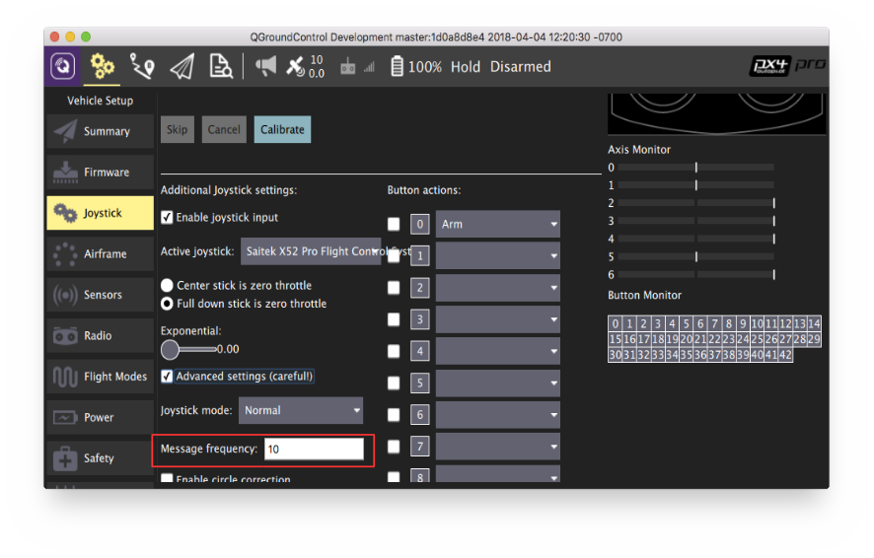

## Hardware Setup

Crazyflie 2.0 is able to fly with precise control in [Stabilized mode](https://docs.px4.io/en/flight_modes/manual_stabilized_mc.html), [Altitude mode](https://docs.px4.io/en/flight_modes/altitude_mc.html) and [Position mode](https://docs.px4.io/en/flight_modes/position_mc.html).

* You will need the [Z-ranger deck](https://store.bitcraze.io/collections/decks/products/z-ranger-deck) to fly in Altitude mode. If you also want to fly in the Position mode, it is recommended you buy the [Flow deck](https://store.bitcraze.io/collections/decks/products/flow-deck) which also has the integrated Z-ranger sensor.
* The onboard barometer is highly susceptible to any external wind disturbances including those created by Crazyflie's own propellers. Hence, we isolated the barometer with a piece of foam, and then mounted the distance sensor on top of it as shown below:

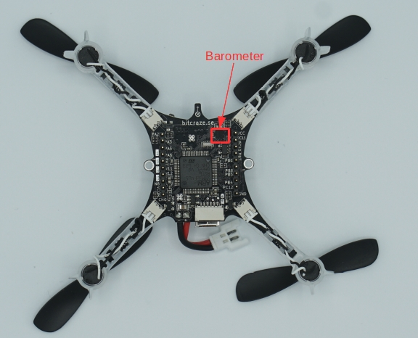

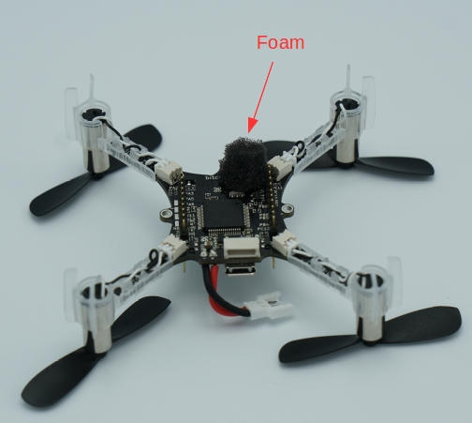

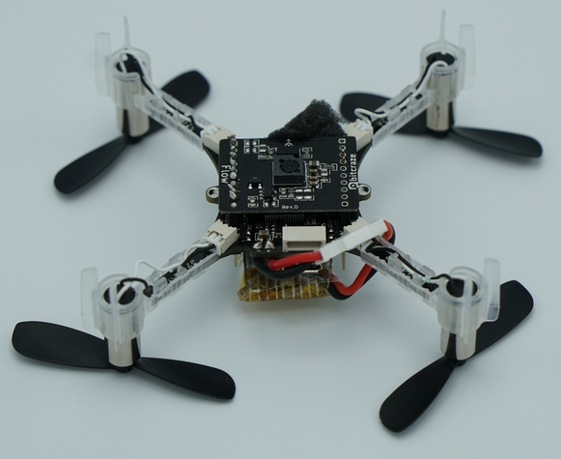

In order to log flight details, you can mount SD card deck on top of crazyflie as shown below:

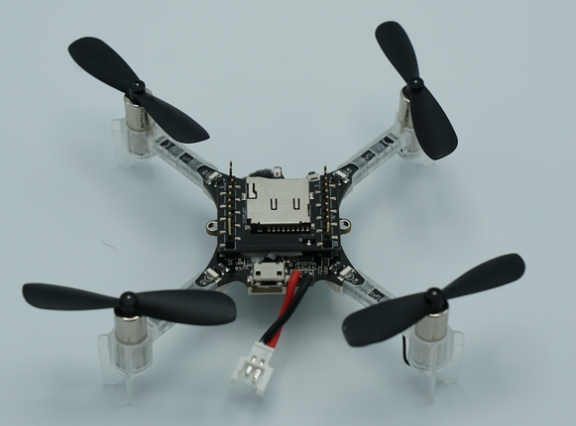

Then, you need to stick the battery on top of the SD card deck using a double sided tape:

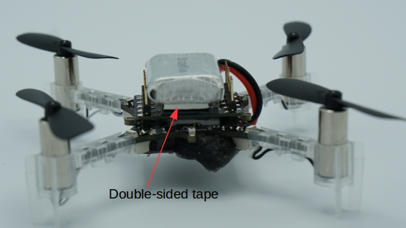

## Altitude Control

Crazyflie is able to fly in Altitude mode if you use a [Z-ranger deck](https://store.bitcraze.io/collections/decks/products/z-ranger-deck). According to the datasheet, the maximum height (above ground) the range finder can sense is 2 m. However, when tested on dark surfaces this value decreases to 0.5 m. On a light floor, it goes up to max 1.3 m. This means you cannot hold altitudes above this value in Altitude or Position flight modes.

If the Crazyflie 2.0 height drifts at mid-throttle command in Altitude mode or Position mode, first try rebooting the vehicle. If this does not fix the problem, recalibrate the accel and mag (compass).

Since the onboard barometer is highly susceptible to wind disturbances created by the Crazyflie's own propellers, you cannot rely on it to hold altitude.

## Position Control

With [Flow deck](https://store.bitcraze.io/collections/decks/products/flow-deck), you can fly Crazyflie 2.0 in Position mode. Unlike PX4flow, the flow deck does not house a gyro, hence the onboard gyro is used for flow fusion to find the local position estimates. Moreover, the flow deck shares the same SPI bus as the SD card deck, therefore logging at high rate on SD card is not recommended when flying in Position mode.

A ulog for flight in Position mode is available [here](https://logs.px4.io/plot_app?log=a0e68bf1-e905-410f-b828-f6146dba9d45). This can be used as a reference to compare your flight performance.

## Using FrSky Taranis RC Transmitter as Joystick

If you already own a Taranis RC transmitter and want to use it as a controller, it can be configured as a USB Joystick:

* Create a new model in Taranis.

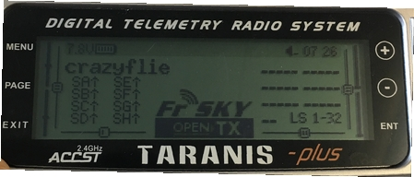

* In MODEL SETUP menu page, turn off both internal and external TX modules.

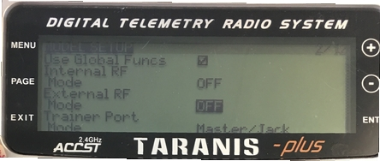

* In OUTPUTS menu page (also called “SERVOS” page in some Taranis transmitters), invert Throttle (CH1) and Aileron (CH3).

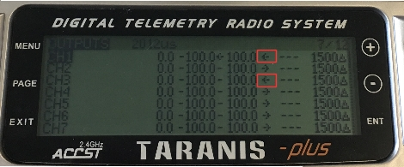

To use Taranis switches to arm/disarm and switch to different flight modes:

* In Taranis UI MIXER menu page, you can assign the switches to any channel in the range channel 9-16 which map to the buttons 0-7 in the QGroundControl Joystick setup. For example, Taranis “SD” switch can be set to channel 9 in Taranis UI:

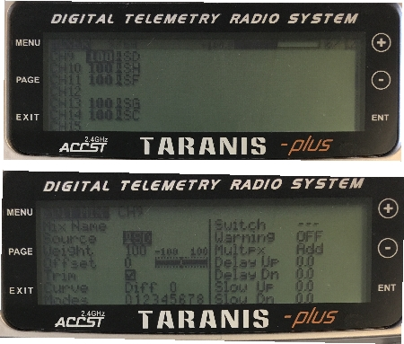

* Connect Taranis to PC with a USB cable and Open QGroundControl.
* In QGroundControl Joystick Setup, you can see the buttons turning yellow when you switch them on. For example, channel 9 in Taranis maps to button 0 in QGroundControl Joystick setup. You can assign any mode to this button e.g. Altitude mode. Now when you lower the switch "SD", flight mode will change to Altitude.

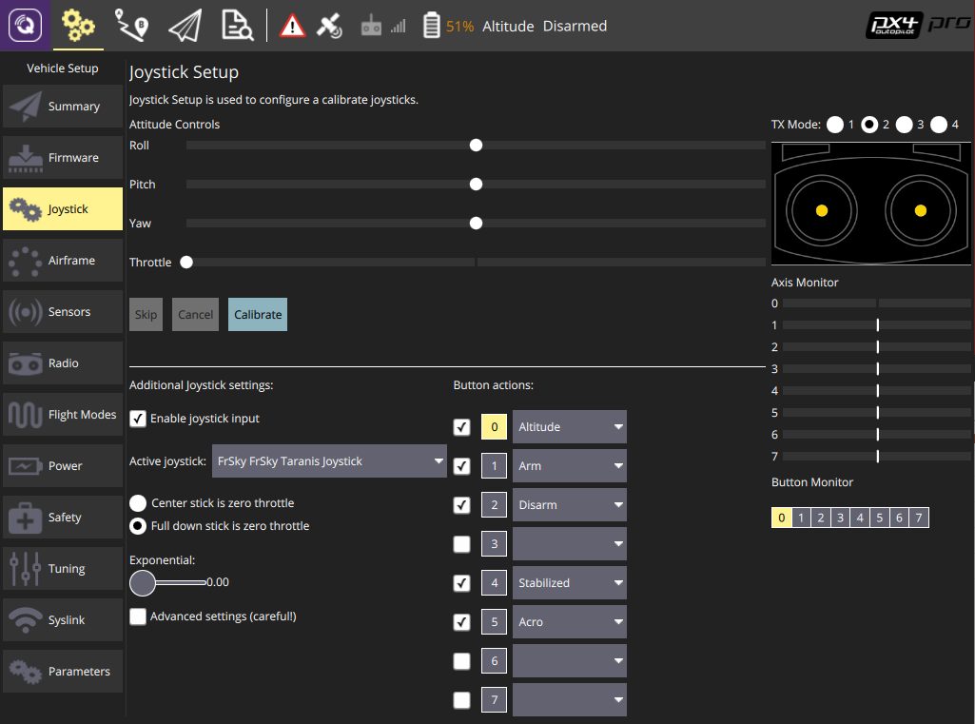

### ROS

To connect to Crazyflie 2.0 via MAVROS:

* Start up cfbridge using the above instructions.
* Change the UDP port QGroundControl listens to:
  + In QGroundControl, navigate to **Application Settings > General** and uncheck all the boxes under Autoconnect to the following devices.
  + Add in **Comm Links** a link of type UDP, check the Automatically Connect on Start option, change the Listening Port to 14557, add Target Hosts: 127.0.0.1 and then press **OK**.
* Make sure you have [MAVROS](https://github.com/mavlink/mavros/tree/master/mavros#installation) installed.
* Start MAVROS with command:
* roslaunch mavros px4.launch fcu_url:="udp://:14550@127.0.0.1:14551" gcs_url:="udp://@127.0.0.1:14557"
* Restart QGroundControl if it doesn't connect.

## Flying

동영상 삭제 됨

# Parrot Bebop

The [Parrot Bebop 2](http://global.parrot.com/au/products/bebop2/) is a popular flying camera. Basic support for PX4 has been added so that it can be used for research and testing.

Bebop support is at an early stage. To use PX4 with Bebop you will need to [build the code](https://dev.px4.io/en/setup/building_px4.html#parrot-bebop) using the developer toolchain.

## Video

<https://youtu.be/SsnzYhiuWiE>

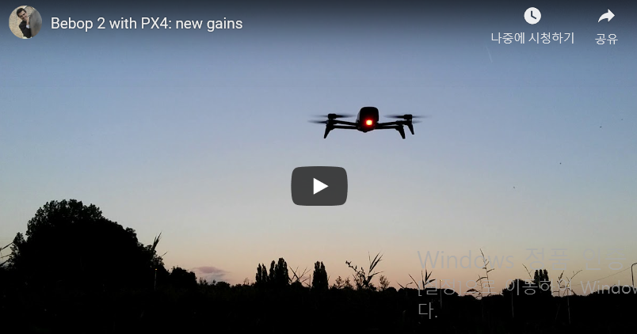

<https://youtu.be/hTVNHlqxWBk>

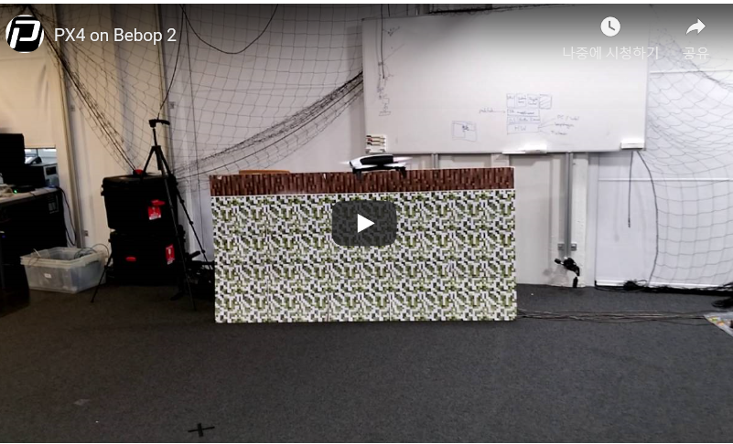

## Advanced Topics

### FTDI connection

Follow the instructions to connect to the Parrot Bebop 2 via FTDI.

* Loosen the two Torx screws (T5) to take off the front cap. 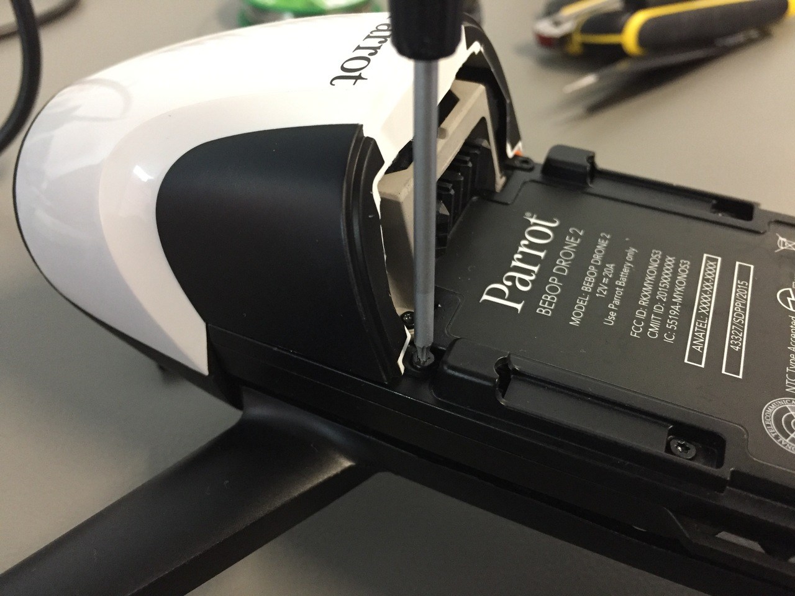
* Use pins to connect to ground/RX/TX or solder cables onto the connectors. 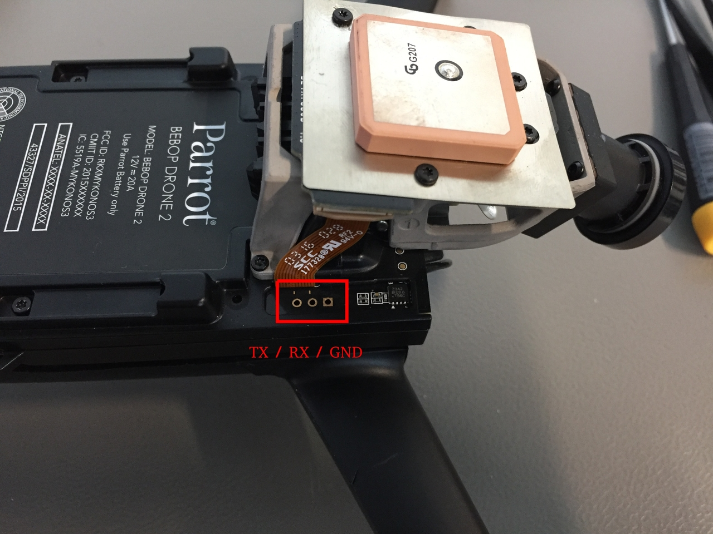
* Connect the FTDI cable and run

screen /dev/ttyUSB0 115200

to connect to the Bebop.

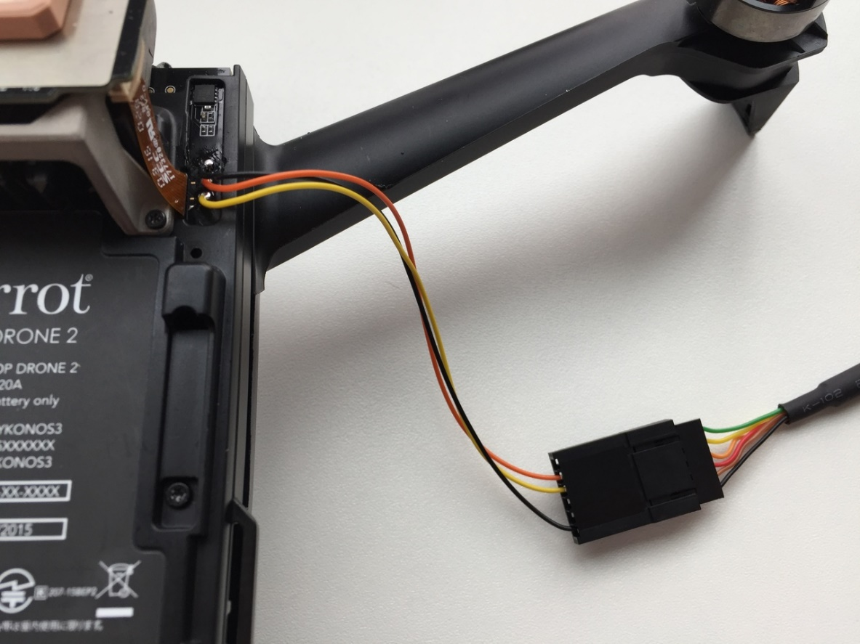

## Resources

Instructions on how to build the code and use PX4 with Bebop 2 available in the Developer Guide here:

* [Building the Code](https://dev.px4.io/en/setup/building_px4.html#parrot-bebop)
* [Airframe Reference](https://docs.px4.io/en/airframes/airframe_reference.html#copter_quadrotor_x_parrot_bebop_frame)

# BeagleBone Blue

[BeagleBone Blue](https://beagleboard.org/blue) is an all-in-one Linux-based computer. Although it is optimized for robotics, this compact and inexpensive board has all necessary sensors and peripherals needed by a flight controller. This topic shows how to set up the board to run PX4 with [librobotcontrol](https://github.com/StrawsonDesign/librobotcontrol) robotics package.

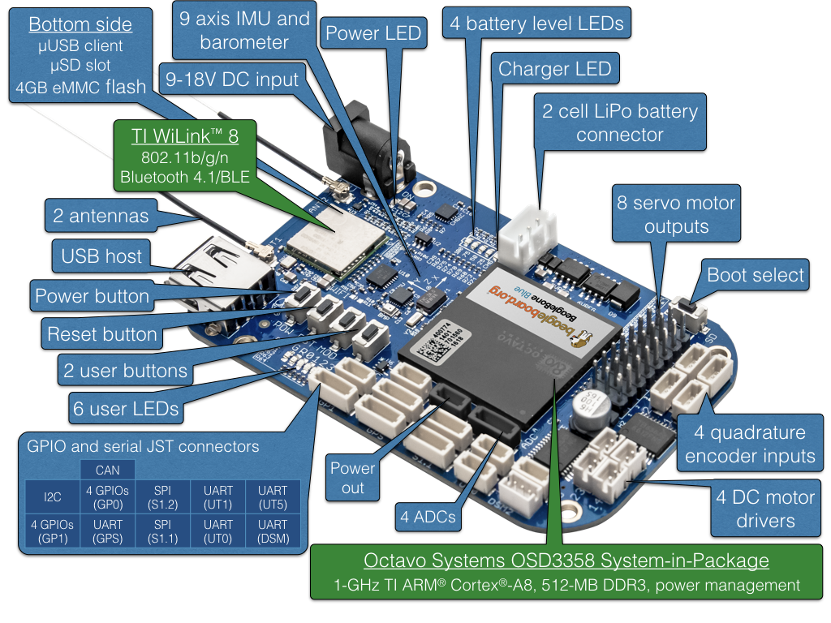

## OS Image

BeagleBone Blue images can be found here:

* [Latest stable OS image](https://beagleboard.org/latest-images).
* [Test OS images](https://rcn-ee.net/rootfs/bb.org/testing/) (updated frequently).

Information about flashing OS images can be found on [this page](https://github.com/beagleboard/beaglebone-blue/wiki/Flashing-firmware). Other useful information can be found in the [FAQ](https://github.com/beagleboard/beaglebone-blue/wiki/Frequently-Asked-Questions-(FAQ)).

## Robot Control Library

On [BeagleBone Blue](https://beagleboard.org/blue), PX4 requires [librobotcontrol](https://github.com/StrawsonDesign/librobotcontrol) version 1.0.0 or higher.

BeagleBoard OS images come with librobotcontrol preinstalled, but it may not work properly in all OS images.

One way to check if librobotcontrol works properly is to run rc_test_drivers which comes with librobotcontrol. As shown in the following example, all tests should pass. Optionally run other tests such as rc_test_bmp, rc_test_mpu, etc.

debian@beaglebone:~$ rc_test_drivers

Kernel: 4.14.56-ti-rt-r64

BeagleBoard.org Debian Image 2018-07-22

Debian: 9.5

PASSED: gpio 0

PASSED: gpio 1

PASSED: gpio 2

PASSED: gpio 3

PASSED: pwm1

PASSED: pwm2

PASSED: eqep0

PASSED: eqep1

PASSED: eqep2

PASSED: pru-rproc

PASSED: uart1

PASSED: uart2

PASSED: uart4

PASSED: uart5

PASSED: i2c1

PASSED: i2c2

PASSED: spi

PASSED: LED

PASSED: ADC iio

Currently running on a:

MODEL_BB_BLUE

Robot Control library Version:

1.0.0

Optionally you can update to a realtime kernel, and if you do, re-check if librobotcontrol works properly with the realtime kernel.

The latest OS images in which librobotcontrol works properly (at time of writing) is [bone-debian-9.5-iot-armhf-2018-07-22-4gb.img.xz](https://rcn-ee.net/rootfs/bb.org/testing/2018-07-22/stretch-iot/bone-debian-9.5-iot-armhf-2018-07-22-4gb.img.xz).

### Setup Robot Control Library

If you want to build PX4, there are additional setup steps for this library.

At time of writing, without modifying its build files to add cross compile support, the librobotcontrol debian package is only available on BeagleBoard products including BeagleBone Blue. Here are the ways to obtain the librobotcontrol on BeagleBone Blue:

1. Use the one pre-installed in BeagleBoard images.
2. Install from debian package or repository:

sudo apt update && sudo apt install librobotcontrol

1. Install from source

git clone https://github.com/StrawsonDesign/librobotcontrol.git

cd librobotcontrol

sudo make install

After acquiring the pre-built library,

1. Select the librobotcontrol installation directory, and set it in the LIBROBOTCONTROL_INSTALL_DIR environment variable so that other unwanted headers will not be included
2. Install **robotcontrol.h** and **rc/\*** into $LIBROBOTCONTROL_INSTALL_DIR/include
3. Install pre-built native (ARM) version of librobotcontrol.* into $LIBROBOTCONTROL_INSTALL_DIR/lib

At this point the BeagleBone Blue target can be built on both cross compile host system and native build system, i.e.,

make posix_bbblue_cross [upload]

## Cross Compiler Build

The recommended way to build PX4 for BeagleBone Blue is to compile on a development computer and upload the PX4 executable binary directly to the BeagleBone Blue.

This approach is recommended over [native build](https://docs.px4.io/en/flight_controller/beaglebone_blue.html#native_builds) due to speed of deployment and ease of use.

### Cross Compiler Setup

ARM Cross Compiler for BeagleBone Blue can be found at [Linaro Toolchain Binaries site](http://www.linaro.org/downloads/). The following is an example setup on development host.

1. First install the toolchain into /opt/bbblue_toolchain/gcc-arm-linux-gnueabihf. Here is an example of using soft link to select which version of the toolchain you want to use:

...@ubuntu:/opt/bbblue_toolchain$ ls -l

lrwxrwxrwx 1 root root 51 Mar 22 16:10 gcc-arm-linux-gnueabihf -> gcc-linaro-6.3.1-2017.05-x86_64_arm-linux-gnueabihf

drwxr-xr-x 8 root root 4096 May 17 2017 gcc-linaro-6.3.1-2017.05-x86_64_arm-linux-gnueabihf

drwxr-xr-x 8 root root 4096 Nov 19 03:51 gcc-linaro-6.4.1-2017.11-x86_64_arm-linux-gnueabihf

1. Add it to the PATH in ~/.profile as shown below

export PATH=$PATH:/opt/bbblue_toolchain/gcc-arm-linux-gnueabihf/bin

export CrossCompiler=/opt/bbblue_toolchain/gcc-arm-linux-gnueabihf/bin/arm-linux-gnueabihf-

GCC in the toolchain should be compatible with kernel in BeagleBone Blue. General rule of thumb is to choose a toolchain where version of GCC is not higher than version of GCC which comes with the OS image on BeagleBone Blue.

### Cross Compile and Upload

1. First set up rsync (this is is used to transfer files from the development computer to the target board over a network - WiFi or Ethernet).
   * For rsync over SSH with key authentication, follow steps similar to those for [Raspberry Pi/Navio](https://docs.px4.io/en/flight_controller/raspberry_pi_navio2.html)
   * On the development computer, define the BeagleBone Blue board as BBBluePX4 in **/etc/hosts**
2. Run the following command to build and upload files:

make posix_bbblue_cross upload

To test the uploaded files, run the following commands on the BeagleBone Blue board:

cd /home/debian/px4

sudo ./bin/px4 -s px4.config

Currently librobotcontrol requires root access.

## Native Builds (optional)

You can also natively build PX4 builds directly on the BeagleBone Blue.

Run the following commands on the BeagleBone Blue (i.e. via SSH):

1. Install dependencies:

sudo apt-get update

sudo apt-get install cmake python-empy

1. Clone the PX4 Firmware directly onto the BeagleBone Blue.
2. Continue with the [standard build system installation](https://dev.px4.io/en/setup/dev_env_linux.html).

## Autostart During Boot

Here is an example [/etc/rc.local]:

#!/bin/sh -e

#

# rc.local

#

# This script is executed at the end of each multiuser runlevel.

# Make sure that the script will "exit 0" on success or any other

# value on error.

#

# In order to enable or disable this script just change the execution

# bits.

#

# By default this script does nothing.

# wait for services to start up

/bin/sleep 25

cd /home/debian/px4

/home/debian/px4/bin/px4 -d -s /home/debian/px4/px4.config > /home/debian/px4/PX4.log &

exit 0

Below is a systemd service example [/lib/systemd/system/px4-quad-copter.service]:

[Unit]

Description=PX4 Quadcopter Service

After=networking.service network-online.target

StartLimitIntervalSec=0

Conflicts=px4-fixed-wing.service

[Service]

WorkingDirectory=/home/debian/px4

User=root

ExecStart=/home/debian/px4/bin/px4 -d -s /home/debian/px4/px4.config

Restart=on-failure

RestartSec=1

[Install]

WantedBy=multi-user.target

### Miscellaneous

#### Power Servo Rail

When PX4 starts, it automatically applies power to servos.

#### Unique Features

BeagleBone Blue has some unique features such as multiple choices of WiFi interfaces and power sources. Refer to comments in **/home/debian/px4/px4.config** for usage of these features.

#### SBUS Signal Converter

SBUS signal from receiver (e.g., FrSky X8R) is an inverted signal. UARTs on BeagleBone Blue can only work with non-inverted 3.3V level signal. [This tutorial](https://dev.px4.io/en/tutorials/linux_sbus.html) contains a SBUS signal inverter circuit.

#### Typical Connections

For a quadcopter with GPS and an SBUS receiver, here are typical connections:

1. Connect the ESC of motor 1, 2, 3 and 4 to channel 1, 2, 3 and 4 of servo outputs on BeagleBone Blue, respectively. If your ESC connector contains a power output pin, remove it and do not connect it to the power output pin of the servo channel on the BeagleBone Blue.
2. Connect the above mentioned converted SBUS signal to the dsm2 port if you have the matching connector for dsm2, otherwise connect it to any other available UART port and change the corresponding port in **/home/debian/px4/px4.config** accordingly.
3. Connect the signals of GPS module to GPS port on the BeagleBone Blue. Note that the signal pins of the GPS port on the BeagleBone Blue are only 3.3V tolerant, so choose your GPS module accordingly.

# PX4 Development

This user guide has everything you need to fly, assemble and configure a vehicle that uses one of the many supported airframes, flight controllers and peripherals.

Developers who want to modify flight algorithms, add new modes, integrate new hardware, communicate with PX4 from outside the flight controller, or contribute to PX4 will need to read the [PX4 Development Guide](http://dev.px4.io/).